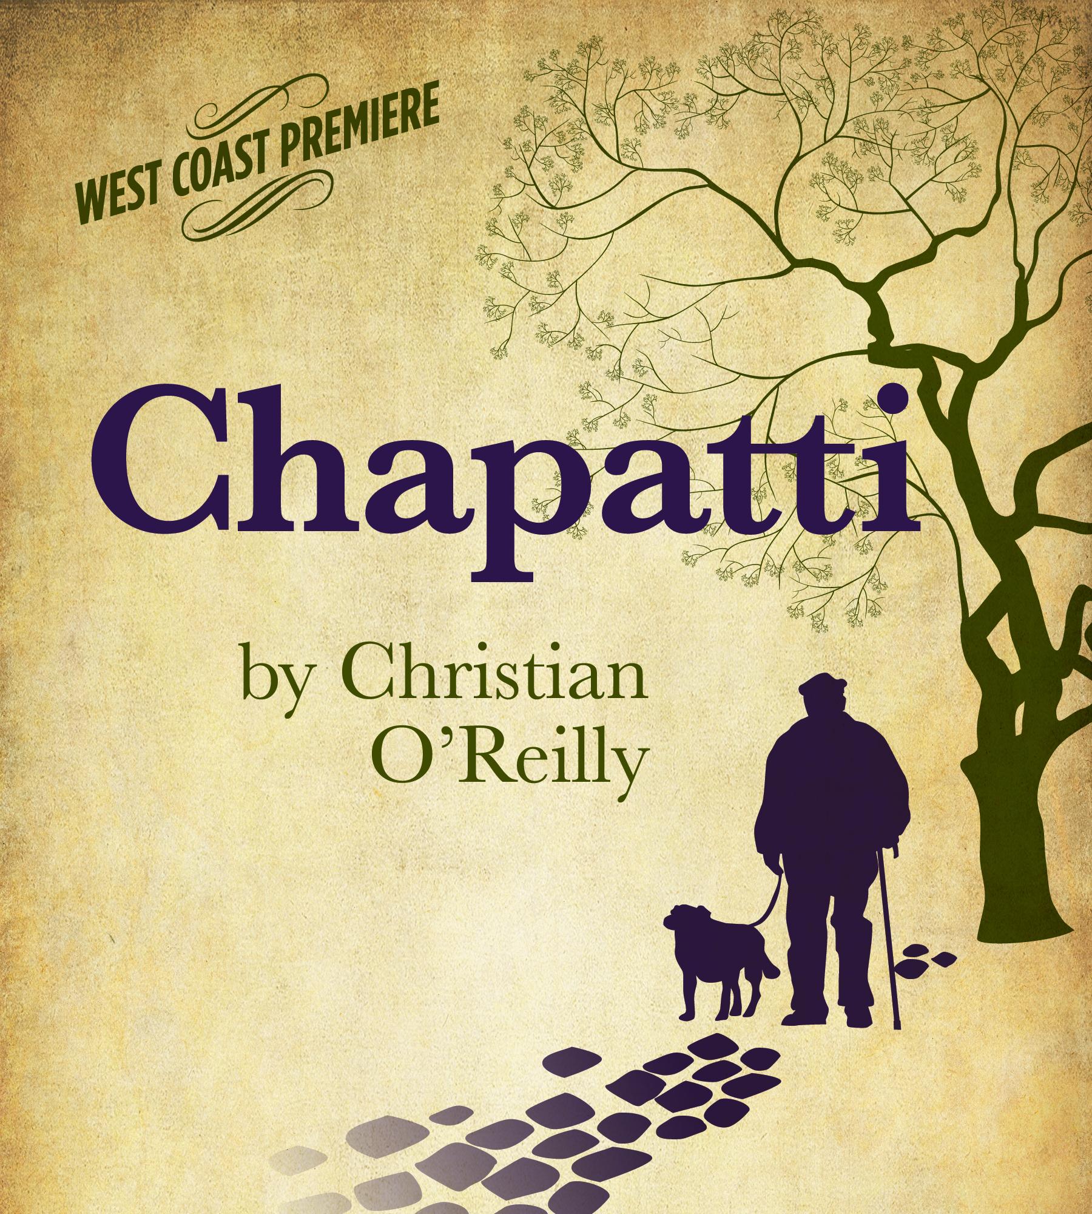
PRESS CONTACT: Nancy Richards – 917-873-6389 (cell)/nancy@northcoastrep.org
MEDIA PAGE: www.northcoastrep.org/press PHOTOS BY: Aaron Rumley
FOR IMMEDIATE RELEASE, PLEASE:
TWO-TIME TONY AWARD-WINNING ACTRESS JUDITH IVEY TO DIRECT
WEST COAST PREMIERE OF CHAPATTI BY CHRISTIAN O’REILLY
AT NORTH COAST REPERTORY THEATRE
Performances Beginning Wednesday, October 21, 2015
Opening Saturday, October 24, 2015 at 8 pm
Running Through Sunday, November 15

Solana Beach, CA, Judith Ivey, a two-time winner of Broadway’s Tony Award, has been tapped by North Coast Rep to direct the West Coast premiere of CHAPATTI. Written with great charm and wit by Irish playwright Christian O’Reilly, the two-character play took Chicago by storm, prompting the Chicago Tribune to label it “a late-in-life romance surprise.”
"What do you get when you mix an Irish tale, 19 cats, one dog named after a pancake and two animal lovers? Give up? The answer is ...CHAPATTI by Christian O'Reilly. It's a humorous and touching story of life and love."
Two lonely animal lovers in Dublin cross paths, and an unexpected spark begins as they re-discover the importance of human companionship. This heartwarming second-chance comedy celebrates unforgettable characters who still believe in love.
Director Judith Ivey directs Annabella Price* and Mark Bramhall* in CHAPATTI. The design staff includes Marty Burnett (Scenic Design), Matt Novotny (Lighting Design), Elisa Benzoni (Costume Design), Melanie Chen (Sound Design), Andrea Gutierrez (Prop Design),Jessica Amador (Scenic Artisan), Jan Gist (Dialect Coach) and Cindy Rumley* is the Stage Manager.
CHAPATTI previews begin Wednesday, October 21. Opening Night on Saturday, October 24, at 8pm includes a post-show reception. There will be a special talkback on Friday, October 30, with the cast and artistic director. It will play Wednesdays at 7pm, Thursdays through Saturdays at 8pm, Saturday and Sunday matinees at 2pm with Sundays at 7pm, through November 15, 2015. (See Schedule below.) North Coast Repertory Theatre is located at 987 Lomas Santa Fe Drive, Solana Beach, CA 92075. Tickets: Previews- $39; Week Nights $46; Sat. Eve. & Sun. Mat $50; Sat. Mat.& Sun. Night $43. Seniors, Students, Military $3 off admission. Call 858-481-1055 or visit www.northcoastrep.org to purchase tickets.
*The actor or stage manager appears through the courtesy of Actors’ Equity Association, the union of professional actors and stage managers in the United States.
For background information and photos, go to www.northcoastrep.org/press.
Please follow North Coast Repertory Theatre on social media as well on Facebook at https://www.facebook.com/North-Coast-Rep
Twitter: https://twitter.com/NorthCoastRep
YouTube: http://www.youtube.com/user/Northcoastrepvideos
Busy director Judith Ivey (here now till October 26th) and her talented cast are available for interviews by phone, in person, and in- studio. For more information and to arrange interviews or press tickets, please contact Nancy Richards at nancy@northcoastrep.org, or 917-873-6389 cell.

FACT SHEET

WHAT: NORTH COAST REPERTORY THEATRE presents
CHAPATTI
by Christian O’Reilly
Directed by Judith Ivey

CAST: Annabella Price* and Mark Bramhall.*

WHERE: North Coast Repertory Theatre
987 Lomas Santa Fe Drive
Solana Beach, CA 92075

SCHEDULE*: Previews: October 21-23, 2015
Opens: October 24, 2015, at 8 pm
Closes: November 15, 2015
Wed. @ 7pm, Thurs-Sat @ 8PM; Sat & Sun @ 2PM, Sun @7pm
Talkback with cast & director: Friday, October 30, 2015

PRICES: Previews $39.00
Week Nights $46.00
Sat. Matinees & Sunday Nights $43.00
Sat. Nights & Sunday Matinees $50.00

DISCOUNTS: Seniors, Students, Military $3.00 off admission

BOX OFFICE (858) 481-1055 or www.northcoastrep.org

OCTOBER
SUN | MON | TUE | WED | THU | FRI | SAT
 |  |  | 21  Preview  8pm | 22  Preview  8pm | 23  Preview  8pm | 24  OPENING  8pm
25  2pm & 7pm | 26 | 27 | 28  7pm | 29  8pm | 30  8pm  Talkback | 31  2pm & 8pm
NOVEMBER

SUN | MON | TUE | WED | THU | FRI | SAT
1  2pm & 7pm | 2 | 3 | 4  7pm | 5  8pm | 6  8pm | 7  8pm
8  2pm & 7pm  ____  15  2pm | 9 | 10 | 11  7pm | 12  8pm | 13  8pm | 14  2pm & 8pm

BACKGROUND:
This Wonderful Life (December 8 – 27) returns to North Coast starring James Leaming in his dazzling one-man tour-de-force based on the perennial favorite, “It’s a Wonderful Life.” In an amazing display of physical and verbal virtuosity, Leaming brings to life over 32 familiar characters. His Jimmy Stewart-inspired George Bailey leads the impressively portrayed cast of characters from Bedford Falls including Clarence the Angel, Mary, Zuzu and all the colorful townsfolk who rely on him to save them from the greedy Mr. Henry Potter. Leaming has left audiences cheering across the nation. Sherlock Holmes and the Adventure of the Great Nome Gold Rush, a wildly entertaining adventure, kicks off the New Year. David Ellenstein directs the World Premiere, which runs January 13 to February 7, 2016. The world’s greatest sleuth, Sherlock Holmes, using his inimitable wit and skill to prove his client innocent of murder, travels to the Wild West frontier town of Nome, Alaska, and ends up at a bar run by Wyatt Earp. This wild and wooly adventure is full of intrigue, mystery, deception, and duplicity. Following is the U.S.Premiere of an outrageously funny farce by the French master Georges Feydeau, in a brilliant translation by British playwright Kenneth McLeish and directed by Bruce Turk. Now You See It, the U.S. Premiere playing February 24 to March 20, 2016, takes audiences on a dizzying escapade fueled by jealousy bordering on paranoia, a philandering husband, hypnotism, a spurned lover and a scandalous discovery. Furiously fast and clever, this visual and verbal treat is guaranteed to tickle your funny bone. The West Coast Premiere, Way Downriver; William Faulkner’s ‘Old Man’, debuts April 13 to May 8, 2016. David Ellenstein directs. A flood of Biblical proportions on the mighty Mississippi provides the dramatic backdrop to this gripping, edge-of-your seat adventure. Adapted from the William Faulkner short story, “Old Man,” Way Downriver reveals an unlikely pair of souls who are bound together by the forces of nature, and who struggle to overcome their fears and prejudice in order to survive their harrowing experiences. You won’t want to miss this exciting West Coast Premiere. Hedda Gabler, arguably one of the most complex and intriguing female characters ever written, will have its debut with a World Premiere adaptation created by the company at North Coast Rep, translated by Anne-Charlotte Harvey and directed by David Ellenstein. Hedda Gabler weaves a mesmerizing tale of a woman trapped in a loveless marriage and driven by a need for power and freedom. Discerning theatre lovers will not want to miss this freshly translated classic running from June 1 to June 26, 2016. Season 34 concludes with Ain’t Misbehavin’ playing from July 13 to August 7, 2016 and directed by Obie Award winner Yvette Freeman. Ain’t Misbehavin’ is a roof-raising musical tribute to the black musicians of the ‘20s and ‘30s. Based on the signature Fats Waller song, this rousing musical revue takes audiences back to the glory days of the Harlem Renaissance when the Cotton Club and Savoy Ballroom served as playgrounds for high society. You’ll be tapping your feet as five performers take you on a journey, presenting an evening of rowdy, raunchy, and humorous songs.
About the North Coast Repertory Theatre
North Coast Repertory Theatre is a professional Equity theatre founded in 1982 by Olive and Tom Blakistone. Currently celebrating its 34th season, North Coast Rep has received critical acclaim from media and audiences alike, and has evolved into one of the area’s leading performing arts organizations. North Coast Rep prides itself on employing the majority of its actors from Actors’ Equity Association for its high quality, award-winning productions, and staging works by established and emerging playwrights. Throughout its history, North Coast Rep has created a platform where artist and audience thrive through the intimacy of live theatre, recognizing the power of theatre to challenge complacency, revitalize the imagination, nurture the unexpected, and embrace the variety and diversity in our lives.

BIOS:
CHRISTIAN O’REILLY (Playwright) Christian O'Reilly's plays include It Just Came Out (Druid Debut Series 2001), The Good Father (Druid - Galway Arts Festival 2002; national tour 2003; joint winner of the 2002 Stewart Parker Trust New Playwright Bursary), Is This About Sex? (Rough Magic - 2007 Edinburgh Fringe Festival; 50th Dublin Theatre Festival; winner of Best Theatre Script at the 2008 Irish Writers' Guild Awards), Here We Are Again Still (Decadent/Galway City Council - 2009 Nun's Island; Bealtaine Festival and national tour in 2011), and Sanctuary (Blue Teapot - 2012 Galway Theatre Festival; 2013 Galway Arts Festival and Dublin Fringe Festival). His screen credits include episodes of BBC One dramas "Doctors," "Casualty," and "Holby City," as well as "Inside I'm Dancing" (2004), a feature film based on his original story, which was released in the U.S. as "Rory O'Shea Was Here." Christian lives in
Galway in the west of Ireland with his wife Ailbhe and their son Cóilín.

JUDITH IVEY (Director) Judith Ivey is a four-time Tony nominee and the recipient of the Tony Award and the Drama Desk Award for her portrayals in Steaming and Hurlyburly, the Obie Award for her performance in The Moonshot Tape, and countless others for her stage and film work. She can be seen in the recently released film, “Big Stone Gap,” written and directed by Adriana Trigiani. Judith has appeared in over 40 films and starred in four TV shows, most notably the last season of “Designing Women”. Ms. Ivey’s stage directing credits include Steel Magnolias and Carapace at the Alliance Theatre in Atlanta (nominated for a Bass Award), premiere of Darrah Cloud’s Our Suburb, the musical, Vanities at the Pasadena Playhouse and Second Stage in NYC, The Butcher Of Baraboo at the Second Stage Uptown Series, Fugue at the Cherry Lane Theatre, and Southern Comforts at Primary Stages in NYC. Judith directed Bad Dates both at the Northlight Theatre in Chicago, and the Laguna Playhouse, Steel Magnolias at the Alley Theatre, and More with Yeardley Smith at Union Square Theatre, and the Falcon Theatre in Los Angeles. Other directing credits include Two For The Seesaw at the Westport Playhouse, The Go-For-It Guy at the Aspen Comedy Festival, and Soccer Moms at Fleetwood Stage and the Snapple Theatre in NYC. Ms. Ivey is married to Tim Braine, and is the proud mother of Maggie and Tom. Judith has been a member of Actors’ Equity for 40 years, and the SSDC for 10 years.
ANNABELLA PRICE* (Betty) is very happy to have North Coast Repertory Theatre and Christian O'Reilly's Chapatti as part of her life in the theatre. Stage, selected list : Steven Berkoff's Metapmorphosis at Mark Taper Forum; Jane Martin's Talking With and Len Jenkins’ The Five of Us at Taper Too; Stephen Metcalfe's Strange Snow, Old Globe San Diego; Beyond Therapy, Empty Space Seattle and South Coast Repertory; Eric Overmeyer's In Perpetuity Throughout the Universe, South Coast Repertory; Maria Irene Fornes' Fefu and Her Friends, Padua Hills Playwright Festival; Julie Johnson, Sundance Playwright Conference; Brian Friel's Translations, Doris Baizley's Mrs. California, LA Stage Company; and Hugh Leonard's A Life, Summer, Theatre 40. TV/Film, selected list : Series: “Christy” (director Michael Rhodes); “Gang of Four” (director Jan Egelson); Television Movies: “Good Night Sweet Wife” (director Jerrold Freedman); “Murder Ordained” (director Mike Robe); “Roe vs. Wade” (director Gregory Hoblit); “Baby M” (director Jim Sadwith), and “Practical Magic” (director Griffin Dunne). She would like to dedicate this play about love to her children Joe, Cal and Nora.
MARK BRAMHALL* (Dan) is honored to make his North Coast Rep debut in CHAPATTI. He began acting professionally in 1966, in the original company of San Francisco’s American Conservatory Theatre. He has performed off-Broadway, at regional theatres nationwide and dozens of SoCal venues, including thirty-four productions while a Resident Artist at A Noise Within. He is a member of LA’s renowned Antaeus Theatre Company, and has recently starred at the Kirk Douglas Theatre, Sacred Fools Theatre, The Lillian Theatre, The Pico Playhouse and Actors Co-op. He won a 2012 Ovation Award covering three of the four principal roles in Center Theatre Group’s Waiting For Godot at the Mark Taper Forum, and was nominated again for that Award in 2013 for Best Performance in a Leading Role, in 24th St. Theatre’s Walking The Tightrope. Other honors and nominations: L.A. Drama Critics Circle, Ovation, Garland, LA Weekly and Dramalogue awards; Audie nomination (2013) and twenty-nine AudioFile Magazine “Earphones” awards for excellence in audiobook narration. Selected film and TV credits: “Star Trek” (2009), “Vanilla Sky,” “Introducing Dorothy Dandridge,” “Nip/Tuck,” “Weeds,” “24,” “ER,” and “Alias”; also “Housecat” and “Emily Flutters,” both in post-production. He voices principal roles in “Call Of Duty: Black Ops,” “Guild Wars 2,” “The Amazing Spiderman” and “Steamboy” (with Alfred Molina). Education/Training: Harvard (AB cum laude, 1965); UC Berkeley; LAMDA (Fulbright Scholar); American Conservatory Theatre; Classical Theatre Lab; Steve Eastin Studio. Mark is a proud lifelong member of AEA and SAG-AFTRA. www.markbramhall.com.

CINDY RUMLEY* (Stage Manager) is in her fifth year at North Coast Rep. Credits include: Side By Side By Sondheim, Freud’s Last Session, Mandate Memories, Dames at Sea, Two By Pinter, and Visiting Mr. Green with North Coast Rep. Snapshots with The Pico Playhouse, Bye Bye Birdie with San Diego Musical Theater, and Conference of the Birds with The Moscow Art Theater. Cindy has worked as a production assistant at North Coast Rep for Heroes, My Name is Asher Lev, 5 Course Love, King O’ the Moon, and The Drawer Boy. Cindy holds an M.F.A in stage management from UC Irvine and is a member of Actor’s Equity Association. In her free time, Cindy enjoys being married to the amazing Mr. Aaron Rumley and taking care of their daughter, Emma Lee.

DESIGN TEAM
MARTY BURNETT (Resident Scenic Designer) Marty is in his 23rd season as Resident Designer/Technical Director at North Coast Rep. He has designed the last 166 shows. Other venues include Laguna Playhouse, Portland Stage Company, Drury Lane (Chicago), Claridge Hotel (Atlantic City), Union Plaza, Sahara Hotel, Hacienda in Las Vegas, Coronado Playhouse, Scripps Ranch Theater, Harrah’s Lake Tahoe. Marty is a proud alumni of Creighton University in Omaha, Nebraska.
MATTHEW NOVOTNY (Light Design) is pleased to be designing another show for North Coast Rep, where he has designed close to 40 shows over the past seven years. Matthew is currently the Lighting Designer in Residence for San Diego Musical Theatre as well as North Coast Rep, and his work can be seen at a wide variety of theatres across San Diego. Matthew holds a BA in Technical Theatre from San Diego State, and a Masters Degree in Lighting Design from Boston University. Matthew is married to his beautiful wife Amanda, with 3 gorgeous children; Ragan, Harper and Heston.

ELISA BENZONI (Costume Design) is thrilled to be working with North Coast Rep again. Recent credits include: The Fox on the Fairway (North Coast Rep); Pericles, Prince of Tyre, Reckless, Much Ado About Nothing, Measure for Measure (Old Globe/ USD); The Who and The What, Our Town, Tall Girls, Brahaman/I, Sam Bendrix at the Bon Soir (La Jolla Playhouse); Sylvia, Much Ado About Nothing (New Village Arts), Snakeskin, Lifeblood Harmony, Chagall, A Man Found Wanting (Malashock Dance); The Storm, The Threepenny Opera, A Man, His Wife, and His Hat (UCSD). Assistant costume credits: Dialogues des Carmelites (Teatro Petruzzelli, Bari), Paradise Found (Menier Chocolate Factory, London), Milk Like Sugar (La Jolla Playhouse), As You Like It, Midsummer Night’s Dream (The Old Globe). Elisa holds a costume design MFA fromUCSD. www.elisabenzoni.com

MELANIE CHEN (Sound Design) is thrilled to be working with North Coast Rep again! She is a freelance sound designer who has designed over 50 productions in San Diego, Los Angeles, and San Francisco. Past North Coast Rep credits include Side by Side by Sondheim, Betrayal, Unnecessary Farce, Freud’s Last Session, Romance/Romance, Faded Glory, Mandate Memories, and Becoming Cuba. Melanie holds an M.F.A. in Sound Design for Theatre & Dance from UC San Diego. For more info, visit her website at www.melaniesound.com.
ANDREA GUTIERREZ (Prop Design) has been working at North Coast Rep since 2012, beginning as the Stage Manager and Prop Master for our theatre school. She worked as backstage crew for the 32nd and the beginning of the 33rd Season, before taking over as Supervising House Manager and Volunteer Coordinator. Her previous prop credits include The Diary of Anne Frank, Alice in Wonderland and Brighton Beach Memoirs, as well as two Seasons as properties assistant at Starlight Theatre. She received her B.A. in Theatrical Design and Production from UCLA’s School of Theatre, Film & Television, and is currently pursuing her M.A. from Johns Hopkins University.
JESSICA AMADOR (Scenic Artisan) A local scenic artist from Solana Beach. This is her second scenic production at North Coast Rep. Other recent productions include: The Fox on the Fairway (North Coast Rep), Comedy of Errors, Baskerville, Twelfth Night, Rich Girl, Arms and the Man at The Old Globe. The Normal Heart, Drowsy Chaperone, Once on this Island, Blood Wedding at MiraCosta College. She attended MiraCosta College 2001-2004 & The Pacific Conservatory of the Performing Arts in 2004-2006
(PCPA Theaterfest).

JAN GIST (Dialect Coach) Jan Gist is professor of voice, speech and dialects for the Old Globe/USD Graduate Theatre Program. She has vocal coached for The Old Globe, La Jolla Playhouse, Ahmanson Theatre, Oregon, Utah, and Alabama Shakespeare Festivals, and The Shakespeare Theatre (D.C.), American Shakespeare Center. Others include American Players Theatre, Arena Stage (D.C.), and Milwaukee, Indiana, and PlayMakers Repertories. She is an original and published member of the Voice And Speech Trainers Association. Recently she gave workshops at Russia’s Moscow Art Theatre and in London’s Central School of Speech and Drama. Her poetry and articles have been published in VASTA’s annual journals, The Complete Voice and Speech Workout, More Stage Dialects, and Voice and Speech Training in the New Millennium, Conversations with Master Teachers.
PRODUCTION ASSISTANT — VICTORIA QUINTANAR
# # #

