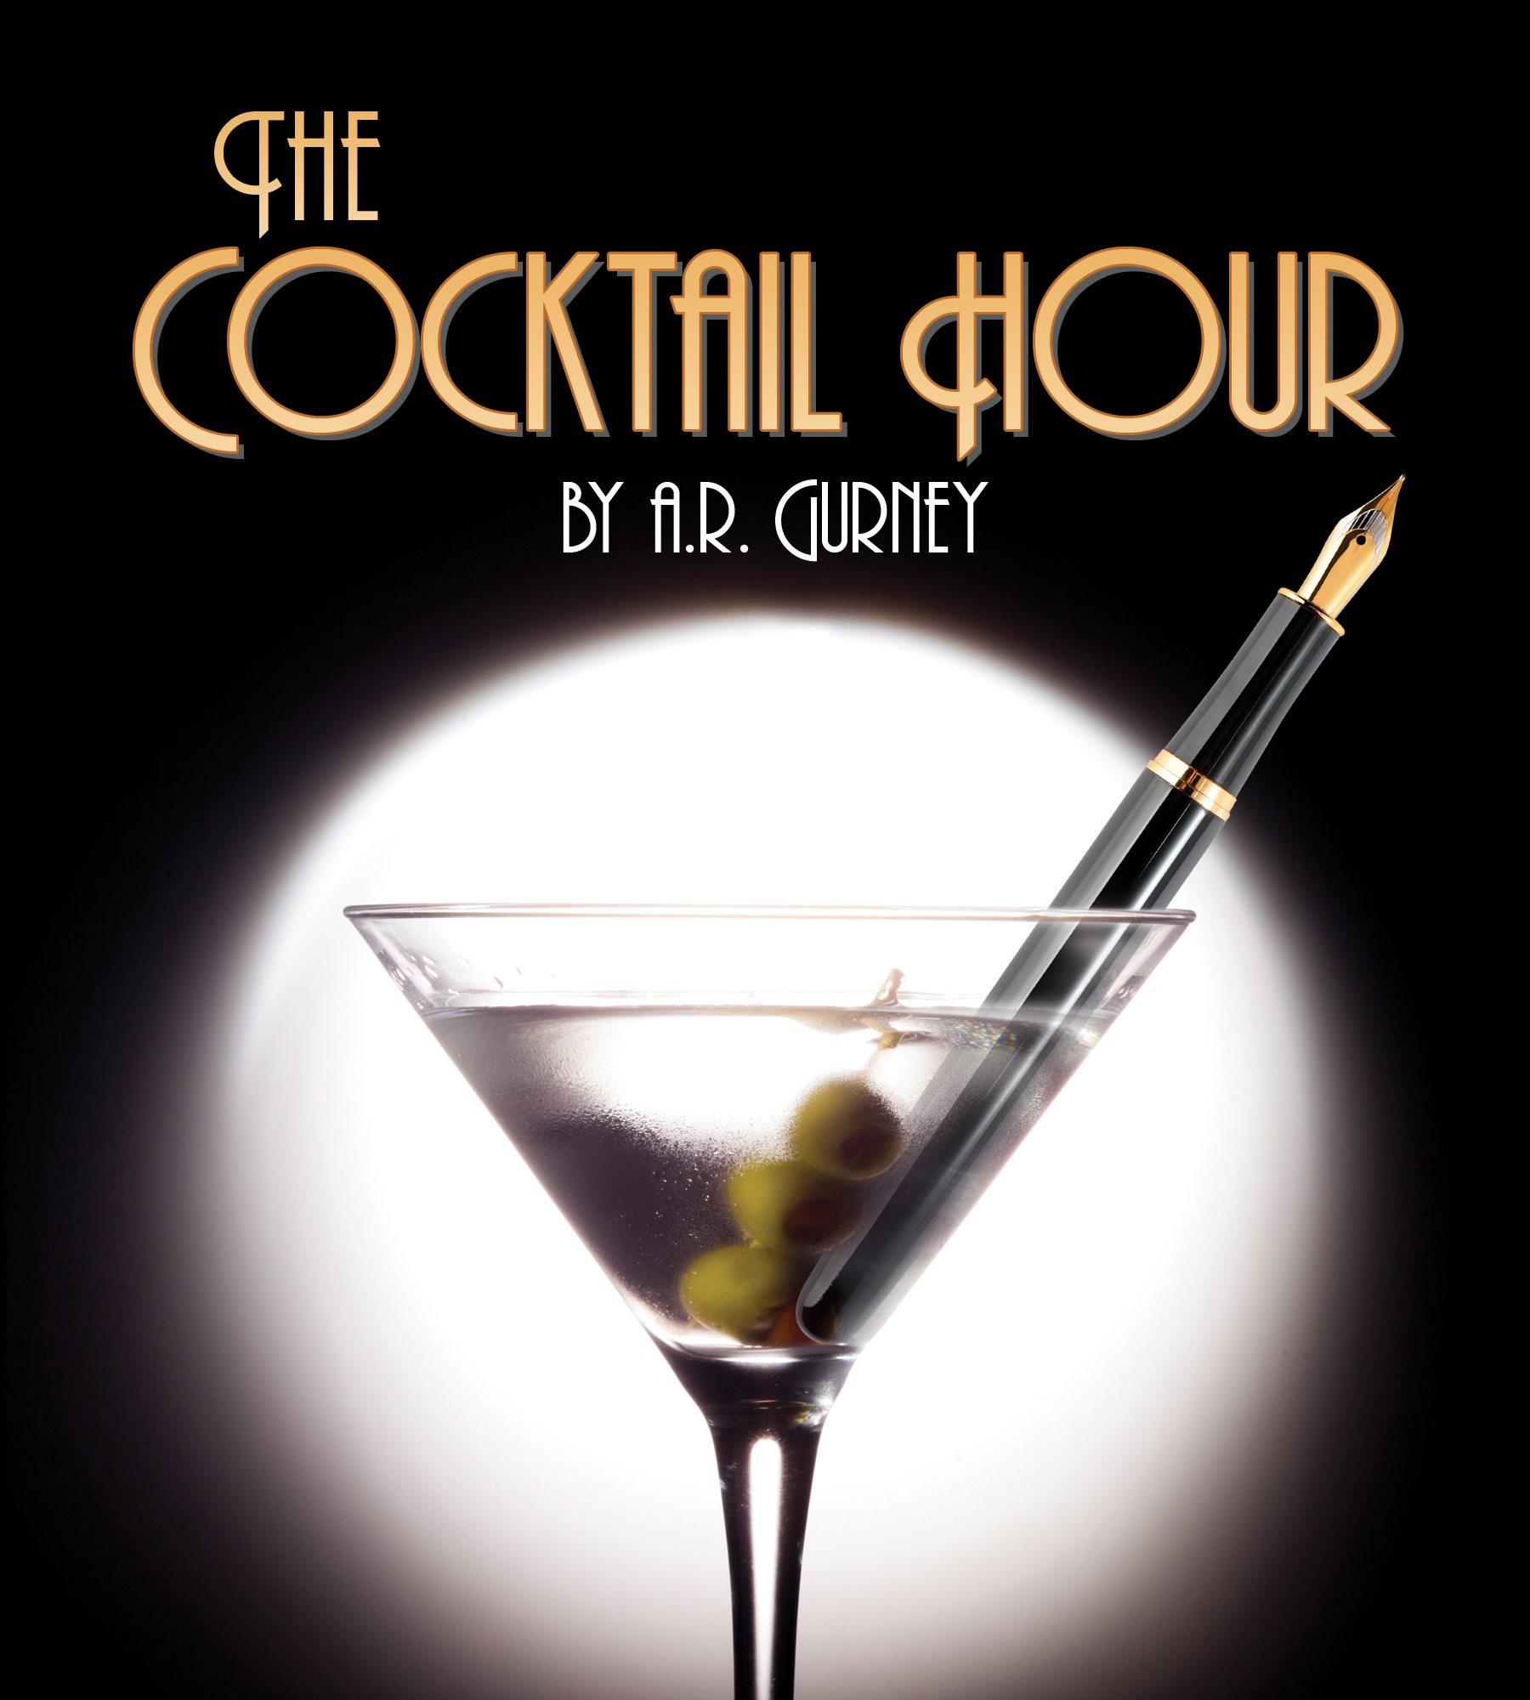
PRESS CONTACT: Nancy Richards – 917-873-6389 (cell)/nancy@northcoastrep.org
MEDIA PAGE: www.northcoastrep.org/press

FOR IMMEDIATE RELEASE, PLEASE:
NORTH COAST REP LAUNCHES SEASON 35
WITH A.R. GURNEY’S POTENT BUT POIGNANT
‘THE COCKTAIL HOUR’
Performances Beginning Wednesday, September 7, 2016
Running Through Sunday, October 2, 2016
Directed by Rosina Reynolds

Solana Beach, Calif. North Coast Repertory Theatre is toasting the opening of Season 35 with the bracing, boisterous comedy, THE COCKTAIL HOUR, by A.R. Gurney. Mix two upper-class New Englanders, their over-privileged adult children and endless cocktails for a delightfully intoxicating evening of fun. Son John arrives for dinner at his parent’s home carrying his provocative tell-all script that leaves the family shaken and stirred. Join the Rep for this free-flowing comedy that The New Yorker praised as Gurney’s “best play he has done.”

Rosina Reynolds directs J. Michael Flynn*, Chris Petschler*, Cristina Soria* and Shana Wride*. The design team includes Marty Burnett (Scenic Design), Matthew Novotny (Lighting), Melanie Chen (Sound), Elisa Benzoni (Costumes), Andrea Gutierrez (Props) and Peter Herman (Wig & Hair). Aaron Rumley* is the Stage Manager.
*The actor or stage manager appears through the courtesy of Actors’ Equity Association, the union of professional actors and stage managers in the United States. For background information and photos, go to www.northcoastrep.org/press.

Busy director Rosina Reynolds and her talented cast are available for interviews by phone, in person, and in- studio. For more information and to arrange interviews or press tickets, please contact Nancy Richards at nancy@northcoastrep.org, or 917-873-6389 cell.

THE COCKTAIL HOUR previews begin Wednesday, September 7. Opening Night on Saturday, September 10, at 8pm includes a post-show reception. There will be a special talkback on Friday, September 16, with the cast and artistic director. It will play Wednesdays at 7pm, Thursdays through Saturdays at 8pm, Saturday and Sunday matinees at 2pm with Sundays at 7pm, through October 2, 2016. (See Schedule below.) North Coast Repertory Theatre is located at 987 Lomas Santa Fe Drive, Solana Beach, CA 92075. Tickets: Previews- $39; Week Nights - $46; Sat. Eve. & Sun. Mat.- $50; Sat. Mat. & Sun. Night - $43. Seniors, Students, Military - $3 off admission. Call 858-481-1055 or visit www.northcoastrep.org to purchase tickets.

FACT SHEET

WHAT: NORTH COAST REPERTORY THEATRE presents
THE COCKTAIL HOUR
By A.R. Gurney
Directed by Rosina Reynolds

CAST: J. Michael Flynn*, Chris Petschler*, Cristina Soria*, Shana Wride*.

WHERE: North Coast Repertory Theatre
987 Lomas Santa Fe Drive, Ste. D
Solana Beach, CA 92075

SCHEDULE Previews: September 7, 2016
Opens: September 10, 2016, at 8 pm
Closes: October 2, 2016
Wed. @ 7pm, Thurs-Sat @ 8PM; Sat & Sun @ 2PM, Sun @ 7pm
Talkback with cast & director: Friday, September 16, 2016

PRICES: Previews $39.00
Week Nights $46.00
Sat. Matinees & Sunday Nights $43.00
Sat. Nights & Sunday Matinees $50.00

DISCOUNTS: Seniors, Students, Military $3.00 off admission

BOX OFFICE (858) 481-1055 or www.northcoastrep.org

SEPTEMBER
SUN |  | MON | TUE | WED | THU | FRI | SAT
 |  |  |  | 7  Preview  8pm | 8  Preview  8pm | 9  Preview  8pm | 10  OPENING  8pm
 | 11  2pm & 7pm | 12 | 13 | 14  7pm | 15  8pm | 16  8pm  Talkback | 17  2pm & 8pm
 | 18  2pm & 7pm | 19 | 20 | 21  7pm | 22  8pm | 23  8pm | 24  2pm & 8pm
 | 25  2pm & 7pm | 26 | 27 | 28  7pm | 29  8pm | 30  8pm | Oct. 1  2pm & 8pm
2
2pm

BIOS:
A.R. Gurney (Playwright) Albert Ramsdell Gurney Jr., also known as A. R. Gurney, and sometimes credited as Pete Gurney, is an American playwright, novelist and academic. Born in Buffalo, New York, in 1930, his plays often explore the theme of a declining upper-class life in contemporary America. Several of his works are loosely based on his patrician upbringing, including The Cocktail Hour and Indian Blood. Among his most-produced works are Sylvia, The Snow Ball, The Dining Room and Love Letters. In 2006, Gurney was elected a member of the American Academy of Arts and Letters, and in 2007, received the PEN/Laura Pels International Foundation for Theater Award as a master American dramatist.

ROSINA REYNOLDS (Director) North Coast Repertory Theatre: Fallen Angels; Broken Glass; Educating Rita; Glorious; Don’t Dress For Dinner; Relatively Speaking; Importance of Being Earnest; Travesties; An American Daughter; The Sum of Us; Blithe Spirit; Corpse; Rough Crossing; Chekov in Yalta. San Diego Repertory Theatre: Bad Dates. Cygnet Theatre: Atwater, Fixin’ to Die. Renaissance Theatre: Caretaker (San Diego Critics Circle Award). Compass Theatre: Three Days of Rain. Fritz Theatre: Vigil. Hahn Cosmopolitan Theatre: Marvin's Room. Diversionary Theatre: Marriage Bed; Happy Endings are Extra; Twilight of the Golds; Beautiful Thing; Wrinkles; Another American; Asking and Telling; Gross Indecency: The Three Trials of Oscar Wilde; Breaking The Code; Lot's Daughters. Chequamegon Children’s Theatre: Founding Artistic Director. Twenty-nine years of Broadway musicals with up to 60 kids annually, rehearsed and presented in 3 weeks. This summer we presented The Pirates of Penzance.

J. MICHAEL FLYNN* (Bradley) Returning to Southern California theatre after eighteen years, Mr. Flynn is thrilled to be joining North Coast Rep. During more than four decades in the theatre, Mr. Flynn has worked with – among others – A Contemporary Theatre, Alabama Shakespeare Festival, American Conservatory Theatre, Arizona Theatre Company, Aurora Theatre, Baltimore CenterStage, Berkeley Rep, Boise Contemporary, Brooklyn Academy of Music, Center Rep, Cleveland Play House, Geva, The Goodman, The Huntington, Idaho Shakespeare Festival, The Long Wharf, The Magic, The Old Globe, Oregon Shakespearean Festival, P.C.P.A., Pittsburgh Public, Portland Center Stage, San Jose Rep, Seattle Rep, Syracuse Stage and The Sundance Institute. His Hollywood career can be traced on the IMDb. BTW, Mr. Flynn is continually in wonder of and deeply grateful for Mrs. Flynn.

CHRIS PETSCHLER* (John) Los Angeles: The Bat, starring Veronica Cartwright; David in Desperate Writers (world premiere.) World tours: Uncle in Beethoven Lives Upstairs, Vivaldi/Giovanni in Vivaldi’s Ring of Mystery, Mozart in Mozart’s Magnificent Voyage. Selected regional: Man #1 in I Love You, You’re Perfect, Now Change (several productions nationwide); Foxfire (Jenny Wiley Theatre, KY); Forty Carats (McArt’s International Theatre, FL); Mark Antony in Julius Caesar (Oak Park Festival Theatre, Chicago); Georg in She Loves Me (Theatre at the Center); Once Upon a Mattress, Lucky Stiff, The Mousetrap (Drury Lane Oakbrook); Jewtopia (Chicago premiere, Mercury Theater). TV and Film: “The Dark Knight” (Warner Brothers), “The Velvet Veil” (Red Walnut Pictures), “A Credit to the Family” (Second City TV, starring Ed Helms). www.chrispetschler.com. For JB.

CRISTINA SORIA* (Ann) - Delighted to be back playing Ann in The Cocktail Hour. Also at North Coast Rep: Hedda Gabler, Tiny Alice. Cygnet Theatre: When the Rain Stops Falling by Andrew Bovell. 6th@Penn Theatre: The Lover and Ashes to Ashes by Harold Pinter (“Billie” Outstanding Leading Actress in a Comedy or Drama), Oedipus Tyrannus. South Coast Repertory: So Many Words. Blackfriars Theatre: La Ronde/Getting Around. San Diego Repertory: A Christmas Carol (2X) and Man of the Flesh. Old Globe Theatre/Cassius Carter: La Fiaca. Theatre in Old Town (produced by USIU): You Can’t Take It With You. Carlsbad Theatre: The Lady Cries Murder. Member AEA, SAG-AFTRA.

SHANA WRIDE*: (Nina) was last seen at North Coast Rep in Faded Glory and Broken Glass. Other acting credits include Baby with the Bathwater, The Further Adventures of Hedda Gabler, Next Fall (Diversionary Theatre); Much Ado About Nothing (Intrepid Theatre); Private Lives (Cygnet Theatre); Women Who Steal, A Christmas Carol, Suds, Working, Six Women with Brain Death (San Diego Repertory Theatre); A Midsummer Night’s Dream, Twelfth Night, Merry Wives of Windsor (Shakespeare Festival Los Angeles); Indoor/Outdoor (The Colony Theatre); Macbeth, Fen, Wooden Breeks, Measure for Measure (Open Fist Theatre); Heidi Chronicles and Lips Together, Teeth Apart (Gaslamp Theatre); Henry IV Parts 1 & 2, Love’s Labor’s Lost (Idaho Shakespeare Festival); New, Shadowy Waters, No Time Like The Present (Sledgehammer Theatre). Directing credits include: The Whale, Mistakes Were Made (Cygnet Theatre); Walter Cronkite is Dead (San Diego Repertory Theatre); Boys & Girls and Anita Bryant Died for Your Sins (Diversionary Theatre); Or (Moxie Theatre), and Who’s Afraid of Virginia Woolf? (Compass Theatre). She co-hosted the nationally syndicated radio show, “Women Aloud” with actor/comedienne Mo Gaffney.

AARON RUMLEY* (Stage Manager) North Coast Repertory Theatre: Hedda Gabler, Sherlock Holmes and the Adventure of the Great Nome Gold Rush; The Fox on the Fairway; Betrayal; Unnecessary Farce; Gunmetal Blues; Fallen Angels; Who Am I This Time?; Broken Glass; Two by Pinter: The Lover and The Dumb Waiter; THIS; The Lion in Winter; Heroes; Lend Me a Tenor; My Name is Asher Lev; The Drawer Boy; Becky’s New Car; Voice of the Prairie; Ghosts; Glorious!; Talley’s Folly; Over the Tavern; Rabbit Hole; The Dresser; Don’t Dress for Dinner; Madagascar; Mornings at Seven; String of Pearls; Dracula; Rashomon; Wit; A Moon for the Misbegotten; Leading Ladies; Collected Stories; Halpern & Johnson; Romeo and Juliet; The Bungler; The Chosen; A Life in the Theatre, and The Rainmaker. North Carolina Theatre: Talley’s Folly; Picnic; The Miser, and On Golden Pond. Aaron received a B.A. in Theatre from the University of North Carolina at Wilmington, and is the production manager at the North Coast Repertory Theatre. Aaron is a Member of Actors’ Equity Association.

DESIGN TEAM:
MARTY BURNETT (Resident Scenic Designer) Marty is in his 23rd season as Resident Designer/Technical Director at North Coast Rep. He has designed the last 166 shows. Other venues include Laguna Playhouse, Portland Stage Company, Drury Lane (Chicago), Claridge Hotel (Atlantic City), Union Plaza, Sahara Hotel, Hacienda in Las Vegas, Coronado Playhouse, Scripps Ranch Theater, Harrah’s Lake Tahoe. Marty is a proud alumni of Creighton University in Omaha, Nebraska.
MATTHEW NOVOTNY (Light Design) is pleased to be designing another show for North Coast Rep, where he has designed close to 40 shows over the past seven years. Matthew is currently the Lighting Designer in Residence for San Diego Musical Theatre as well as North Coast Rep, and his work can be seen at a wide variety of theatres across San Diego. Matthew holds a BA in Technical Theatre from San Diego State, and a Masters Degree in Lighting Design from Boston University. Matthew is married to his beautiful wife Amanda, with 3 gorgeous children: Ragan, Harper and Heston.
ELISA BENZONI (Costume Design) is thrilled to be working with North Coast Rep again. Previous work with North Coast Repertory Theatre includes: Hedda Gabler, Sherlock Holmes and the Adventure of the Great Nome Gold Rush, Chapatti, The Fox on the Fairway for which she was nominated for a Craig Noel Award; Other select credits: Sex with Strangers (Geffen Playhouse), Constellations (Old Globe) Pericles, Prince of Tyre, Reckless, Much Ado About Nothing, Measure for Measure (Old Globe/USD); The Who and The What, Our Town, Tall Girls, Brahaman/I, Sam Bendrix at the Bon Soir (La Jolla Playhouse); Emilie, Sylvia, Much Ado About Nothing (New Village Arts), Snakeskin, Lifeblood Harmony, Chagall, A Man Found Wanting (Malashock Dance); The Storm, The Threepenny Opera, A Man, His Wife, and His Hat (UCSD). Assistant costume credits: Dialogues des Carmelites (Teatro Petruzzelli, Bari), Paradise Found (Menier Chocolate Factory, London), Milk Like Sugar (La Jolla Playhouse), As You Like It, A Midsummer Night’s Dream (The Old Globe). Elisa holds a costume design MFA from UCSD. www.elisabenzoni.com

MELANIE CHEN (Sound Design) is thrilled to be working with North Coast Rep again! She is a freelance sound designer who has designed over 50 productions in San Diego, Los Angeles, and San Francisco. Past North Coast Rep credits include Ain’t Misbehavin’, Hedda Gabler, Way Downriver, Now You See It, Side by Side by Sondheim, Betrayal, Unnecessary Farce, Freud’s Last Session, Romance/Romance, Faded Glory, Mandate Memories, and Becoming Cuba. Melanie holds an M.F.A. in Sound Design for Theatre & Dance from UC San Diego. For more info, visit her website at www.melaniesound.com

ANDREA GUTIERREZ (Prop Design) has been working at North Coast Rep since 2012, beginning as the Stage Manager and Prop Master for our theatre school. She worked as backstage crew for the 32nd and the beginning of the 33rd Season, before taking over as Supervising House Manager and Volunteer Coordinator. Her previous prop credits include Hedda Gabler, Way Downriver; William Faulkner’s ‘Old Man’, Now You See It, Sherlock Holmes and the Adventure of the Great Nome Gold Rush, Chapatti, and The Fox on the Fairway, as well as two seasons as properties assistant at Starlight Theatre. She received her B.A. in Theatrical Design and Production from UCLA’s School of Theatre, Film & Television, and is currently pursuing her M.A. from Johns Hopkins University.

PETER HERMAN (Hair & Wig Design) has previously designed wigs for over 30 North Coast Rep productions including: Way Downriver; William Faulkner’s ‘Old Man’, Now You See It, Sherlock Holmes and the Adventure of the Great Nome Gold Rush, Fallen Angels, Romance Romance, Faded Glory, Mandate Memories, The School For Lies, Honky Tonk Angels, Travesties, I Love You Because, Little Women, My Name is Asher Lev and Five Course Love. He has also designed costumes for past North Coast Rep productions of 25th Annual Putnam County Spelling Bee, The Big Bang, Madagascar, and Jacques Brel is Alive and Well and Living in Paris. Peter teaches wig and makeup design at San Diego State University. He is glad to be part of the creative team on this show.

BACKGROUND:

Season 35 continues with Neil Simon’s Laughter on the 23rd Floor, a riotous love letter to his early career as a writer for Sid Caesar’s “Your Show of Shows” (Oct. 19-Nov. 13). Next, The Girl Singers of the Hit Parade Holiday Show offers a tuneful tribute to the ‘50s’ favorite holiday songs as well as sing-a-longs to engage young and old alike (Dec. 6-23). The New Year rings in with the San Diego premiere of Marjorie Prime, a fascinating family drama set in the near future that dazzled critics and audiences in New York and Los Angeles (Jan. 11-Feb. 5, 2017). Following is a wildly inventive tour-de-force, The Illusion, by the legendary Tony Kushner (Feb. 22-March 19, 2017). Next, audiences are invited to take an entertaining, offbeat journey with Travels With My Aunt, a New York Times Critic’s Pick in 2015 (April 12-May 7, 2017). The Spitfire Grill, an emotional, all-American musical, is certain to win hearts with its compelling story and engaging melodies (May 31-June 25,2017). Season 35 concludes with a second San Diego premiere, a gut-busting, uproarious backstage farce, At This Evening’s Performance (July 12-Aug. 6, 2017).

About the North Coast Repertory Theatre
North Coast Repertory Theatre is a professional Equity theatre founded in 1982, currently celebrating its 35th season, North Coast Rep has received critical acclaim from media and audiences alike, and has evolved into one of the area’s leading performing arts organizations. North Coast Rep prides itself on employing the majority of its actors from Actors’ Equity Association for its high quality, award-winning productions, and staging works by established and emerging playwrights. Throughout its history, North Coast Rep has created a platform where artist and audience thrive through the intimacy of live theatre, recognizing the power of theatre to challenge complacency, revitalize the imagination, nurture the unexpected and embrace the variety and diversity in our lives.

#####

