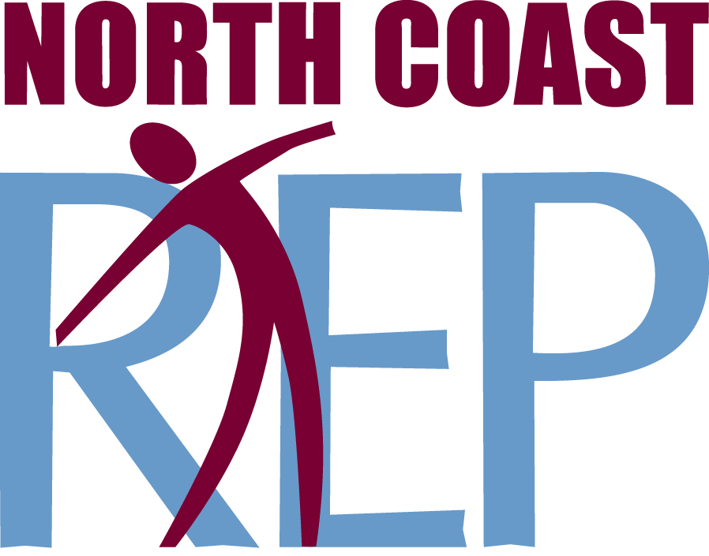
PRESS CONTACT: Nancy Richards – 917-873-6389 (cell)/nancy@northcoastrep.org
MEDIA PAGE: www.northcoastrep.org/press
PHOTOS BY: Aaron Rumley

FOR IMMEDIATE RELEASE, PLEASE:

UNNECESSARY FARCE By Paul Slade Smith
LIGHTS UP THE STAGE AT NORTH COAST REP
Performances Beginning Wednesday, April 15th,
With Opening Night, Saturday, April 18th, at 8 pm
Running Through Sunday, May 10, 2015
Directed by Matthew Wiener

It’s the perfect setup for a laugh-filled evening at the theatre. An embezzling mayor, his female accountant who can’t stay dressed, two undercover cops, nefarious hit men, and of course, videotape. In this side-splitting escapade, playwright Paul Slade Smith has reinvented the in-one-door innuendo, and out-the-door comic shtick. A zany San Diego premiere that will leave you howling with laughter.

Director Matthew Wiener directs a stellar cast: Ted Barton*, Dagmar Fields, Jessica John, David McBean*, John Nutten*, Jacque Wilke & Christopher M. Williams*. The design staff includes Marty Burnett (Scenic Design), Matt Novotny (Lighting Design), Alina Bokovikova (Costume Design), Melanie Chen (Sound Design), and Benjamin Cole (Props) comprise the crew. Aaron Rumley* stage manages.
THIS PRODUCTION IS SPONSORED BY MARILYN & LOU TEDESCO

UNNECESSARY FARCE previews begin Wednesday, APRIL 15TH. Opening Night on Saturday, APRIL 18 at 8pm includes a post-show reception. There will be a special talkback on Friday, APRIL 24, with the cast and artistic director. It will play Wednesdays at 7pm, Thursdays through Saturdays at 8pm, Saturday and Sunday matinees at 2pm with Sundays at 7pm, through May 10, 2015. (See Schedule below.) North Coast Repertory Theatre is located at 987 Lomas Santa Fe Drive, Ste D, Solana Beach, CA 92075. Tickets: Previews- $37; Week Nights - $44; Sat. Eve. & Sun. Mat.- $48; Sat. Mat. & Sun. Night - $41. Seniors, Students, Military - $3 off admission. Call 858-481-1055 or visit www.northcoastrep.org to purchase tickets.

*The actor or stage manager appears through the courtesy of Actors’ Equity Association, the union of professional actors and stage managers in the United States.

For background information and photos, go to www.northcoastrep.org/press.
Please follow North Coast Repertory Theatre on social media as well on Facebook at https://www.facebook.com/North-Coast-Rep
Twitter: https://twitter.com/NorthCoastRep
YouTube: http://www.youtube.com/user/Northcoastrepvideos

Busy directors Matthew Wiener and their talented cast are available for interviews by phone, in person, and in- studio. For more information and to arrange interviews or press tickets, please contact Nancy Richards at nancy@northcoastrep.org, or 917-873-6389 cell.

FACT SHEET

WHAT: NORTH COAST REPERTORY THEATRE presents
UNNECESSARY FARCE
by Paul Slade Smith
Directed by Matthew Wiener

CAST: Ted Barton*, Dagmar Fields, Jessica John, David McBean*, John Nutten*, Jacque Wilke & Christopher M. Williams*.

WHERE: North Coast Repertory Theatre
987 Lomas Santa Fe Drive, Ste. D
Solana Beach, CA 92075

SCHEDULE*: Previews: April 15-17, 2015
Opens: April 18, 2015, at 8 pm
Closes: May 10, 2015
Wed. @ 7pm, Thurs-Sat @ 8PM; Sat & Sun @ 2PM, Sun @7pm
Talkback with cast & director: Friday, April 24

PRICES: Previews $37.00
Week Nights $44.00
Sat. Matinees & Sunday Nights $41.00
Sat. Nights & Sunday Matinees $48.00

DISCOUNTS: Seniors, Students, Military $3.00 off admission

BOX OFFICE (858) 481-1055 or www.northcoastrep.org

April
SUN | MON | TUE | WED | THU | FRI | SAT
 |  |  | 15  Preview  8pm | 16  Preview  8pm | 17  Preview  8pm | 18  OPENING  8pm
19  2pm & 7pm | 20 | 21 | 22  7pm | 23  8pm | 24  8pm  Talkback | 25  2pm & 8pm
26  2pm & 7pm | 27 | 28 | 29  7pm | 30  8pm | MAY 1  8pm | 2  2pm & 8pm
3  2pm & 7pm | 4 | 5 | 6  7pm | 7  8pm | 8  8pm | 9  2pm & 8pm
10
2pm & 7pm

BACKGROUND:
North Coast Repertory Theatre’s 2014-2015 -Season 33- June brings master playwright Harold Pinter’s Betrayal (June 3 – 28), a play that explores the shifting balance of power within a love triangle. Filled with taut drama and deception, the story unfolds in reverse chronology as the audience takes this treacherous journey with characters who are compelling and brimming with human frailty. Passionate, explosive and surprisingly funny, Betrayal is considered one of Pinter’s most innovative and influential works, one that is certain to provoke lively discussion long after the curtain falls. Season 33 concludes with Side By Side With Sondheim (July 15 – August 9). Revel in the sophistication, wit, insight, heart and genius of Broadway’s most innovative and influential artist, composer-lyricist Stephen Sondheim. Audiences will hear familiar favorites from such shows as Company, Follies, A Little Night Music, A Funny Thing Happened on the Way to The Forum, Westside Story, Gypsy and so many more. An unmatched evening of enchantment for musical theatre fans.

About the North Coast Repertory Theatre
North Coast Repertory Theatre is a professional Equity theatre founded in 1982 by Olive and Tom Blakistone. Currently celebrating its 33rd season, North Coast Rep has received critical acclaim from media and audiences alike, and has evolved into one of the area’s leading performing arts organizations. North Coast Rep prides itself on employing the majority of its actors from Actors’ Equity Association for its high quality, award-winning productions, and staging works by established and emerging playwrights. Throughout its history, North Coast Rep has created a platform where artist and audience thrive through the intimacy of live theatre, recognizing the power of theatre to challenge complacency, revitalize the imagination, nurture the unexpected and embrace the variety and diversity in our lives.

BIOS:
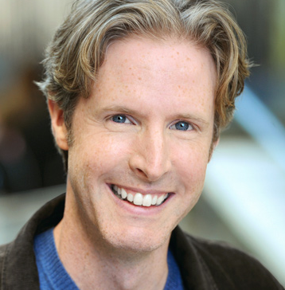 PAUL SLADE SMITH (Playwright) is a New York actor and writer. His play Unnecessary Farce premiered at the humble and fearless BoarsHead Theater in Lansing, Michigan in October of 2006, and by the end of 2013 will have seen its hundredth production. As an actor, Mr. Smith has appeared in the national touring companies of Wicked and The Phantom of the Opera, as well as regional theatres including The Goodman Theatre, Steppenwolf and Chicago Shakespeare Theatre, where he appeared earlier this year in The School For Lies, an adaptation of The Misanthrope by David Ives. He is currently at work on his next play, A Real Lulu.

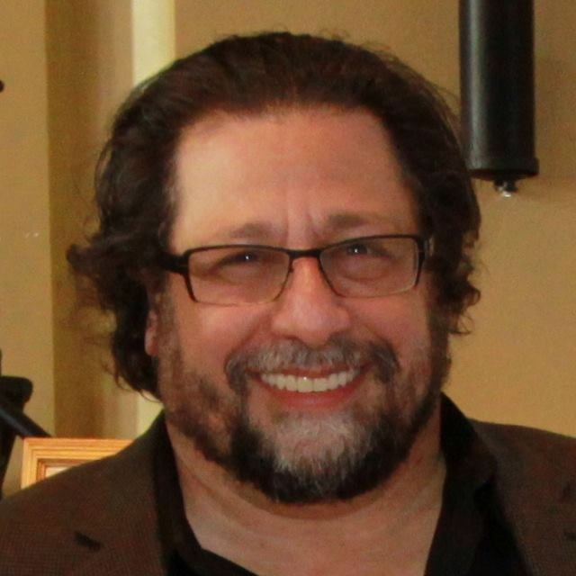 MATTHEW WIENER (Director) is thrilled to return to North Coast Rep where he previously directed: Perfect Wedding, Lend Me a Tenor (nominated for 2011 Craig Noel Award for Excellence in Theatre for Outstanding Direction of a Play, Outstanding Production, and Outstanding Ensemble) and Shipwrecked! For the past 20 years, he was the Producing Artistic Director of Actors Theatre of Phoenix. Other companies include: Arizona Theatre Company, The Fulton Theatre, Phoenix Theatre, The Children’s Theatre Company, Arizona Jewish Theatre Company, and Childsplay.

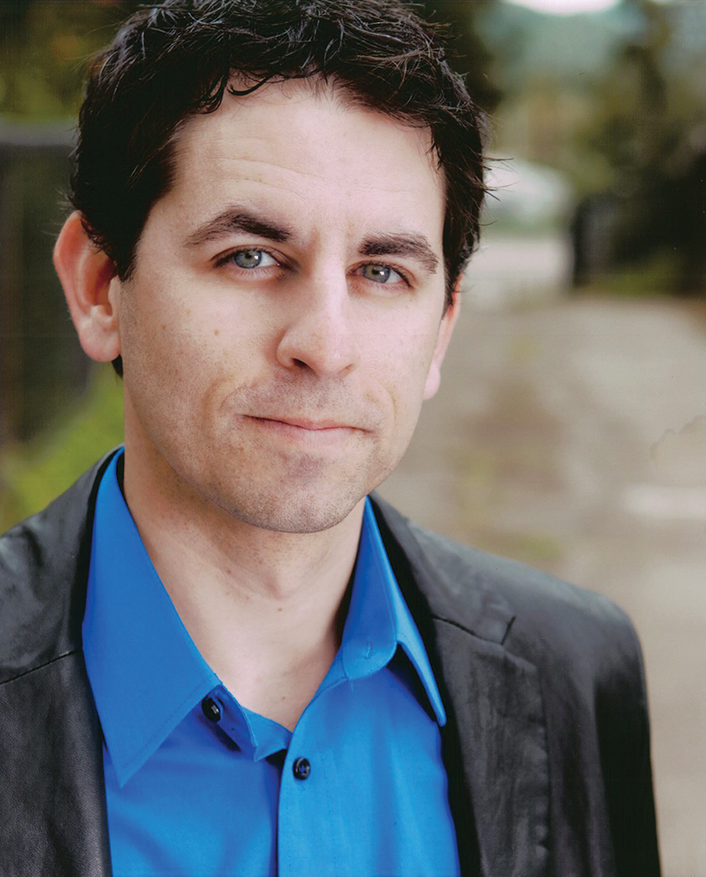 CHRISTOPHER M. WILLIAMS* (Eric Sheridan) Since playing Danny Saunders in The Chosen, Christopher has been working as an actor, director and stage manager on various productions with North Coast Repertory Theatre since 2003. He is proud to be working alongside Matthew and Aaron once again. Some North Coast Rep credits include: Visiting Mr. Green, Don't Dress for Dinner, Lend Me a Tenor, Perfect Wedding, Talley's Folly, My Name is Asher Lev, Tuesdays with Morrie, Glorious!, The Tempest. Other theatres: AZ Theatre Company, Idaho Shakespeare Festival, Southwest Shakespeare, Actor's Theatre, Phoenix Theatre, AZ Jewish Theatre, Intrepid Shakespeare, New Village Arts, Oceanside Theatre Company. Christopher is the artistic director of Oceanside Theatre Company and a producer of the recent WWII film, Walking with the Enemy, starring Jonas Armstrong and Sir Ben Kingsley.

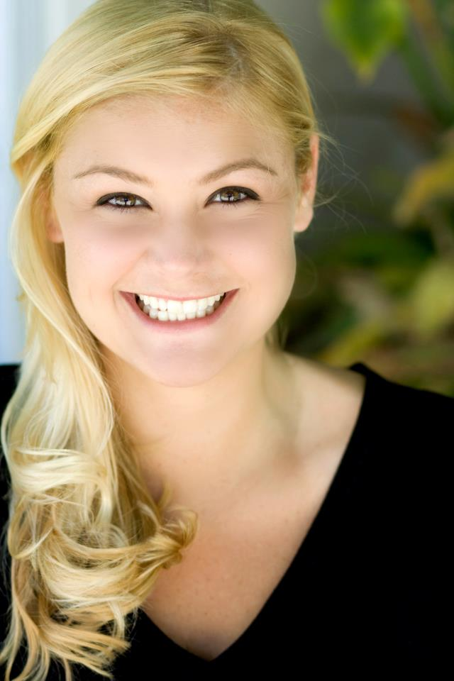 JACQUE WILKE (Billie Dwyer) recent credits include: San Diego Repertory Theater: Honky (Craig Noel Recipient for Outstanding Featured Actress); Intrepid Shakespeare: All My Sons; Cygnet Theatre: The Importance of Being Earnest, Travesties, and Mistakes Were Made; Moonlight Theater at the Avo: Blithe Spirit; Diversionary Theater (Associate Artist): The Divine Sister, The Further Adventures of Hedda Gabler, Scrooge in Rouge, Next Fall, Fair Use, The New Century, Anita Bryant Died for your Sins; North Coast Repertory Theatre: Lend me a Tenor, Mistletoe, Music, and Mayhem, and Don’t Dress for Dinner; MOXIE: Or,; New Village Arts: The Seven Year Itch, and The Heidi Chronicles; Bang Productions: Side Man; Circle Circle Dot Dot: Red Planet Respite and The Break-up Breakdown; Laterthanever Productions: He Said, She Said.

JESSICA JOHN (Karen Brown) is delighted to return to North Coast Rep where she last appeared as Celimene in The School of Lies. Other select San Diego productions include North Coast Rep: Lend Me a Tenor, A Shayna Maidel; New Fortune Theatre Company: Henry V; ion Theatre: Shining City, In the Heat of the Night, Angels in America; Oceanside Theatre Company: Lost in Yonkers; Moonlight Theatre at the Avo: Born Yesterday, The Mousetrap, Barefoot in the Park, Ring Round the Moon; Diversionary Theatre: The Pride, A Bright Room Called Day (co-production with Backyard Productions); Cygnet Theatre (Resident Artist): Private Lives, Noises Off (SD Critic’s Circle - Best Ensemble), Mauritius, Love Song, Desire Under the Elms, Communicating Doors (Patte’ - Best Production), Cat on a Hot Tin Roof (SD Playbill - Best Actress), Burn This (SD Critic’s Circle - Best Actress); New Village Arts: The Playboy of the Western World (Patte’ - Best Actress); and Renaissance Theatre: A View from the Bridge (SD Critic’s Circle - Best Actress).

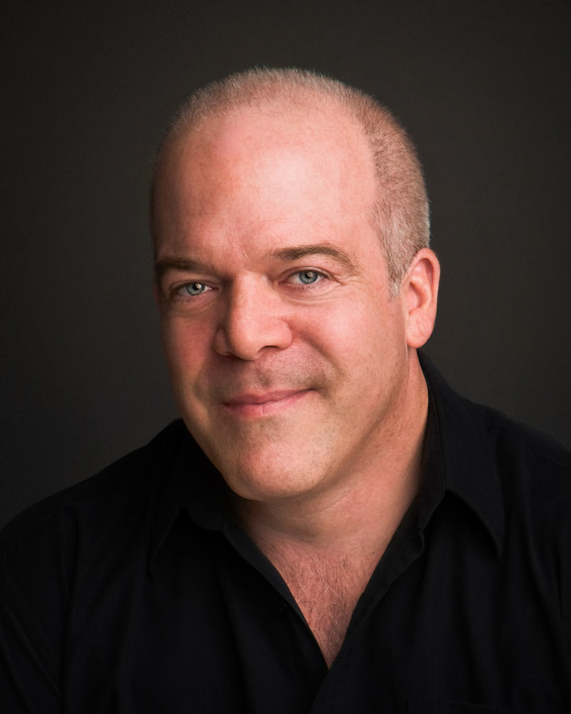 TED BARTON* (Mayor Meekly) is happy to return to North Coast Repertory Theatre, where he played Saunders in Lend Me a Tenor, also directed by Matthew Wiener. Matthew directed him again in The Fox on the Fairway, at Actors Theatre of Phoenix. Other credits: Mark Taper Forum, TheatreWorks, Berkeley Playhouse, Native Voices, Ensemble Theatre Company, Foothill Theatre Company, MainStreet Theatre Company, Coeurage Theatre, Sierra Repertory Theatre, Warehouse Repertory Theatre, International City Theatre,Theatricum Botanicum; California, Colorado, Lake Tahoe, Kingsmen Shakespeare Festivals; Shakespeare Sedona, Southwest Shakespeare Company, and Shakespeare Santa Cruz. He toured in On Golden Pond, and was an AEA Guest Artist at the University of Alabama.

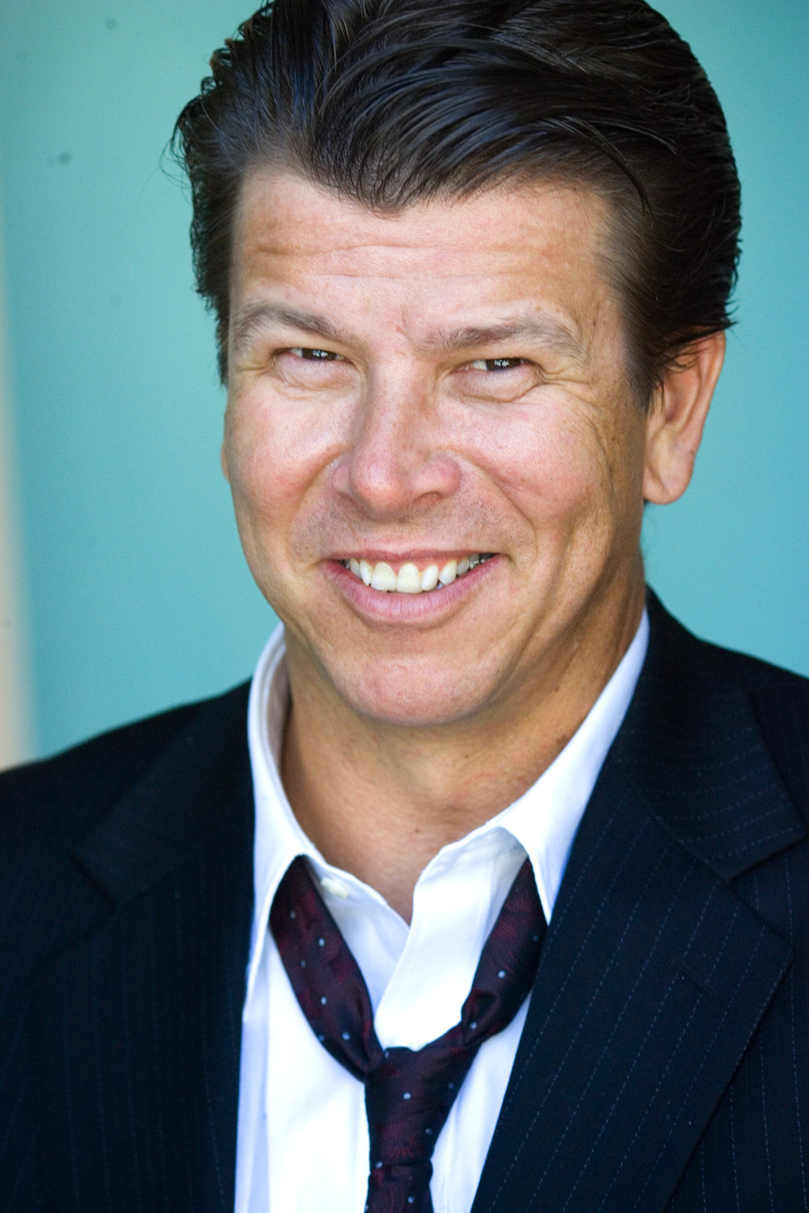 JOHN NUTTEN* (Agent Frank) This is John’s fourth production with North Coast Repertory Theatre. Performances include: The Odd Couple, Time Stands Still, & Breaking Legs at North Coast Rep. Other local theatre credits include, Threeplay, A Prayer for My Daughter, Absolutely, 1776, Twelfth Night, Our Lady of 121st St, Detective Story, Hyper Focus, Rounding Third, and Zoot Suit. John received his bachelor’s degree at UCLA’s school of Film, Television and Theatre. John has various Film & Television credits as well. John would like to thank North Coast Rep for this opportunity, and is eternally grateful to his wonderful wife Charlene for her unwavering support!
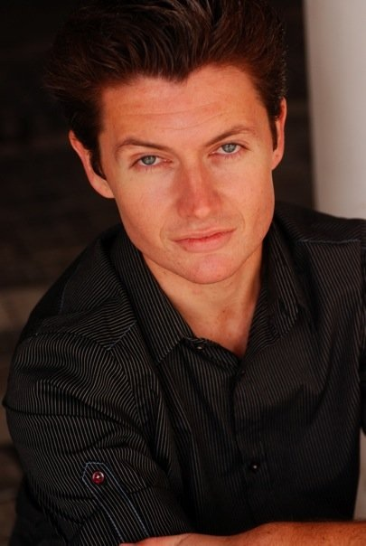 DAVID MCBEAN* (Todd) was last seen on the North Coast Rep in School For Lies as Clitandre. Previous North Coast Rep credits include: Glorious, Shipwrecked!, Charley’s Aunt, Pageant, and Holiday Memories. Other credits include: A Christmas Carol, Pageant, Dirty Blonde, It’s A Wonderful Life, The Book of Liz, Burn This, and Fully Committed (SD Critic’s Circle Award, Patte Award) at Cygnet Theatre; Sextet, Twist, Bunbury, The Mystery of Irma Vepp, Psycho Beach Party, The Rocky Horror Show, and 10% Review at Diversionary Theatre; The Sound of Music for SD Musical Theater, and The 39 Steps for La Mirada Theatre. David has a BA from the University of San Diego in Theater Arts, teaches for SD Junior Theater, and music directs for Mission Hills United Methodist Church.

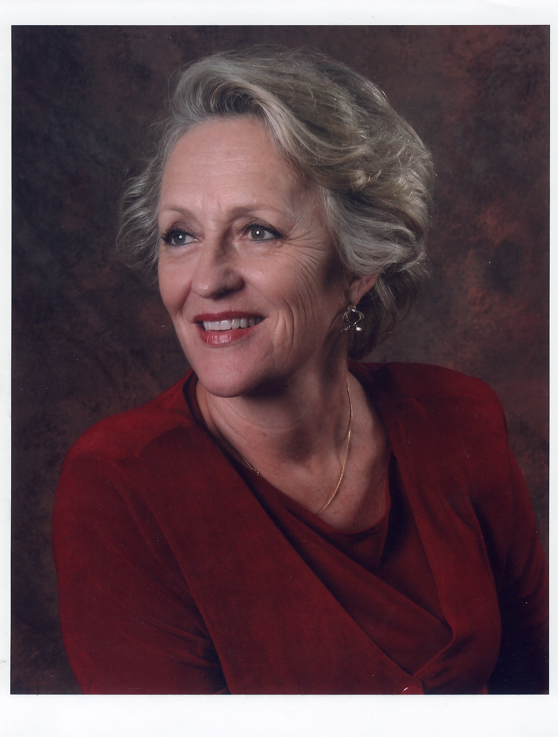 DAGMAR KRAUSE FIELDS (Mary Meekly) is delighted to be working with North Coast Rep again. Most recently she appeared in Moonlight Stage Production’s Lion in Winter (Eleanor), Diversionary’s Regrets Only (Marietta), Intrepid Shakespeare’s I Hate Hamlet (Lilian), Oceanside Theatre Company’s Lost in Yonkers (Grandma Kurnitz), and Moonlight Stage Productions’ Blithe Spirit (Madam Arcati). Earlier appearances at North Coast Rep include Morning’s at Seven, Amy’s View, Man of La Mancha, Last Night of Ballyhoo, & Auntie Mame. Elsewhere: Anything Goes, The Mousetrap, Crazy for You, Barefoot in the Park, The Foreigner, Magic Fire, Hay Fever, and Radio Gals (Moonlight Stage Productions; Into the Woods (Lambs Players); American Dream (Renaissance Productions); Night Must Fall, & Hamlet (Octad One). She teaches at Southwestern College. (Love to Marv, Eric, Khara, Matt, Taylor, Ava, and Ayden.)

AARON RUMLEY* (Stage Manager) North Coast Repertory Theatre: Gunmetal Blues, Fallen Angels, Who Am I This Time?, Broken Glass, Two by Pinter: The Lover and the Dumb Waiter, THIS, The Lion in Winter, Heroes, Lend Me a Tenor, My Name is Asher Lev, The Drawer Boy, Becky’s New Car, Voice of the Prairie, Ghosts, Glorious!, Talley’s Folly, Over the Tavern, Rabbit Hole, The Dresser, Don’t Dress for Dinner, Madagascar, Mornings at Seven, String of Pearls, Dracula, Rashomon, Wit, A Moon for the Misbegotten, Leading Ladies, Collected Stories, Halpern & Johnson, Romeo and Juliet, The Bungler, The Chosen, A Life in the Theatre and The Rainmaker. North Carolina Theatre: Talley’s Folly, Picnic, The Miser and On Golden Pond. Aaron received a B.A. in Theatre from the University of North Carolina at Wilmington, and is the production manager at the North Coast Repertory Theatre. Aaron is a Member of Actors’ Equity Association.

DESIGN TEAM

MARTY BURNETT (Resident Scenic Designer) Marty begins his 23rd season as Resident Designer/Technical Director at North Coast Rep. He has designed the last 166 shows. Other venues include Laguna Playhouse, Portland Stage Company, Drury Lane (Chicago), Claridge Hotel (Atlantic City), Union Plaza, Sahara Hotel, Hacienda in Las Vegas, Coronado Playhouse, Scripps Ranch Theater, Harrah’s Lake Tahoe. Marty is a proud alumni of Creighton University in Omaha, Nebraska.

MATT NOVOTNY (Lighting Design) recently designed the lighting for Gunmetal Blues, Freud’s Last Session, Fallen Angels, Romance Romance, Faded Glory, Mandate Memories, The School For Lies, Who Am I This Time?, Broken Glass, Man with a Load of Mischief, Perfect Wedding, Becoming Cuba, The Odd Couple, Time Stands Still, Educating Rita, The Underpants, Dames at Sea, Two by Pinter: The Lover and The Dumb Waiter, THIS, Visiting Mister Green, Lend Me a Tenor, Five Course Love, My Name Is Asher Lev, King O’ the Moon, Ghosts, Glorious, I Love You Because, Old Wicked Songs, Rabbit Hole, Shipwrecked!, The Dresser, Don’t Dress for Dinner, Mornings at Seven, Baby and Rashomon at North Coast Rep. He was the Director of Production for Lyric Opera San Diego. Lighting designs include: Iolanthe, The Merry Widow, The King and I, Countess Maritza, and The Mikado. San Diego: Das Barbecu, The Wiz, West Side Story and Rumors. Regional: Yankee Doodle Dandy (Seattle), Noises Off! (Boston), The Game, (Washington D.C.) and Primal Twang, a guitar concert featuring six Grammy-winning artists. Matthew holds a B.A. in Technical Theatre from San Diego State University, and an M.F.A. from Boston University.

ALINA BOKOVIKOVA (Costume Design) has designed more than 50 different productions and is proud to be a resident designer at North Coast Repertory Theatre. Her recent credits include Chapter Two, Gunmetal Blues, Freud's Last Session, Fallen Angels, School for Lies, Romance, Romance, Words By, Broken Glass. Other favorite works are Bird Lady (Link Theatre, Chicago) A Doll's House (The Old Globe Theatre), A Raisin in the Sun (MOXIE Theatre), Camino Real (Patté Award), opera La Traviata. Ms. Bokovikova has an M.F.A. in Costume Design from UC San Diego and a Masters Degree in Education from Russia. She is teaching at UC San Diego, Fashion Institute of Design & Merchandising and Grossmont College.
MELANIE CHEN (Sound Design) is a freelance sound designer, currently residing in San Diego. West Coast credits: Summer Shakespeare Intensive: Julius Caesar & Comedy of Errors (The Old Globe); Dance of the Holy Ghosts (Ubuntu Theatre Company in San Francisco); Words By Ira Gershwin, Romance/Romance, Faded Glory, Mandate Memories, Becoming Cuba (North Coast Rep); Passion, Bug, reasons to be pretty, Bengal Tiger at the Baghdad Zoo, Grey Gardens, Blasted (Craig Noel Nomination), Angels in America (Craig Noel Award), Body Awareness, The Lieutenant of Inishmore, Dr. Jekyll & Mr. Hyde, Jack Goes Boating (ion theatre company); Boys & Girls (Diversionary Theatre); Crumbs from the Table of Joy (Moxie Theatre); As You Like It, The Tempest, One Flew over the Cuckoo’s Nest (New Village Arts). She also assisted designers such as award winning composer Michael Roth and Tony Nominee designer Cricket Myers at La Jolla Playhouse, San Diego Rep, and South Coast Rep. Up next, she will be composing original music for East West Player’s production of Animals Out of Paper, and sound designing for Uncle Vanya at Pomona College and Pericles at The Old Globe. Education: MFA in Sound Design for Theatre & Dance from UC San Diego. www.melaniesound.com

BENJAMIN COLE (Properties Designer/Set Dressing), is proud to be part of the North Coast Rep family as Artistic Associate. Additional Properties Designs/Set Dressing at North Coast Rep include: Chapter Two, Gunmetal Blues, This Wonderful Life, Freud’s Last Session, Fallen Angels, Romance/Romance, Faded Glory, Mandate Memories.

JOHN FINKBINER (Scenic Artist) John has been a member of the North Coast Repertory Theatre staff for more than six years. His favorite shows are Halpern and Johnson, SHIPWRECKED!, The Dresser and Jacques Brel. John received his BA degree at UCLA’s School of Theater, Film and Television in 1991. John is also an accomplished singer/songwriter and performs with his band, the Stereotypes. His music has been featured on Showtime’s “Californication,” Fox’s “Bones” and NBC’s “Knight Rider,” among others. John lives with his wife Judi and his son John Gibson in Leucadia.

# # # #

