Press Release:
For immediate release: August 15, 2013

From: Sandra Schwarzmann
Office: 858-481-1055 ext. 220
Cell: 619-261-5944
Email: Sandra@northcoastrep.org

North Coast Repertory Theatre Presents:
Man with a Load of Mischief
Music by John Clifton
Lyrics by John Clifton & Ben Tarver
Book by Ben Tarver
Directed by Rick Simas
Previews: September 4 – 6, 2013
September 7 – 29, 2013

This production is sponsored by the generosity of Jere & Joyce Oren

The stage is set for romance and intrigue! A great Off-Broadway musical sensation of the late 1960’s, this charming tale set in a roadside country inn in the England of the early nineteenth century is filled with song, humor and love. A handsome Nobleman and his Lackey, a beautiful Lady and her Maid. However, the Nobleman isn’t noble, the Lackey is no lackey, the Lady is no lady, and the Maid is no maiden.

PRESS/OPENING IS SATURDAY September 7, 2013 at 8:00pm.
PLEASE RSVP AS SOON AS POSSIBLE AS SEATS ARE LIMITED.
To RSVP email sandra@northcoastrep.org or call 858-481-2155 ext.220

For press images: Images will be available at www.northcoastrep/press.

Featuring:
Robert Yacko* (The Man)
Jacquelyn Ritz* (The Lady)
Ron Choularton* (The Innkeeper)
Annie Hinton* (The Innkeeper’s Wife)
Randall Dodge* (The Lord)
Tatiana Mac (The Maid)
*The actor or stage manager appears through the courtesy of Actor’s Equity Association, the union of professional actors and stage managers.

Intermission:
There will be one 15-minute intermission.

The place is:
England, a wayside inn.

The time is: Early in the 19th Century.

Ticket prices: $40 - $57 (Senior/Student & Military discount save $3.00 per ticket with valid I.D. off regular ticket prices. North Coast Repertory Theatre subscribers save $5.00 off regular prices.)

Show times: All Previews are at 8:00pm. Regular show times are Wednesdays at 7:00pm, Thursday - Saturday at 8:00pm, Saturday & Sunday matinees at 2:00pm and Sunday evenings at 7:00pm.

How to buy tickets: Tickets for Man with a Load of Mischief are available only at North Coast Repertory Theatre in Solana Beach at 987 Lomas Santa Fe Drive, Suite D, 92075. Box Office hours are Noon to 4PM daily and Noon to Curtain day of shows. Call 858-481-1055 for tickets or visit www.northcoastrep.org.

The playwright of this production is:
Music by John Clifton
Lyrics by John Clifton & Ben Tarver
Book by Ben Tarver

The Director of this production is:
Rick Simas

The Choreographer for this production is:
Jill Gorrie

The Music Director for this production is:
Ron Councell

The Show Music Director for this production is:
Steven Withers

The cast of this production includes:
Robert Yacko* (The Man)
Jacquelyn Ritz* (The Lady)
Ron Choularton* (The Innkeeper)
Annie Hinton* (The Innkeeper’s Wife)
Randall Dodge* (The Lord)
Tatiana Mac (The Maid)
*The actor or stage manager appears through the courtesy of Actor’s Equity Association, the union of professional actors and stage managers.

The Musicians of this production include:
Steven Withers (Piano)
Nicole Krause (Cellist)
Matt Best (Woodwinds)

The design team of this production includes:
Marty Burnett (Scenic Design)
Renetta Llyod (Costume Design)
Matt Novotny (Light Design)
Nicholas Drashner(Sound Design)
Angelica Ynfante (Props and Set Dressing)
Peter Herman (Hair and Wig Design)

The crew of this production includes:
Amy Duffy* (Stage Manager)
Cindy Khoury* (Sub Stage Manager)
Jason Nall (Production Manager)
Ryan Ford (Associate Production Manager)
Andrea Gutierrez (Assistant Stage Manager)
Tom Kaye (Assistant Stage Manager)
John Finkbiner (Scenic Artist)
*The actor or stage manager appears through the courtesy of Actor’s Equity Association, the union of professional actors and stage managers.

Bios are as follows:
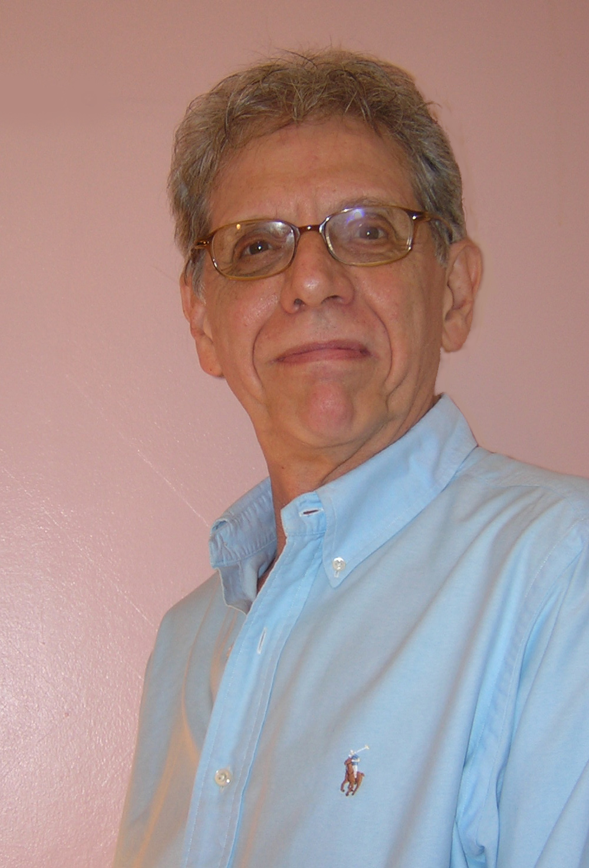
John Clifton (Music & Lyrics) Besides writing music and co-authoring the lyrics for Man with a Load of Mischief, John has had a remarkably varied career in the musical theater. He wrote the music and lyrics for the New York musical El Bravo! and We The People (for the bicentennial of the Constitution). Broadway heard his songs in The Madwoman Of Central Park West (Phyllis Newman, directed by Arthur Laurents). His Mama (starring the late Celeste Holm) was presented by the Studio Arena, and The Maiden of Ludmir, a Yiddish musical, by the Folksbeine Playhouse. John has written scores for more than a score (!) of musicals for young people, as well incidental music for many plays, such as A Midsummer Night’s Dream (Walnut Street Theater, Philadelphia) and Diary of a Scoundrel (Huntington Theatre, Boston). He has currently completed music and lyrics for Two Eagles, a musical about a romance between an Israeli soldier and a militant Palestinian girl. John, an avid pet advocate, is married to author Josée Clerens, with whom he wrote Sparky Fights Back, a best-selling book about their miraculous dog. Subsequently, John authored two more books, Stop the Shots! : Are Vaccinations Killing Our Pets? and a humor book, The Forbidden Political Dictionary: Complete and Unapproved.
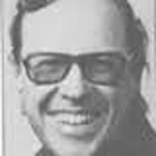
Ben Tarver (Book & Lyrics) Ben counts three “home towns” – New York City, Santa Fe, New Mexico and Edmonton, Canada. He now lives in Toronto. Tarver was active in the early years of the off-Broadway movement that so revolutionized New York theatre. He was a producer, director, playwright, stage manager, and general manager. After fifteen years of this exhilarating work he took a teaching position at the University of Alberta in Edmonton, where he remained for 25 years. He re-settled in his native New Mexico accepting the position of literary manager at the New Mexico Repertory Theatre. He also joined a small film production company dedicated to the work of Native Americans. He has taken up residence again in Canada to be closer to his family. His directing credits in New York include Cicero by Upton Sinclair and The David Show, A. R. Gurney’s initial New York production. He produced off-Broadway the first professional production of Calderon’s Life Is a Dream – La Vida es Sueno – the first dual-language theater event in New York’s history. His gothic comedy, The Murder of Auguste Dupin, played to sold-out houses across Canada, then ran in repertory for months at one of Britain’s major resident theatres. A revival is now planned in Canada. Ben recently teamed up with John Clifton again to write the book for their new musical, Appalachian Fling
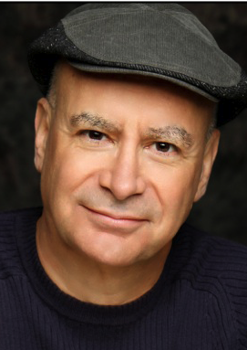
Rick Simas (Director) NCRT: The Fantasticks, No Way to Treat a Lady, The Big Bang, I Love You Because, The 25th Annual Putnam County Spelling Bee, Five Course Love and Dames at Sea. In the Bay Area, Rick directed Good News; No, No, Nanette; Promises, Promises and the West Coast premiere of Smile, which collectively won 13 Bay Area Theatre Critics Circle Awards. Other directing credits include the West Coast premiere of Goblin Market at UC Berkeley, and the East Coast premiere of The Death of Meyerhold at Studio Theatre. At San Diego State University, he directed Triumph of Love, Bat Boy, Honk! and Zombie Prom, which collectively won 8 KPBS Patté Awards. At SDSU, he also directed The Normal Heart, the San Diego premieres of A New Brain and The Musical of Musicals, and the Southern California premiere of A Man of No Importance. At the Poway Center for the Arts, he directed Master Class; at Diversionary Theatre, the San Diego premiere of When Pigs Fly; and at the Old Globe Theatre, he assisted Tina Landau on the West Coast premiere of Floyd Collins. At the University of Judaism (now the American Jewish University), he directed Jerry Herman’s Milk and Honey, and created a series of successful cabarets and concerts, including From Berlin to Brooks: How Jews Made Broadway; Berlin, Bernstein and Bock: Boychiks on Broadway; and Richard Rodgers: A Centennial Celebration. Rick holds a Ph.D. in Dramatic Art from UC Berkeley and has been a faculty member of the American Conservatory Theatre (ACT) in San Francisco, and the American Musical and Dramatic Academy (AMDA) in New York. For the past 21 years, he has taught in San Diego State University’s MFA Musical Theatre Program—one of only two such graduate programs in the nation.

This artist sponsored by The Dodson Family Trust.

Jill Gorrie (Choregrapher) Jill Gorrie is a bi-coastal choreographer and teaching artist. Recently the choreographer of Gary Goldfarb: Master Escapist, which was performed off -Broadway as part of the New York Musical Theatre Festival. Jill is the resident director--choreographer-casting associate of the international production of Grease, which has toured the world including Berlin, Vienna, Zurich, Istanbul, and Byblos, Lebanon. Other choreography credits include: Elton John's Aida and Hairspray (Arts Center of Coastal Carolina), Gotta Get A Gimmick-Burlesque to Broadway (BB King's, NYC), The People Vs. Mona (Off- Broadway), Comden and Green's New York (Chashama Theatre, NYC), 24 Hour Musicals (Atlantic Theatre, NYC), Oklahoma and Hello Dolly (associate choreographer) at the Westchester Broadway Theatre, A Little Night Music, and I Love A Piano (SDSU). Jill is a graduate of NYU's Tisch School of the Arts (BFA in Dance), and is currently pursuing her MFA in Musical Theatre at SDSU. She is on the dance faculty at the American Musical and Dramatic Academy (AMDA) and CAP21 in NYC, and teaches master classes throughout the US as well as guest teaches world-wide.

Ron Councell (Music Director) Ron Councell, an accomplished musical director and accompanist, performs at many of the theatres in San Diego, which include the Lyceum (Reunion, Always…Patsy Cline), The Old Globe (Dirty Rotten Scoundrels, Chita Rivera: The Dancer’s Life, Working, The Grinch), La Jolla Playhouse (Dracula, Zhivago), and the Civic Theatre (The Full Monty, The Producers). He also works in children’s theatre and has directed and conducted numerous productions for San Diego Junior Theatre (The Sound of Music, 42nd Street, Cinderella), Peter Pan Junior Theatre (Annie, Guys and Dolls, My Fair Lady), the San Diego Opera Education
and Outreach Program (Rip Van Winkle), and Muirlands Middle School (Working, Once Upon a Mattress, Pippin). Currently, Mr. Councell is the Music Director for Unity of San Diego, as well as the Associate Conductor and Accompanist for the San Diego Festival Chorus. He also works for the Grossmont College Theatre Department co-teaching a Musical Theatre Proﬁles Workshop class with Susan Jordan-DeLeon. Ron has music directed six productions at Grossmont College: The Fantasticks, Suds, Company, I Love You Because, Parade, and most recently, The 25th Annual Putnam County Spelling Bee.

Steven Withers (Show Music Director) Steven Withers, native of San Diego. Toured with Michael Crawford in his 1998’s 36-city solo tour. Played keyboards for Jane Eyre (La Jolla Playhouse) and The Full Monty (Old Globe), and both on Broadway after moving to Manhattan (2000-2004.) Recorded the Jane Eyre Original Broadway Cast Album. After return to San Diego in 2004: Associate Music Director/pianist for Plaid Tidings (Old Globe,) keyboards for Paul Gordon’s Emma (Old Globe,) Burt Bacharach/Steven Sater’s Some Lovers (Old Globe,) Associate Music Director of Duncan Sheik/Steven Sater’s Nightingale (La Jolla Playhouse) and Associate Conductor of How The Grinch… (Old Globe, 15th Anniversary Production.) Steven is happily married to Marc d’Hondt, his partner since 1993.

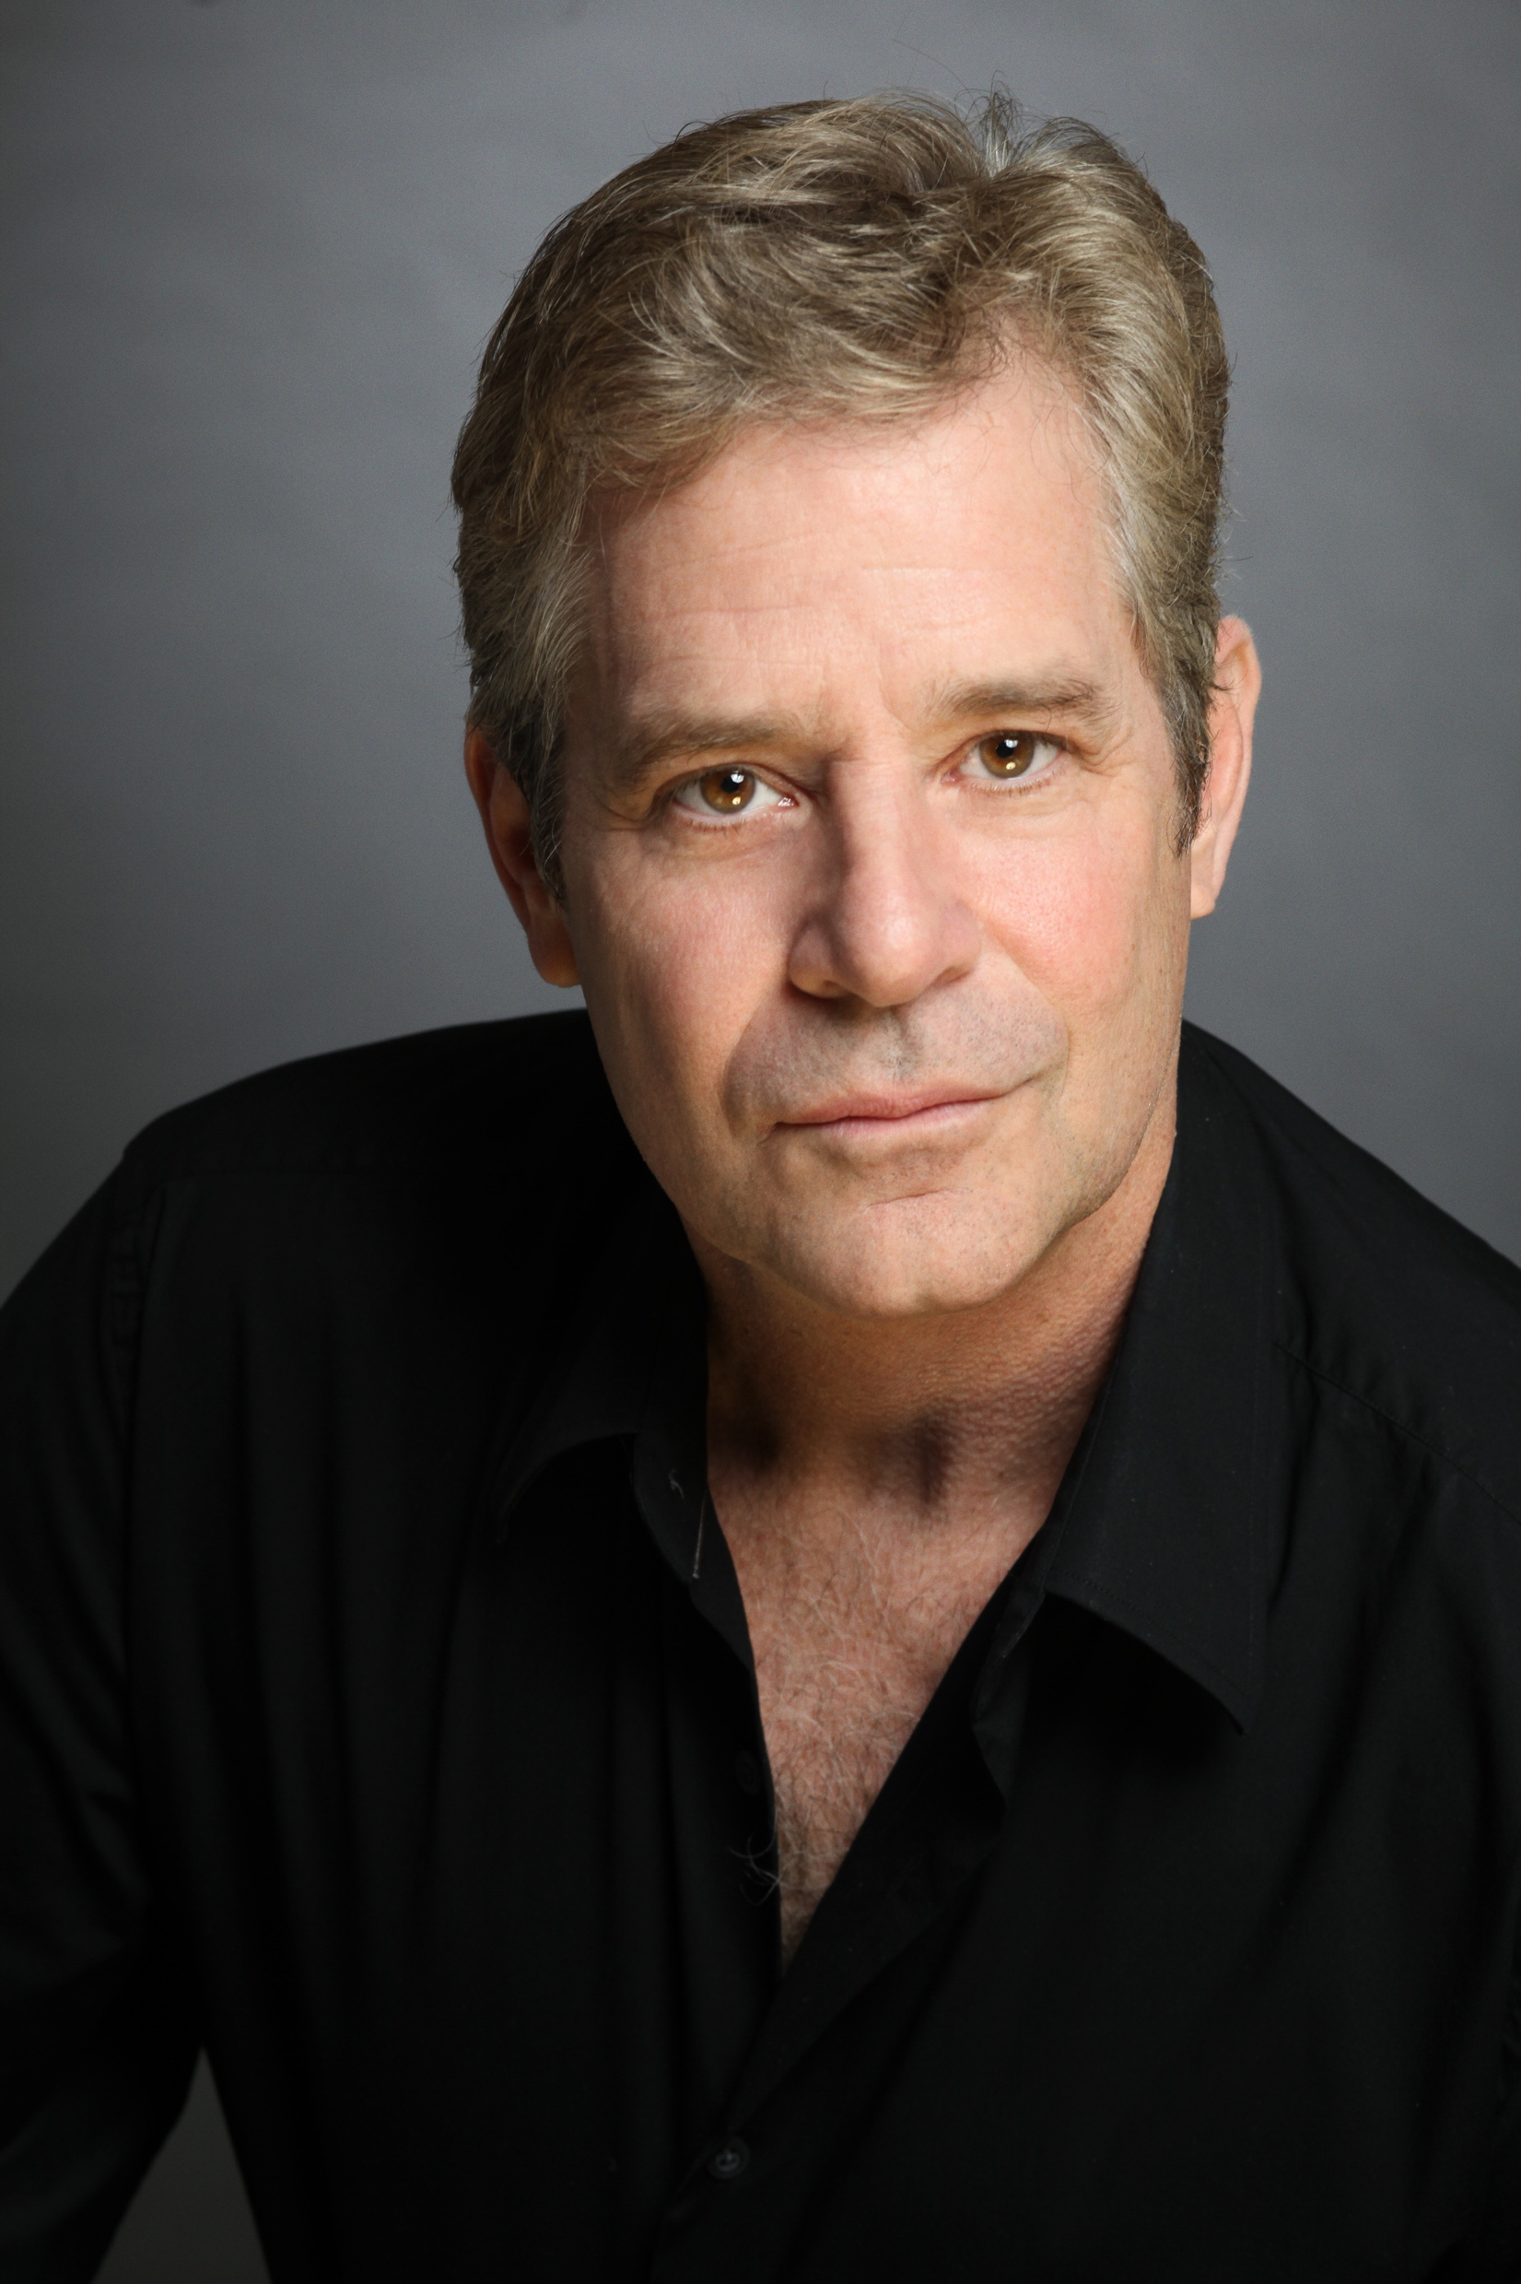
Robert Yakko* (The Man) is making his North Coast Repertory debut on the heels of playing Governor Slaton in the highly acclaimed production of the Alfred Uhry/Jason Robert Brown epic Parade at 3D Theatricals. Robert has been seen in the San Diego area in I Do, I Do at the Welk Theater in Escondido, and he starred in the West Coast Premiere of Romance, Romance at The Old Globe. He has appeared on Broadway and National Tour (Perchik & Fyedka) in Fiddler on the Roof with Herschel Bernardi, directed by Jerome Robbins. His regional credits include the recent Donmar Warehouse production of Parade (Dorsey), at the Mark Taper Forum, Legacy of Light (Voltaire) and Splitting Infinity (Saul) at San Jose Rep, The Bernstein/Barrie Peter Pan (Hook/Mr. Darling) and The Real Thing (Henry) at the Santa Barbara Theater Company, Sylvia (Greg) with Cathy Rigby for Rigby/McCoy Productions, Can Can-Revised (Le Petomane) at Pasadena Playhouse, and Five Course Love at Sacramento Rep. He starred in the Los Angeles Premiere of Sunday in the Park with George (George), and also appeared in Company (Paul) with Carol Burnett and Patrick Cassidy, Into the Woods (Baker) with Leslie Uggams, the L.A. Premiere of Chess (Anatoly), and in Marry Me a Little (Man) at South Coast Rep. His screen credits include Raising Helen, The Closer with Tom Selleck, General Hospital, Golden Girls and Get A Life.
This artist sponsored by Holly Smith Jones.

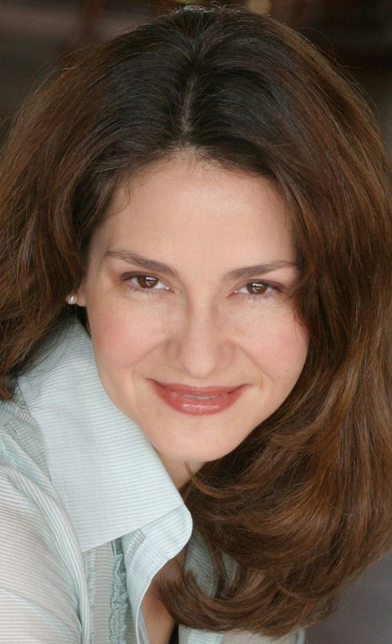
Jacquelyn Ritz* (The Lady) A recent transplant from Chicago, she comes directly to North Coast Rep from Intrepid Shakespeare where she played Titania in A Midsummer Night’s Dream. In Chicago, she performed with the Goodman Theatre, Northlight, Royal George, Barto (Shakepeare) Productions, Drury Lane Oakbrook, Marriott Lincolnshire, and Peninsula Players. Regional credits include Bounce at the Kennedy Center (directed by Harold Prince), productions with Milwaukee Repertory, Colorado Shakespeare Festival, Madison Repertory, Asolo Center for the Arts, and many others. Favorite roles include Guinevere in Camelot (Barn Theatre) and Beatrice in Servant of Two Masters (New American Theatre). She studied Chekhov at the Moscow Art Theatre and holds an MFA in Acting from the Asolo Conservatory. She is a member of SAG/AFTRA. The kiddies can listen for her as Madame Blueberry and others in VeggieTales cartoons.
This artist sponsored by Edward T. Koch.

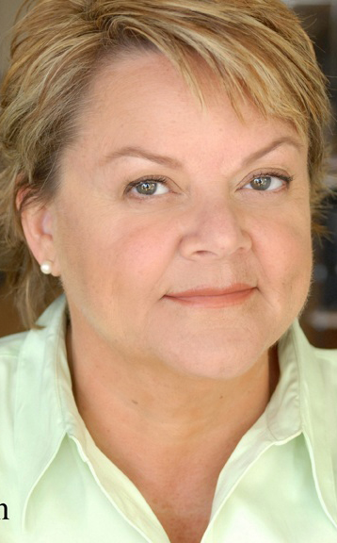
Annie Hinton* (The Innkeeper’s Wife) Regional: Old Globe Theatre, The Hostage (Jack O’Brien); Seattle Repertory Theatre, Our Town (Dan Sullivan); A Contemporary Theatre; Empty Space Theatre; Seattle Children’s Theatre; and New Mexico Repertory Theatre. Local: Ion Theatre, Grey Gardens; San Diego Rep, The Clean House; Cygnet Theatre, Book of Liz, A Christmas Carol, Private Lives; North Coast Rep, Importance of Being Earnest, Travesties, Glorious. Film/TV: Bring It On; 29th & Gay; The Jenni Project (Disney); Veronica Mars and many others. An exuberant Freeway-Flyer Professor she has traveled thousands of miles teaching at every university and college in San Diego save two, channels her creative energy into her private students and in February will be directing Circle Mirror Transformation for New Village Arts.
This artist sponsored by Martin & Dr. Cynthia Davis.

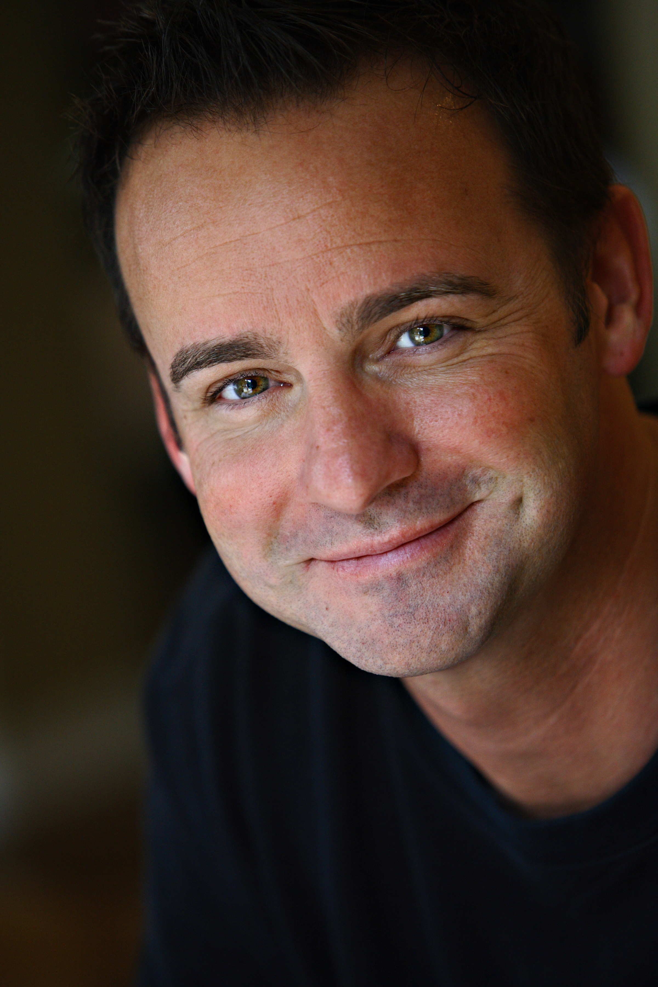
Randall Dodge* (The Lord) North Coast Rep appearances: Story Theatre, The Fantasticks, and No Way to Treat a Lady. Favorites elsewhere: The Wizard of Oz, South Pacific, Sweeney Todd, Annie Get Your Gun, Thoroughly Modern Millie, The Sound of Music, Beauty and the Beast, The Pirates of Penzance, and The Most Happy Fella, Moonlight Stage Productions; Chicago, South Pacific, Welk Resort; Thoroughly Modern Millie, Drury Lane Oak Brook; How the Grinch Stole Christmas, Old Globe; The Scarlet Pimpernel and Company, Starlight Bowl; Children of Eden, Cape Fear; A Little Night Music, Cygnet Theatre. Randall would like to thank Rick, David, Ron, and Amy for this incredible opportunity. He would also like to dedicate his performance to his amazing wife Brenda for her love and support. www.randalldodge.net
This artist sponsored by Stella Bolog.

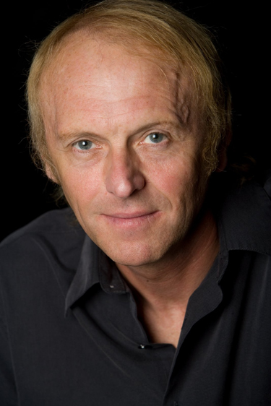
Ron Choularton* (The Innkeeper) Ron is thrilled to return to NCRT, last seen in A Christmas Carol, other selected, Jacob Marley’s Christmas Carol, Breaking The Code, M Butterfly. Regional Credits: Dram of Drumhiccit, Peter & The Starcatchers (La Jolla Playhouse); Moon For The Misbegotten, Da, Sight Unseen (Old Globe); A Christmas Carol (3yrs), The Clean House, The Seafarer (San Diego Rep). Recently - Bengal Tiger At The Baghdad Zoo, ion theatre. Selected others: Cygnet, The Fritz, Lambs Players, New Village Arts, The Fritz, Edinburgh Fringe Festival. FILM/TV: The Dark, Splitsville, Pensacola, Renegade; Wrote/presented KPBS Britcom intros. Recipient of numerous Dramalogue, SD Critic's Circle, Patte, & SD Playbill Awards.
This artist is sponsored by Steve Flynn & Kathleen Bell Flynn

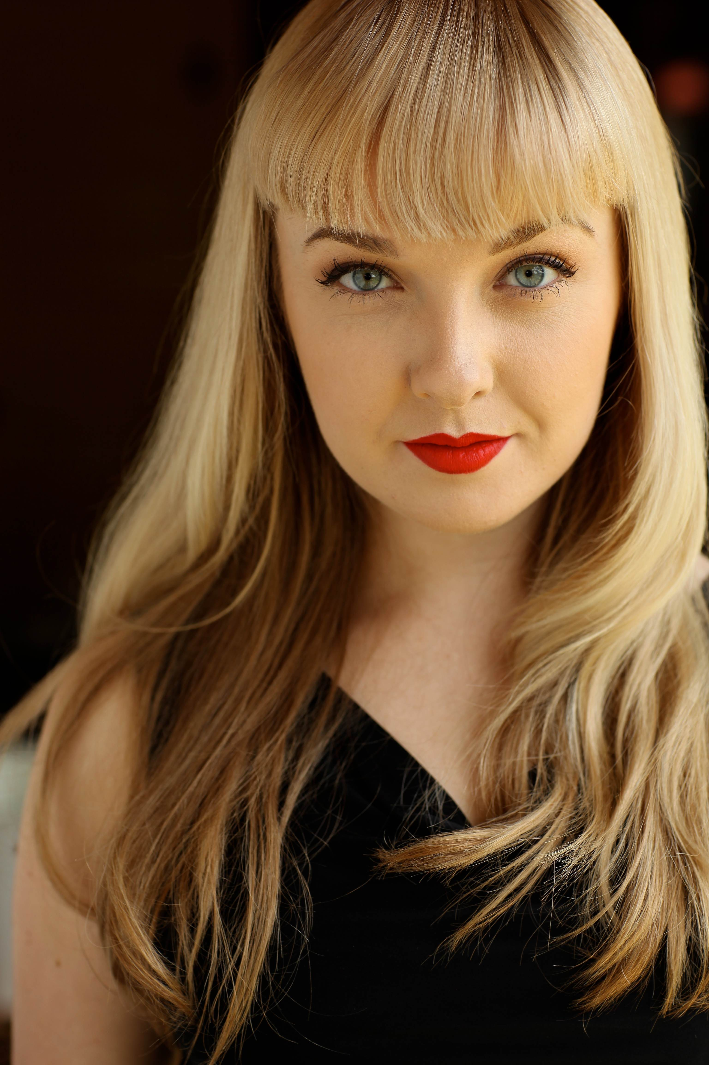
Tatiana Mac (The Maid) Tatiana Mac, a San Diego native, is a recent graduate of UCLA's Ray Bolger Musical Theatre program where she appeared in RENT, Cabaret, & Happy End. Her other theatre credits include: Hairspray at the Hollywood Bowl, The Robber Bridegroom at Long Beach's International City Theatre, originating the role of Mary Weiss in the premiere workshop production of The Boy From New York City (written and directed by screenwriter Floyd Mutrux) and charity performances for the USO organization & Broadway Comes to Anaheim. She is thrilled to be back in San Diego for her first show at North Coast Rep! Photos & updates can be found at misstatianamac.com or on facebook-- facebook.com/tatianacats.
This artist sponsored by Sam De Luca.

Steven Withers (Piano) See bio under Show Music Director.

Nicole Krause (Cello) Nicole Cristine is a San Diego based musician who works in the arts community as a cellist, vocalist and private cello teacher. As a cellist she has played in symphonies and orchestra pits, performed as a soloist and played for the premiers of original compositions, participated in various chamber ensembles and has visited classrooms introducing students to the cello. Nicole has also sung in “Beauty Shop Quartets”, such as an alto section leader in various choirs and has taken part in several duet/vocal ensemble pieces. In the past, Nicole has worked with Young Artists Symphony, Valley Center Community Theater, Soloists Ensemble, Grossmont Community College’s Theatre Department, Premier Chamber Ensemble, Chamber Singers, Euphoria trio and many more. Her newest musical endeavor being the trio Coleviana! Already taking great strides in the musical community, the new trio is currently planning to premier the music of several local composers. While attending a concert at Point Loma University, Nicole saw the cello being played by two amazing cellists - they were her inspiration to take up the alluring instrument. At age 14 she began taking lessons under Jennifer Epler. Since she began taking lessons, Nicole knew that she had found her life's passion and she has dedicated herself to learning how to better share her love of music.
Matt Best (Woodwinds) Matt Best is a local musician, woodwind repair technician, and private teacher. Originally from Iowa, Matt started playing piano at age nine, alto sax at ten, and flute and clarinet in his late teens. After studying jazz in college, he embarked on a five year career as a reed player and music director for various cruise lines. Since settling in San Diego nearly six years ago, Matt now works independently as a private teacher, woodwind coach, woodwind musician in various local venues, and woodwind technician in his home-based repair shop. But most of all he is excited to be back at North Coast Rep!

Marty Burnett (Scenic Design) Marty begins his 22nd season as Resident Designer/TechDirector at NorthCoast Rep. He has designed the last 150 shows. Other venues include Laguna Playhouse, Portland Stage Company, Drury Lane(Chicago), Claridge Hotel(AtlanticCity), Union Plaza, Sahara Hotel, Hacienda in Las Vegas, Coronado Playhouse, Scripps Ranch Theater, Harrahs Lake Tahoe. Marty is a proud alumni of Creighton University in Omaha, Ne.

Renetta Llyod (Costume Design) A costumer and seamstress for several North County theatres including Moonlight Stage Productions and Mira Costa College, Renetta is happy to be back at NCRT this year. Previous shows at NCRT include Dames at Sea, Lion in Winter, Five Course Love, Glorious, and several others. Period pieces like this are her passion, however. In fact, she so enjoyed researching the period of this show that she decided to build just about everything from scratch! When not behind the sewing machine, Renetta spends most of her time running around after her 2 amazing young children. She thanks her wonderfully supportive family who allow her to pursue so many great opportunities. Enjoy the show!! www.nattyloucreations.com

Matt Novotny (Light Design) Matthew recently designed the lighting for Perfect Wedding, Becoming Cuba, The Odd Couple, Time Stands Still, Educating Rita, The Underpants, Dames at Sea, Two by Pinter: The Lover and The Dumb Waiter, THIS, Visiting Mister Green, Lend Me A Tenor, Five Course Love, My Name is Asher Lev, King O¹ the Moon, Ghosts, Glorious, I Love You Because, Old Wicked Songs, Rabbit Hole, Shipwrecked!, The Dresser, Don¹t Dress for Dinner, Mornings at Seven, Baby and Rashomon at North Coast Rep. He¹s currently the Director of Production for Lyric Opera San Diego. Lighting designs include: Iolanthe, The Merry Widow, The King and I, Countess Maritza, and The Mikado. San Diego: Das Barbecu, The Wiz, West Side Story and Rumors. Regional: Yankee Doodle Dandy (Seattle), Noises Off! (Boston), The Game, (Washington DC) and Primal Twang, a guitar concert featuring six Grammy-winning artists. Matthew holds a BA in Technical Theatre from San Diego State University, and an MFA from Boston University.

Nicholas Drashner (Sound Design) Chagall (La Jolla Playhouse), A Lonely Boys Guide to Survival and Werewolves (La Jolla Playhouse), Words By (North Coast Repertory Theatre), 100 feet (Space4Art/UCSD), Blood and Gifts (ASD: La Jolla Playhouse), TopDog/Underdog (Ion Theatre), A Man His Wife and His Hat (Moxie Theatre), UCSD productions: Live In the Wake, Spring Awakening, A Man His Wife and His Hat, Kasimir & Karoline, A Fish Without a Bicycle, Phantom Band, The Threepenny Opera (ASD),The Seagull (ASD), Camino Real (ASD).

Angelica Ynfante (Props and Set Dressing) Angelica is a Texas State University graduate with a BFA in theatre. She made her way around the US and Mexico for five years working in Texas, Virginia, West Virginia, Vermont, New York, Tennessee, Kentucky and Cancun until she made it to sunny California where she is currently the props mistress with San Diego Rep for the 5th season. She is the props mistress for Scripts Ranch for 2 seasons, Cygnet theatres props designer this season and has worked with Moxie as a props designer and or a technical director for almost 3 seasons, she worked on Becoming Cuba and is thrilled to be back working on this performance.

Peter Herman (Hair and Wig Design) Bio coming soon.

Amy Duffy* (Stage Manager) Amy is happy to be opening Season 32 with North Coast Repertory Theatre. Amy holds a BTA from the University of Michigan, and past work credits include The Second City, Detroit; Michigan Opera Theatre; Bayview Festival of Music; Music Academy of the West; Chautauqua Opera; La Jolla Playhouse and San Diego Opera.
This artist sponsored by Jeannette & Harold Coons.

Jason Nall (Production Manager) Jason is in his second season with North Coast Rep. Previously, he was production manager with The Cutting Ball Theatre, where he worked on their award-winning Pelleas and Melisande, Tontlawald, and Tenderloin, a documentary piece of the famous San Francisco neighborhood. He was also the resident PM for Crowded Fire Theatre Company (Exit, Pursued by a Bear; Songs of the Dragon Flying to Heaven; The Secretaries) and served as production manager for Boxcar Theatre (Clue), and Lamplighters Music Theatre (Pirates of Penzance, Iolanthe, Mikado). He is also an AEA stage manager, working for San Francisco Opera’s Merola Opera Program, The Magic Theatre, and North Coast Repertory Theatre. He has also participated in several new works, including Cybil Shepherd’s one-woman show Curvy Widow, Lou Harrison’s Young Caesar with Ensemble Parallèle, and Mark Foeringer Dance Project’s Bitter Fruit. Originally from Claremont, CA, he has a BA in Criminology from UC Irvine.

Ryan Ford (Associate Production Manager) Ryan is a proud staff member here at NCRT as the Associate Production Manager. Previous works at NCRT include: as stage manager: The Odd Couple; as a sound mixer; Dames at Sea, Honky Tonk Angels, and Back to Bacharach and David; as ASM/PA; Dracula, String of Pearls, Madagascar, A Shayna Maidel, Tuesdays with Morrie, and Leading Ladies. Around San Diego, Ryan has worked as a stage manager at several theatre companies including Moxie, ion, Diversionary, Cygnet, Intrepid Shakespeare, and San Diego Rep. Favorite productions include Twist (Diversionary), A Hammer A Bell and A Song to Sing (SDRep), King John (Intrepid) and Angels in America (ion). Ryan holds a B.A. in Theatre Arts from UCSD.

Cindy Khoury* (Sub Stage Manager) Bio coming soon.

Andrea Gutierrez (Assistant Stage Manager) Andrea previously worked with NCRT on their production of Educating Rita, and is grateful to return for the Rep's 32 Season opening production! Andrea has had the opportunity to work in many venues around San Diego including The Old Globe, The La Jolla Playhouse, and Starlight Theater. Since graduating from UCLA's TFT Program, she has spent much of her time stage managing productions performed for, and by youth around San Diego; including productions of Les Mis, Spring Awakening, A Year with Frog and Toad, CATS, and most recently Shrek: The Musical. As a fourth generation San Diegan, she looks forward to working with and enriching the lives of those in her hometown for years to come.

Tom Kaye (Assistant Stage Manager) Bio coming soon.

John Finkbiner (Scenic Artist) John has been a member of the NCR staff for nearly three years. His favorite shows are Halpern and Johnson, SHIPWRECKED!, The Dresser and Jacques Brel. John received his BA degree at UCLA’s School of Theater, Film and Television in 1991. John is also an accomplished singer/songwriter and performs with his band, the Stereotypes. His music has been featured on Showtime’s “Californication”,
Fox’s “Bones” and NBC’s “Knight Rider”, among others. John lives with his
wife Judi and his son John Gibson in Leucadia.

About the North Coast Repertory Theatre:
North Coast Repertory Theatre is a professional equity theatre founded in 1982. Currently celebrating its 32nd season, North Coast Rep has received critical acclaim from media and audiences alike. With the fifth largest operating budget of non profit theatre and employing the third most Actors' Equity Association members (the union of professional actors and stage managers) in San Diego, North Coast Rep continues to produce high quality, award winning theatre and has evolved into one of the area's leading performing arts organizations. Located in Solana Beach, California, NCR not only draws its audience from the North Country region, but 50% of its audience base resides in metro San Diego and throughout Southern California. Recognized for the quality of its work and its commitment to quality, this season will be performed on the Blakistone Stage, dedicated to North Coast Rep founders Olive Blakistone and her departed husband, Tom, who passed away in March of 2009.

####

