PRESS CONTACT:
Nancy Richards – 917-873-6389 (cell)/nancy@northcoastrep.org
MEDIA PAGE: www.northcoastrep.org/press
PHOTOS BY: Aaron Rumley

FOR IMMEDIATE RELEASE, PLEASE:

ROMANCE IS IN THE AIR AS NORTH COAST REP RINGS IN THE NEW YEAR WITH
A KURT VONNEGUT-INSPIRED COMEDY,
WHO AM I THIS TIME? (& Other Conundrums Of Love)
BY AARON POSNER
Performances begin Wednesday, January 8,
With Opening Night, Saturday, January 11, at 8 pm
Running Through Sunday, February 2
A San Diego Premiere
Directed by Andrew Barnicle

This production is made possible by the generosity of Elaine and Leonard Hirsch

San Diego December 10, 2013 – North Coast Repertory Theatre will take a funny, warm-hearted look at love, pure and complicated, in its first production of 2014, WHO AM I THIS TIME? (& other conundrums of love). This San Diego premiere is based on three early comic masterpieces by Kurt Vonnegut, “Long Walk to Forever,” “Who Am I This Time,” and “Go Back to Your Precious Wife and Son.” Seven versatile actors will take audiences on a delightful journey through three love stories set in mythological small-town America. With Valentine’s Day soon approaching, WHO AM I THIS TIME? is a perfect date night play for brand-new and long-established couples as well as for those hoping to find love.

Andrew Barnicle will direct a cast that includes James Leaming,* Cindy Marty,* Ben Cole, Christina Flynn, Jason Maddy,* Greg North,* and Rosina Reynolds.* The design staff includes Marty Burnett (Scenic Design), Matt Novotony (Light Design), Sonia Elizabeth Lerner(Costume Design), Colleen McCamy (Costume Intern), Chris Luessmann (Sound Design), and Aaron Rumley* (Production Manager/Stage Manager), Andrea Gutierrez (Production Assistant) and John Finkbiner (Scenic Artist) comprise the crew.

*The actor or stage manager appears through the courtesy of Actors’ Equity Association, the union of professional actors and stage managers in the United States.

WHO AM I THIS TIME? (& other conundrums of love) previews begin Wednesday, January 8th. Opening Night on Saturday, January 11th at 8pm includes a post-show reception. There will be a special talkback on Friday, January 17th with the cast and director. It will play Wednesdays at 7pm, Thursdays through Saturdays at 8pm, Saturday and Sunday matinees at 2pm with Sundays at 7pm, through February 2, 2014. (See Schedule below.) North Coast Repertory Theatre is located at 987 Lomas Santa Fe Drive, Ste D, Solana Beach, CA 92075. Tickets: Opening Night - $54, Previews- $37; Week Nights - $44; Sat. Eve. & Sun. Mat.- $48; Sat. Mat. & Sun. Night - $41. Seniors, Students, Military - $3 off admission. Call 858-481-1055 or visit www.northcoastrep.org to purchase tickets.

For background information and photos, go to www.northcoastrep.org/press.
Please follow North Coast Repertory Theatre on social media as well on Facebook at https://www.facebook.com/pages/North-Coast-Rep/128553240497901
Twitter: https://twitter.com/NorthCoastRep
YouTube: http://www.youtube.com/user/NCRTheatre?ob=0

Busy director Andrew Barnicle and his cast members are available for interviews by phone, in person, and in-studio. For more information and to arrange interviews or press tickets, please contact Nancy Richards at nancy@northcoastrep.org, or 917-873-6389 cell.

FACT SHEET

WHAT: NORTH COAST REPERTORY THEATRE presents
WHO AM I THIS TIME? (& other conundrums of love)
Written by Aaron Posner
Adapted from the short stories of Kurt Vonnegut
Directed by Andrew Barnicle

CAST: James Leaming,* Cindy Marty,* Ben Cole, Christina Flynn, Jason Maddy,* Greg North,* and Rosina Reynolds.*

WHERE: North Coast Repertory Theatre
987 Lomas Santa Fe Drive, Ste. D
Solana Beach, CA 92075

SCHEDULE*: Previews: January 8 – 10, 2014
Opens: January 11 @ 8pm
Closes: February 2, 2014
Wed. @ 7pm, Thurs-Sat @ 8PM; Sat & Sun @ 2PM, Sun @7pm
Talkback with cast & director: January 17, 2014
*Schedule Varies

PRICES: Previews $37.00
Opening Night $54.00
Week Nights $44.00
Sat. Matinees & Sunday Nights $41.00
Sat. Nights & Sunday Matinees $48.00

DISCOUNTS: Seniors, Students, Military $3.00 admission

BOX OFFICE (858) 481-1055 or www.northcoastrep.org

January
M | T | W | T | F | S | S
 |  | 8  Preview 8pm | 9  Preview 8pm | 10  Preview 8pm | 11  OPENING  8pm | 12  2pm & 7pm
13 | 14 | 15  7pm | 16  8pm | 17  Talkback 8pm | 18  2pm & 8pm | 19  2pm & 7pm

20 | 21 | 22  7pm | 23  8pm | 24  8pm | 25  2pm & 8pm | 26  2pm & 7pm
27 | 28 | 29  7pm | 30  8pm | 31  8pm | FEB. 1  2pm & 8pm | FEB 2  Final Perf. 2pm

BACKGROUND:
North Coast Repertory Theatre’s 2013-2014 -Season 32 runs September 4, 2013, through August 3, 2014. Up next is THE SCHOOL FOR LIES by David Ives, adapted from Moliere’s The Misanthrope, directed by Andrew Paul, beginning on February 19 to March 16. Molière’s wit meets its match in this saucy, scintillating new adaptation. Tony Award nominee David Ives’ deliciously off-color tribute to The Misanthrope stuffs a seventeenth-century farce full of contemporary slang—with results worthy of a Baroque vaudeville show. Amid a glittering world of gossip, glamour and scandal, a gaggle of misbehaving characters chatter away in hilarious rhyming couplets. A world premiere, MANDATE MEMORIES, follows on April 9 to May 4. In this taut and witty drama filled with revelations of love affairs, dreams and the founding of Israel, layers are peeled away to reveal the deep hearts of two caring and compassionate human beings. There is a mysterious connection between Gustav Frolich, an 80-year-old Holocaust survivor and Jane Stirling, a 62-year-old English widow as their debate reveals how different and yet how similar they are. By the author of Halpern and Johnson, Lionel Goldstein once again takes us deep into the hearts of two fascinating characters. Our second world premiere of the season, FADED GLORY previews on May 28 and runs till June 22. Meet Daniel Sickles, a 19th-century congressman, friend to presidents, Civil War general, lover of Queen Isabella of Spain, notorious philanderer, embezzler, murderer, and the officer who almost cost the Union victory in perhaps the most pivotal battle of the Civil War, only to receive the Congressional Medal of Honor. Based on this real figure from American history, funny, poignant and filled with astonishing little-known historical information, FADED GLORY promises to be a highlight of our season. Audiences will enjoy a rollicking comedic romp through this amazing life. The season will end with ROMANCE/ROMANCE beginning on July 9 to August 3. Frothy and fun, this musical reminds us of those secret, frivolous, and embarrassing romantic impulses to which we are susceptible. In this rousing two-act musical we take a varied look at romance seekers in two ways: from a delightful romp through the sexual ennui of the turn of the century Vienna in the first act, to a second act modern look at affection and disaffection in a summer house in the Hamptons. An Off-Broadway sensation that successfully moved to Broadway, ROMANCE/ROMANCE is a sweetheart of a musical perfect for North Coast Rep’s intimate stage.

About the North Coast Repertory Theatre
North Coast Repertory Theatre is a professional Equity theatre founded in 1982 by Olive and Tom Blakistone. Currently celebrating its 32nd season, North Coast Rep has received critical acclaim from media and audiences alike, and has evolved into one of the area’s leading performing arts organizations. North Coast Rep prides itself on employing the majority of its actors from Actors’ Equity Association for its high quality, award-winning productions, and staging works by established and emerging playwrights. Throughout its history, North Coast Rep has created a platform where artist and audience thrive through the intimacy of live theatre, recognizing the power of theatre to challenge complacency, revitalize the imagination, nurture the unexpected and embrace the variety and diversity in our lives.

#####

.
BIOS
Kurt Vonnegut, Jr. was born on Nov. 11, 1922, in Indianapolis. Kurt Sr. was one of the most prominent architects in the city, and his wife, Edith, the daughter of a wealthy Indianapolis brewer. Blindsided by the Depression, the family lost everything, causing his father to give up on life and his mother to commit suicide. Kurt Jr.’s lifelong pessimism clearly had its roots in his parents’ inability to cope with adversity. At 20 he entered the army and was captured by the Germans in the Battle of the Bulge. He was sent as a POW to Dresden, where on Feb. 13, 1945, British and American bombs destroyed the city. His experiences marked him for life and eventually resulted in his 1969 literary masterpiece, “Slaughterhouse-Five.” Many of his early short stories were based on his courtship and marriage to his first wife, Jane Cox. He mastered his trademark black comic voice with the whimsical sci-fi epic “The Sirens of Titan”; the spy novel, “Mother Night”; and a fanciful anthropological satire of religion, “Cat’s Cradle.” The disintegration of families became a major theme in Vonnegut’s two novels in the middle 1970s, “Breakfast of Champions” and “Slapstick.” His 1979 marriage to photographer Jill Krementz formalized their relationship of several years, and the social realist novels “Jailbird,” “Deadeye Dick,” and “Bluebeard” showed a remarkable resurgence of Vonnegut’s career. His novel “Galapagos” was a brilliant look at Vonnegut’s concerns that the “oversized human brain” was ironically leading mankind to possible extinction. At this time Vonnegut also published his third major collection of essays, “Palm Sunday.” Throughout the 1980s and 1990s, Vonnegut acted as a passionate spokesman for the preservation of our Constitutional freedoms, for nuclear arms control, for the protection of the earth’s fragile biosphere, and against the militarization of our county after the terrorist attacks of 2001. In his last novel, “Timequake,”and in his last collection of essays, “A Man without a Country,” Vonnegut powerfully expressed his sense that corporate greed, overpopulation, and war would in the end win out over simple humanity. Kurt Vonnegut died on April 11, 2007, after a fall on the steps of his New York brownstone. He was mourned the world over as one of the great American writers of the second half of the 20th Century.
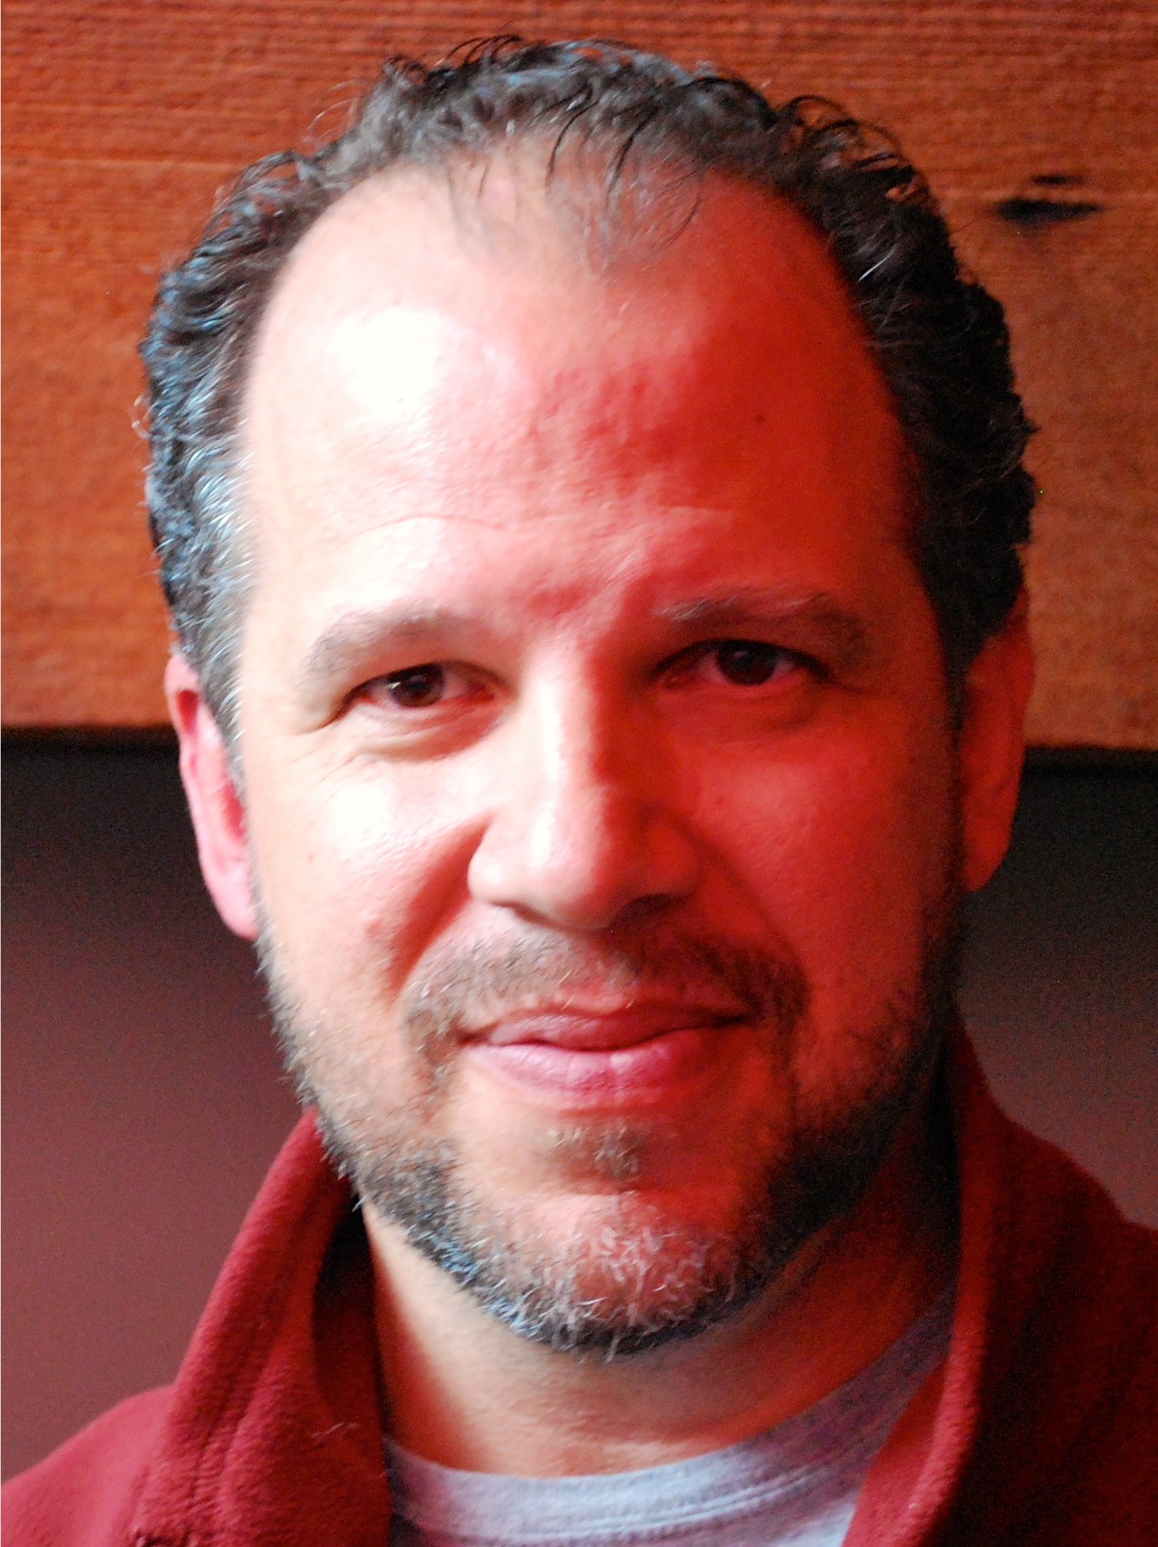Aaron Posner (Playwright) is a freelance director and playwright, an Associate Artist at the Folger Theatre in Washington, D.C., and the Milwaukee Repertory Theatre, and was the founding Artistic Director of Philadelphia's Arden Theatre. Aaron has won Barrymore Awards as both a director and playwright, and Helen Hayes Awards for Best Director three of the last nine years. His published and produced plays and adaptations include My Name Is Asher Lev (winner of the 2013 Outer Circle Critics Award), The Chosen, Stupid Fucking Bird, Sometimes A Great Notion, Mark Twain’s A Murder, A Mystery & A Marriage (with James Sugg), and many others. Aaron is an Eisenhower Fellow and a graduate from Northwestern University. Originally from Eugene, Oregon, he lives outside D.C. with his wife, actress Erin Weaver, and his amazing daughter, Maisie.

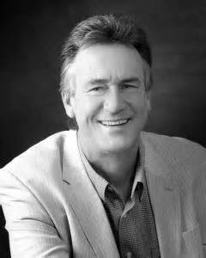ANDREW BARNICLE (Director) is pleased to return to North Coast Rep for his tenth producion, including the recent The Odd Couple, and last season's The Lion In Winter. Andy served as artistic director of The Laguna Play­house from 1991 through 2010. In that time he produced over 100 Playhouse shows and directed over 40 of them, including many World, U.S., West Coast and Southern California premieres. Recent directing projects at Laguna include Willy Russell’s Shirley Valentine, Noel Coward’s Private Lives, Ron Hutchinson’s Moonlight and Magnolias, which also played the La Mirada Theatre for the Performing Arts as a co-production with McCoy/Rigby Entertainment, and Burbank's Colony Theatre. In the past few years, he directed Coward’s Present Laughter at Chapman University, Shirley Valentine at the Falcon Theatre in Burbank, The Irish Curse at the Odyssey Theatre in LA, Blame It On Beckett at the Colony, and Private Lives at the Rubicon Theatre in Ventura. Andrew previously served as Head of Theatre at United States International University’s School of Performing and Visual Arts in San Diego, and was the Associate Artistic Director at North Coast Repertory Theatre. He has also directed at San Diego’s Theatre at Old Town, Michigan’s Meadow Brook Theatre, Gunmetal Blues, Rounding Third, Charles Evered's Celadine at the Colony Theatre, and The Foreigner at the San Jose Repertory Theatre. As an actor, he has appeared numerous times Off-Broadway and in major roles in eighteen LORT productions across the country, including Meadow Brook Theatre, the Alabama Shakespeare Festival, San Diego Rep, the Alaska Rep, and five roles at The Laguna Playhouse, including The Actor in Enter The Guardsman, Sam Galahad in both the production and on the cast album CD of Gunmetal Blues, in David Rambo's The Ice-Breaker, and most recently in Noel Coward's Fallen Angels. He played the title role in Shakespeare’s Henry IV, Part One at North Coast Rep. Upcoming, he will be directing Stephanie Zimbalist in Sex and Education at the Colony.
This artist is sponsored by the Mandell Weiss Charitable Trust

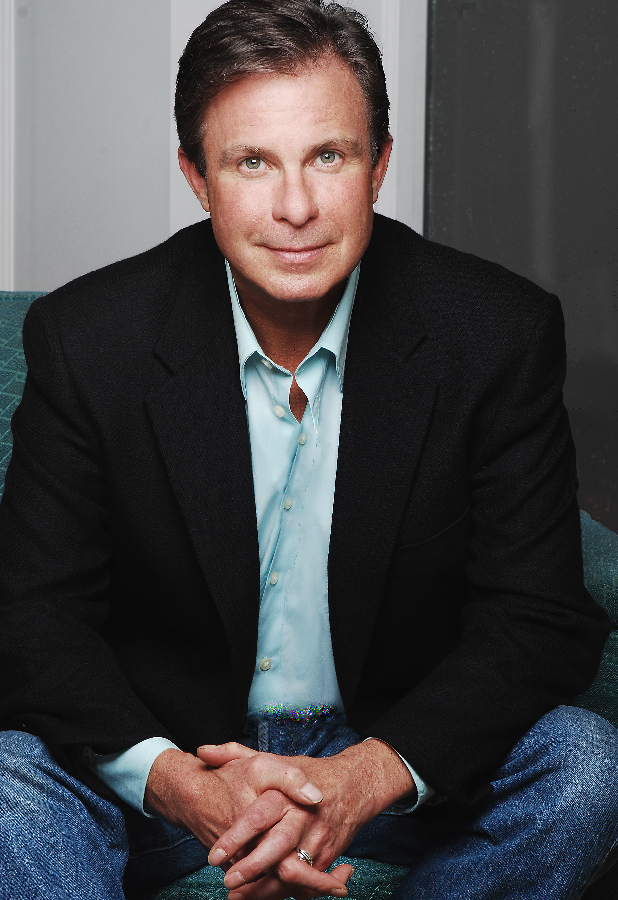James Leaming* (Actor 1-Tom Newton) –This is his first appearance at North Coast Rep. Last up- Hank Williams: Lost Highway at American Blues Theater where he is a founding member (1985): Tobacco Road, The Hairy Ape, Two Rooms, Bad Moon, A Lie Of The Mind, Catch 22, American Dead. On Going: This Wonderful Life: (solo version of It’s A Wonderful Life) Laguna Playhouse, 2011, Cleveland Playhouse, 2010, Syracuse Stage, New York, 2009, and Asolo Repertory, Florida, 2008. Regional Theater: Alliance Theatre, Georgia, in the world premiere of Broke; 9 seasons at Peninsula Players in Door County, Wisconsin: A Few Good Men, Cherry Orchard, Foreigner, A Man For All Seasons; Asolo Repertory: Devil’s Disciple, Winter’s Tale and Inventing Van Gogh. In Chicago he has worked for Steppenwolf, Northlight, Next, Victory Gardens, Goodman, Body Politic, Fox Theatricals and with Canamac Productions in Botanic Garden with his wife, Carmen Roman, directed by Olympia Dukakis. Training: American Conservatory Theatre (San Francisco), Second City (Chicago). Awards: After Dark Award- Best Actor for The Man Who Fell in Love With the Moon; Sarasota Magazine Award- Best Actor and Best Show for This Wonderful Life, and a Joseph Jefferson Award for the set design of Tobacco Road (American Blues). Film/TV: Mind Games (airs January 2014), Prison Break, Early Edition, Running Scared, Code Of Silence and numerous commercials and voice-overs.
This artist is sponsored by Arthur and Molli Wagner

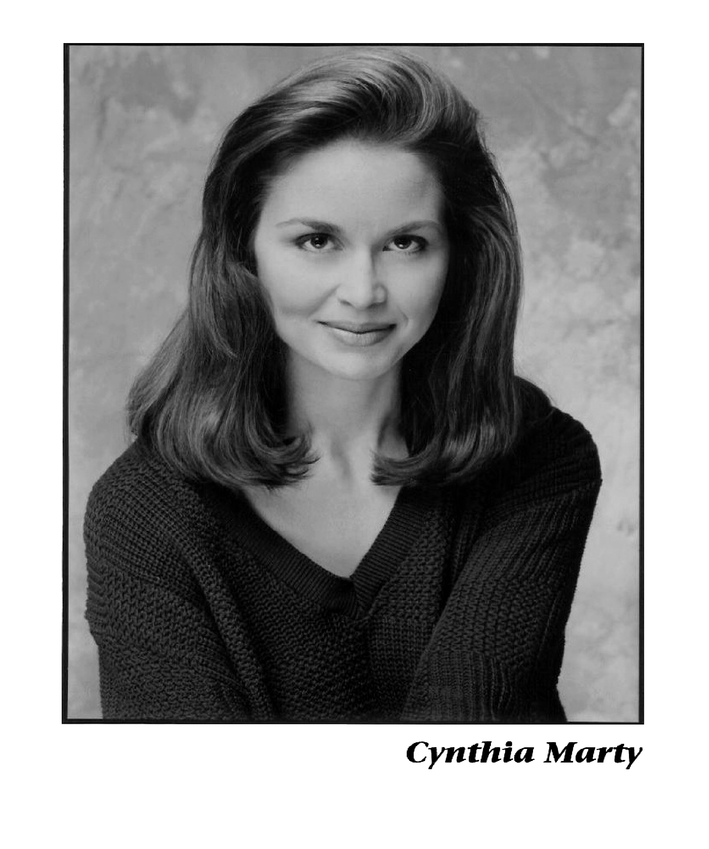Cynthia Marty* (Actor 2-Kate Newton) is tickled to be here at North Coast Rep at last, and to be sharing the stage in this love story with her for-real husband Greg Zerkle (North). They performed in San Diego Starlight’s 1776, and have teamed up over the years in Guys and Dolls, Sound of Music, Camelot and Kiss Me Kate around the country. Selected favorites NY: Company, Lend Me A Tenor, Most Happy Fella, Will Rogers Follies and 110 in the Shade; CA: One Flew Over the Cuckoo’s Nest, Hello Dolly, The Immigrant, Spitfire
Grill, Secret Garden and Sweeney Todd (Cygnet). Cindy loves to sing. She can be heard on motion picture soundtracks and with the Los Angeles Master Chorale on the stages of the Walt Disney Concert Hall and the Hollywood Bowl. She humbly serves on the Council of Actors' Equity. Thank you Andy and David. Who am I this time? One of the lucky ones
This artist is sponsored by Kenneth Baca

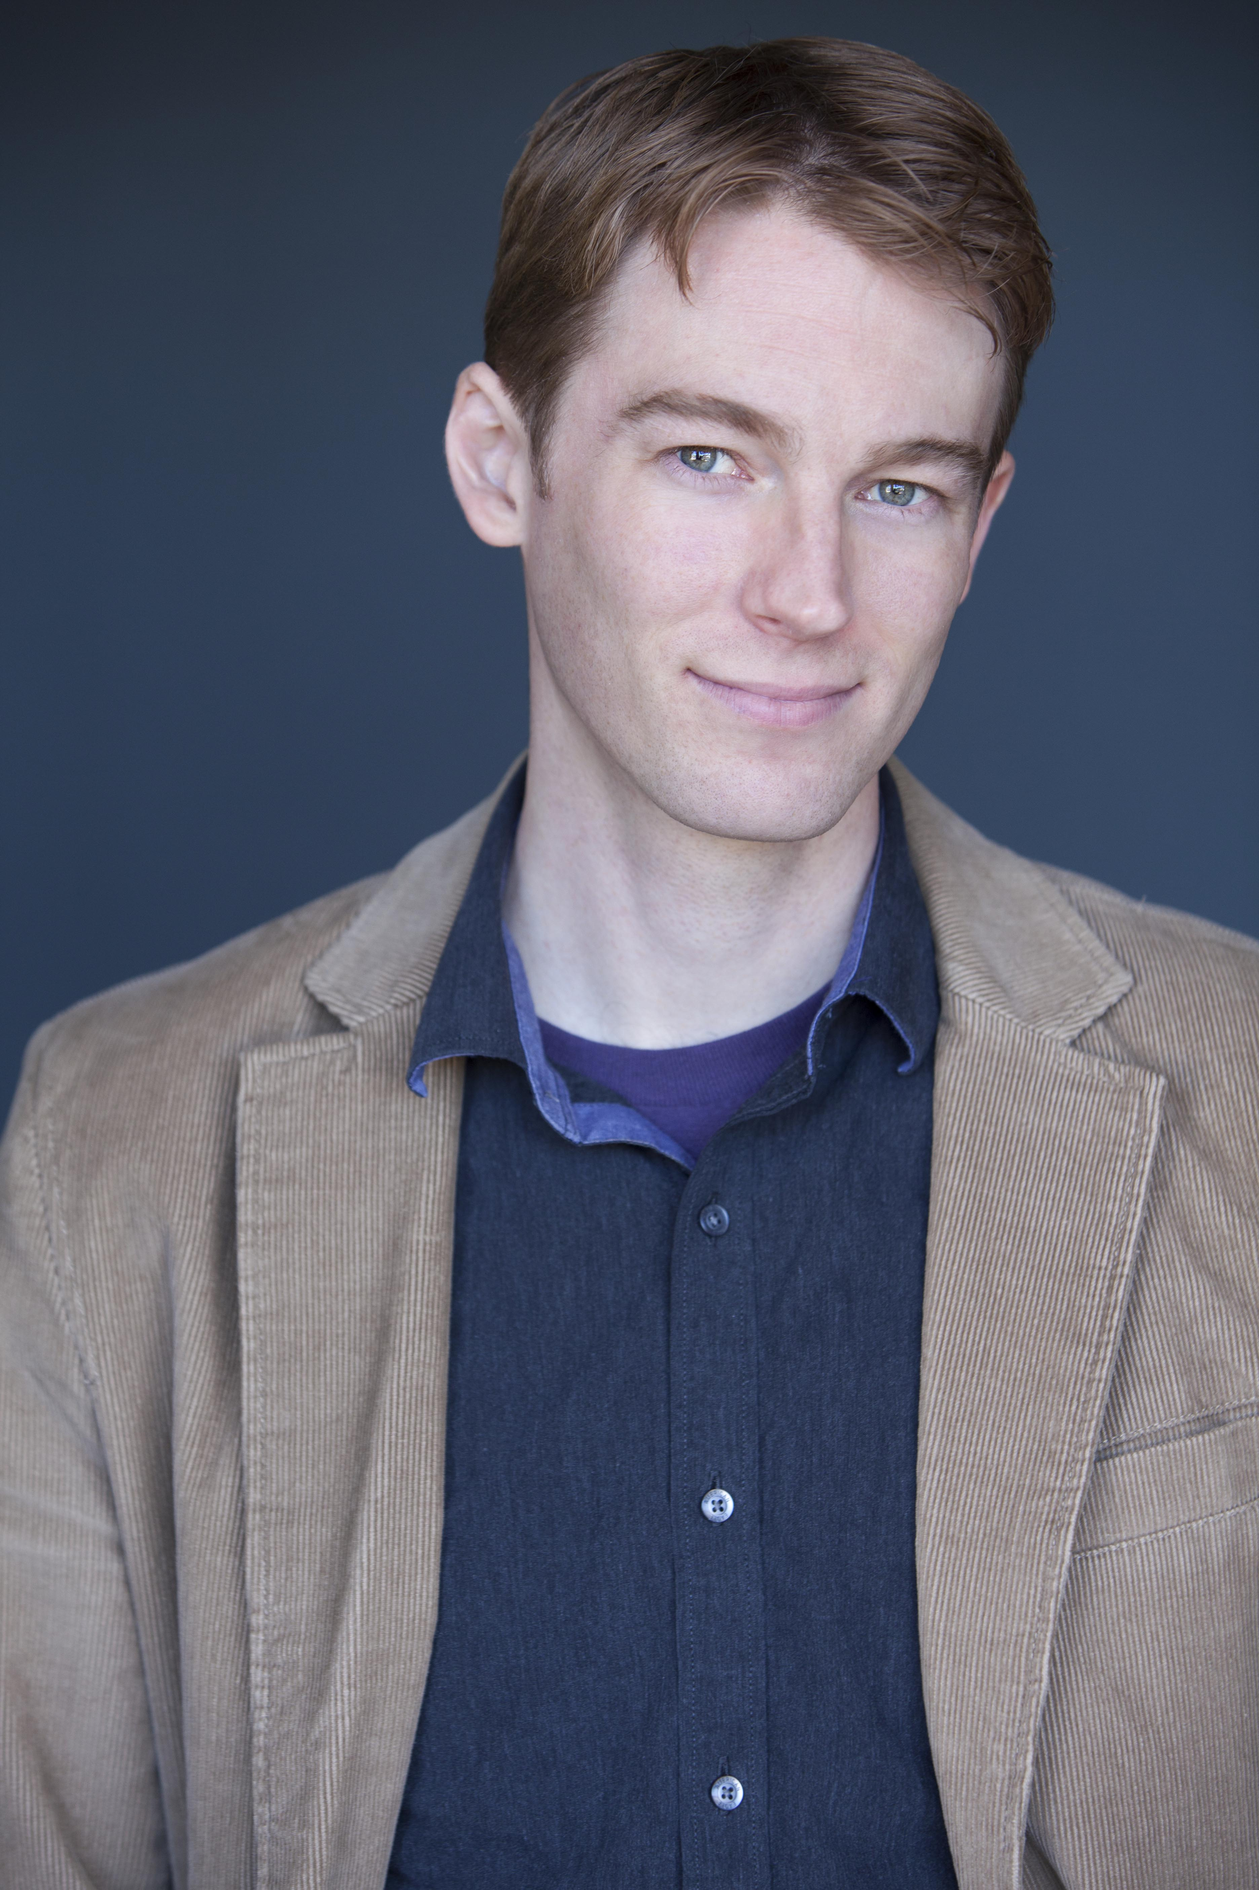Ben Cole (Actor 3- Newt, Joey, John Murra) earned his MFA in Acting from Western Illinois University, his BFA in Acting/Directing from Central Michigan University, and studied acting through New York University in Ireland. He has experience acting, teaching, directing, and fight choreographing nationally including work with the Orlando Shakespeare Theater, Macbeth; the Oklahoma Shakespearean Festival, Henry IV p.1 & 2; and the Illinois Shakespeare Festival, The Tempest, Merry Wives of Windsor. Locally he has worked with New Village Arts: Macbeth, A Midsummer Night’s Dream; Intrepid Shakespeare: A Midsummer Night’s Dream; ion theatre: Punk Rock, The Mystery Plays; Moxie Theatre: Coming Attractions; Scripps Ranch Theatre: Holiday Spirits, Almost, Maine; and North Coast Rep: Sleeping Beauty, A Year with Frog and Toad, and directed the Theatre School production of Romeo and Juliet. Ben will be directing the rarely seen Shakespeare show: All’s Well That Ends Well for the Theatre School@ North Coast Rep this coming summer.
This artist is sponsored by Heidi and David Hodges

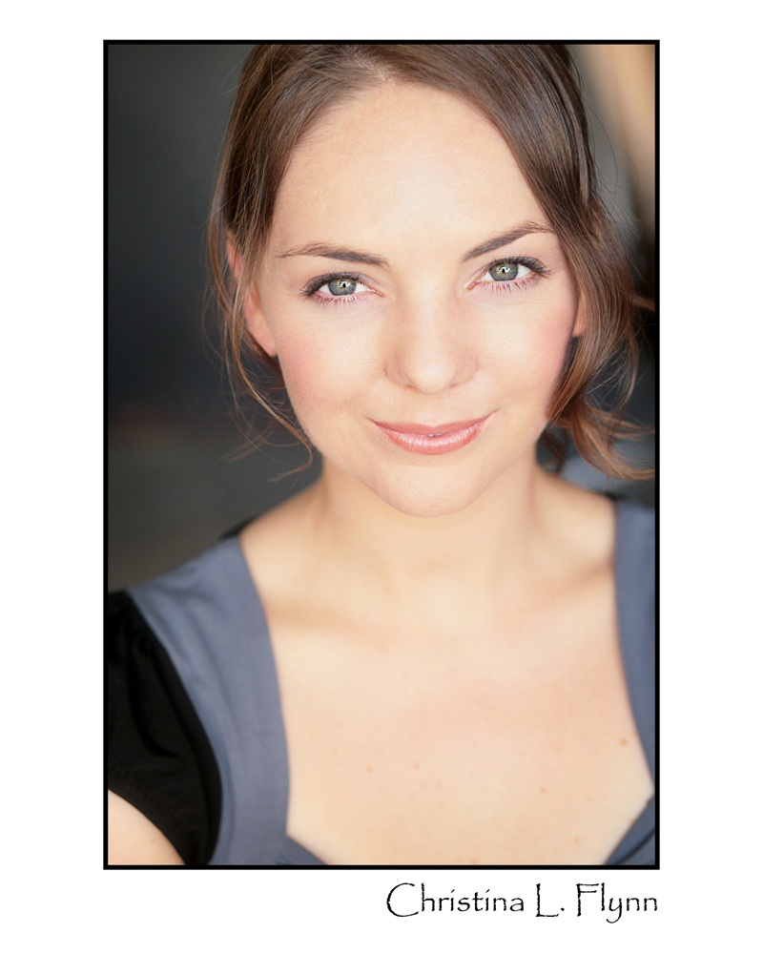Christina Flynn (Actor 4-Catherine, Helene Shaw, Paula Newton) is thrilled to be making her North Coast Rep debut. She recently returned to San Diego after living in the Bay Area and Midwest for 10 years. Past regional credits include: The Importance of Being Ernest (Tipping Point Theatre), Tartuffe, The Winter’s Tale, Much Ado About Nothing (Michigan Shakespeare Festival), Sonya Flew (Jewish Ensemble Theatre and Performance Network Theatre), Born Yesterday, All My Sons, The Seagull, The Fantastiks, Servant of Two Masters, A Midsummer Night’s Dream, Hamlet (Hilberry Repertory Theatre), A Midsummer Night’s Dream (Utah Shakespeare Festival Tour). She has her MFA in Acting from Wayne State University and has studied at The Moscow Art Theatre in Russia. Christina would like to thank David and Andy for this opportunity and her family for their continuous support and love. www.christinaflynn.com
This artist is sponsored by Robert and Adrienne Feldner

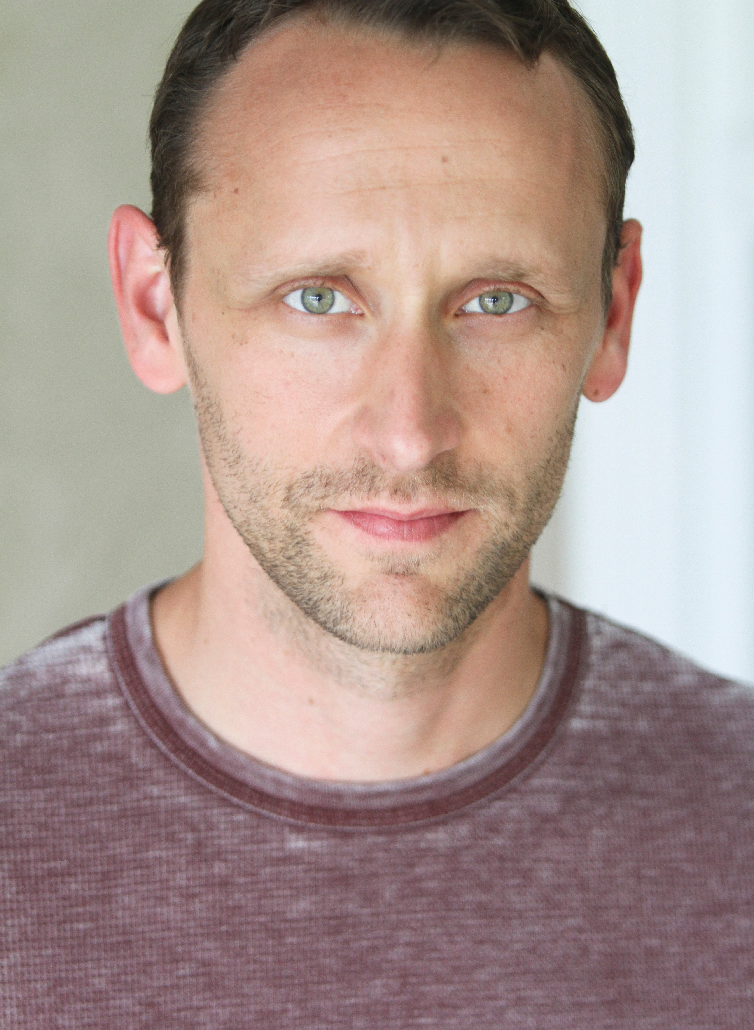Jason Maddy* ((Actor 5-Harry Nash, Roy Crocker) North Coast Repertory Credits include: Baby, I Love You Because, The Dresser, Jacques Brel, Lion in Winter, and most recently, Perfect Wedding. Other San Diego Credits include roles with: The Old Globe Theatre, Cygnet Theatre, San Diego Repertory Theatre, Moonlight Stage Productions, ion Theatre Company, Welk Resort Theatre, San Diego Musical Theater, Premiere Productions and Intrepid Theatre Company. Regional Credits: The Utah Shakespearean Festival, Illinois Shakespeare Festival and Kingsmen Shakespeare Festival. Favorite roles include Louis in Angels in America, Jeff in I Love You Because, Touchstone in As You Like it and Leon Csolgosz in Assassins. Jason holds an MFA from the University of Illinois Urbana-Champaign.
This artist is sponsored by Gigi and Ed Cramer

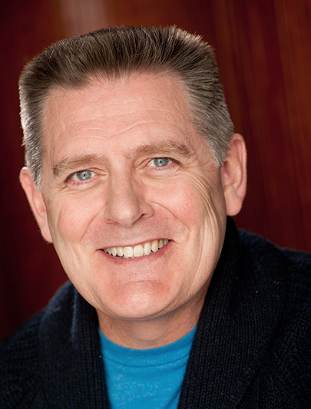Gregory North* (Actor 6-Verne Miller, George Murra) comes directly from 12 Angry Men at the Pasadena Playhouse. He is chockfull of happy to be working at a theatre called North and reunited with the remarkable Mr. Barnicle. Born Greg Zerkle behind the Cheddar Curtain in Wisconsin, he began pursuing show business in the 5th Grade – writing and directing himself in the groundbreaking play Myron Talks to God. Since then he’s worked with lots of talented artists, played some wonderful roles, overheard a few supportive remarks in the lobby and had a real swell time. His career spans Broadway - Into the Woods, The Secret Garden, Grand Hotel, A Christmas Carol, the pre-Broadway run of The Kiss of the Spider Woman and in 2014 he returns in Sting’s new musical, The Last Ship; National Tours - Phantom, Les Miz, Show Boat; Regional Theatre - over 100 roles; TV, Film, Voice-overs and Commercials. He also dabbles in hypnotism – If you loved the show, tell everyone – if not, at the count of 3 you will awaken feeling refreshed. A proud member and National Councillor of Actors Equity, Greg holds an MFA from the University of Washington and is happily married to his favorite leading lady, Cynthia Marty. For Dad. gregorynorthactor.com
This artist is sponsored by the Jonathan McMurtry Actors’ Fund

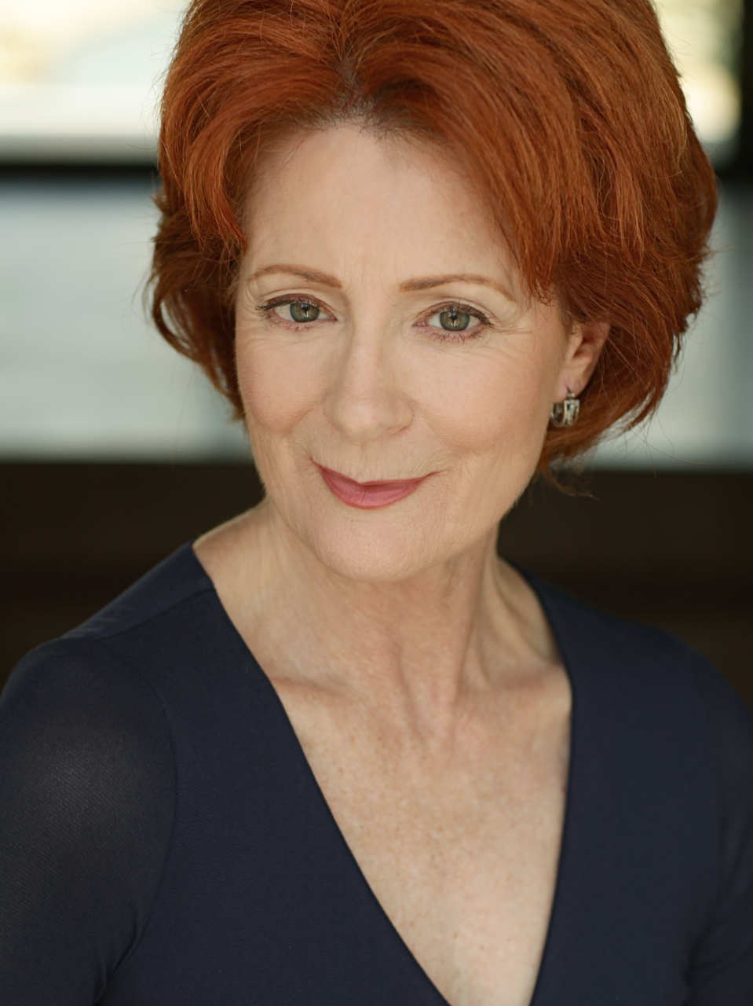Rosina Reynolds* (Actor 7-Doris Sawyer, Gloria Hilton) Previous shows at North Coast Repertory Theatre: Ghosts, Madagascar, Wit, Amy's View, The Rivals, Eleanor. Regional Theatre: 33 Variations (Theatreworks), Love In American Times (San Jose Rep), Steel Magnolias (La Mirada Theatre), Dividing the Estate, Sea of Tranquility, Romeo and Juliet, Missing Footage, Trojan Women, (Old Globe Theatre), Doubt, The Clean House, Cymbeline, A Lovely Sunday at Creve Couer, Christmas Carol; (San Diego Repertory Theatre;) San Diego Theatre:The Glass Menagerie, Noises Off, Arcadia, Copenhagen, The Little Foxes; (Cygnet Theatre); Joyful Noise, Lettuce & Lovage, Woman of No Importance. (Lambs Players Theatre) Shirley Valentine, Long Days’ Journey Into Night, (Renaissance Theatre Company.) Other San Diego theatres include New Village Arts, Mo’olelo, Performing Arts Company, Sledgehammer Theatre, Malashock Dance Company and Moonlight Avo. Rosina has directed over 30 productions in San Diego including the recent production of Broken Glass here at North Coast Rep. She is the founding artistic Director of the Chequamegon Children’s Theatre in Northern Wisconsin, where they produced their 28th production, Fiddler on the Roof, this past summer.
This artist is sponsored by Noddy and Ira Epstein

The Designers
Marty Burnett (Resident Designer) Marty begins his 22nd season as Resident Designer/ Technical Director at North Coast Rep. He has designed the last 150 shows. Other venues include Laguna Playhouse, Portland Stage Company, Drury Lane (Chicago), Claridge Hotel (Atlantic City), Union Plaza, Sahara Hotel, Hacienda in Las Vegas, Coronado Playhouse, Scripps Ranch Theater, Harrah’s Lake Tahoe. Marty is a proud alumni of Creighton University in Omaha, Nebraska.

Matt Novotny (Light Design) recently designed the lighting for Man With A Load Of Mischief, Perfect Wedding, Becoming Cuba, The Odd Couple, Time Stands Still, Educating Rita, The Underpants, Dames at Sea, Two by Pinter: The Lover and The Dumb Waiter, THIS, Visiting Mister Green, Lend Me A Tenor, Five Course Love, My Name is Asher Lev, King O’ the Moon, Ghosts, Glorious, I Love You Because, Old Wicked Songs, Rabbit Hole, Shipwrecked!, The Dresser, Don’t Dress for Dinner, Mornings at Seven, Baby and Rashomon at North Coast Rep. He’s currently the Director of Production for Lyric Opera San Diego. Lighting designs include: Iolanthe, The Merry Widow, The King and I, Countess Maritza, and The Mikado. San Diego: Das Barbecu, The Wiz, West Side Story and Rumors. Regional: Yankee Doodle Dandy (Seattle), Noises Off! (Boston), The Game, (Washington D.C.) and Primal Twang, a guitar concert featuring six Grammy-winning artists. Matthew holds a B.A. in Technical Theatre from San Diego State University, and an M.F.A. from Boston University.

Sonia Elizabeth Lerner (Costume Design) having graduated from SDSU with her MFA two years ago, Sonia now works as a designer in L.A. for film and TV. Her costume designs can soon be seen at the High Roller in Las Vegas (the 550 ft tall ferris wheel) opening early 2014! She has also recently started a company for customized hand-painted silk scarves called Sonia Elizabeth Design. This is Sonia's fifth show with North Coast Repertory. Her other shows here have been Becky's New Car, Lend Me a Tenor, Time Stands Still, and The Odd Couple. www.SoniaElizabethDesign.com

Chris Luessmann (Sound Design) for North Coast Repertory Theatre Chris has designed: A Christmas Carol and Dracula, for which he won Patte Awards; Don’t Dress for Dinner, Time Stands Still, Leading Ladies, The Odd Couple, Educating Rita, The Big Bang, Ghosts, A Moon for the Misbegotten, Lend me a Tenor, The Drawer Boy, Becky’s New Car, The Lion in Winter, Over the Tavern, King O’ The Moon, and Voice of the Prairie. He designed The Third Story for MCC Off-Broadway; Billy Crystal's 700 Sundays at La Jolla Playhouse; Das Barbecü, Forbidden Broadway SVU, and Too Old for the Chorus at Miracle Theatre Productions; Les Misérables, South Pacific, Ring Round the Moon, Moon Over Buffalo, and Sweeney Todd at Moonlight Stage Productions. Chris holds a BA in theatre from UCLA, and an MFA in theatre from UC San Diego.

Aaron Rumley* (Stage Manager) North Coast Repertory Theatre: Broken Glass; Two by Pinter: The Lover and the Dumb Waiter, THIS, The Lion in Winter, Heroes, Lend Me A Tenor, My Name is Asher Lev, The Drawer Boy, Becky’s New Car, Voice of the Prairie, Ghosts, Glorious!, Talley’s Folly, Over the Tavern, Rabbit Hole, The Dresser, Don’t Dress for Dinner, Madagascar, Mornings at Seven, String of Pearls, Dracula, Rashomon, Wit, A Moon for the Misbegotten, Leading Ladies, Collected Stories, Halpern & Johnson, Romeo and Juliet, The Bungler, The Chosen, A Life in the Theatre and The Rainmaker. North Carolina Theatre: Talley’s Folly, Picnic, The Miser and On Golden Pond. Aaron received a B.A. in Theatre from the University of North Carolina at Wilmington, and is the production manager at the North Coast Repertory Theatre. Aaron is a Member of Actors’ Equity Association.
This artist is sponsored by Linda Brandes
#####

For Immediate Release: December 2, 2013
On Exhibit in the North Coast Rep Café & Gallery
Art by Michael Carini
January 8 – February 2, 2014
(Gallery open during performance times of Who Am I This Time)
987 Lomas Santa Fe Drive, Suite D
Reception January 17, 7 pm - 8 pm

Contact: (858) 481-2155 ext. 203 Leslie Zwail, Gallery Director
www.northcoastrep.org leslie@northcoastrep.org

Michael Carini received his artistic training in Los Angeles, studying at Loyola Marymount University while simultaneously serving as an apprentice under respected artists Jane Brucker and Roland Reiss. Graduating at the top of his class in 2006 with honors including the Scholar of Distinction Award in Painting, Carini returned to his hometown in San Diego, where he currently maintains his studio. Exhibited and published both in the United States and internationally, Carini spent the summer of 2012 as the Artist in Residence for Alexander Salazar Fine Art, by whom he is now currently represented.

Michael Carini’s creative visions will play with your senses and illuminate the human condition as he delves into the uncensored depths of his mind and invites you to catch a glimpse of the other side. It is a journey through his darkest dreams and highest hopes. The visions shared are done so through a broad and ever expanding repertoire of subject matter, combined with the intimate touch of personal experience and introspection, as Carini transmutes his medium in what he describes as a poetically alchemical process based upon the principals of equivalent exchange. It is the artist’s hope that you will completely lose yourself within these labyrinthine experiences, only to discover a new sense of self and emerge reborn.
www.michaelcarini.com

