CONTACT: Nancy Richards – 917-873-6389 (cell) /nancy@northcoastrep.org
MEDIA PAGE: www.northcoastrep.org/press
FOR IMMEDIATE RELEASE, PLEASE:

NORTH COAST REPERTORY THEATRE LAUNCHES SEASON 41
WITH DELIGHTFULLY WHIMSICAL WORLD PREMIERE
OF ANNABELLA IN JULY
By Richard Strand
Performances Beginning Wednesday, September 7, 2022
Running Through Sunday, October 2, 2022
Directed by David Ellenstein

Solana Beach, Calif. – The World Premiere of ANNABELLA IN JULY inaugurates North Coast Repertory Theatre’s eclectic Season 41, starting September 7. Penned by Richard Strand of last season’s smash-hit, Ben Butler, this comedic fantasy transforms a ski resort during the off-season into a strangely magical environment of self-discovery. This funny and insightful new work poses questions of identity and perception that will have audiences laughing out loud, while simultaneously examining the hopes and dreams of their own lives. Buy your tickets now for this joyous night at the theatre.

David Ellenstein directs Louis Lotorto,* Jacquelyn Ritz,* Leilani Smith,* Bruce Turk,* and Catalina Zelles in ANNABELLA IN JULY. The design team includes Marty Burnett (Resident Scenic Designer), Matthew Novotny (Light Design), Renetta Lloyd (Costume Design), Aaron Rumley (Sound & Projections) Cindy Rumley (Prop Design), Peter Herman (Hair & Wig Design) and Kris Danford (Dialect Coach). Heather Bennett* is the Stage Manager.

*The actor or stage manager appears through the courtesy of Actors’ Equity Association. For photos, go to www.northcoastrep.org/press.

ANNABELLA IN JULY previews begin Wednesday, September 7. Opening Night on Saturday, September 10, at 8pm. There will be a special talkback on Friday, September 16, with the cast and artistic director. It will play Wednesdays at 7pm, Thursdays through Saturdays at 8pm, Saturday and Sunday matinees at 2pm with Sundays at 7pm through October 2. Two performances has just been added on Friday, September 9th at 2pm and Wednesday, September 28, at 2pm. (See Schedule below). North Coast Repertory Theatre is located at 987 Lomas Santa Fe Drive, Solana Beach, CA 92075. Tickets: Previews - $54 (including Friday preview at 2pm), Week Nights/Wed. & Sat. Matinees - $60; Sat. Eve. & Sun. Mat. $65; Sun Night - $57. Seniors, Students, Military & Educators - $3 off admission. Call 858-481-1055, or visit www.northcoastrep.org to purchase tickets.

FACT SHEET:

WHAT: NORTH COAST REPERTORY THEATRE presents
ANNABELLA IN JULY
A World Premiere by Richard Strand
Directed by David Ellenstein

CAST: Louis Lotorto,* Jacquelyn Ritz,* Leilani Smith,* Bruce Turk,* & Catalina Zelles

WHERE: North Coast Repertory Theatre
987 Lomas Santa Fe Drive
Solana Beach, CA 92075

SCHEDULE: Previews start September 7, 2022
Opens: September 10, 2022
Closes: October 2, 2022
Wed. @ 7pm, Thurs-Sat @ 8PM; Sat & Sun @ 2PM, Sun @ 7pm
Fri (Sept 9) @ 2pm
Wed (Sept 28) @ 2pm

PRICES: Previews $54.00
Week Nights & Sat. Matinees $60.00
Sat. Nights & Sunday Matinees $65.00
Sunday Nights $57.00

DISCOUNTS: Seniors, Students, Military & Educators $3.00 off admission. Rush tickets available for $20.Sold 15 minutes prior to showtime.

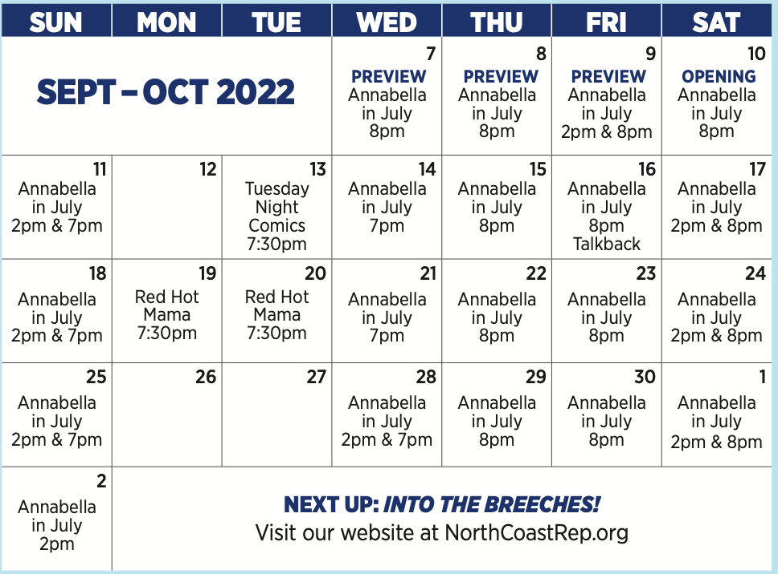

BIOS:
RICHARD STRAND (Playwright) Richard Strand has had premieres at Victory Gardens Theater, GeVa Theatre, Steppenwolf Theatre, The Cricket Theatre, New Jersey Repertory Company, Detroit Repertory Theatre and a number of other venues. Two of his plays, The Bug, and The Death of Zukasky, premiered at The Humana Festival at Actors Theatre of Louisville. Ten Percent of Molly Snyder, My Simple City and The Second-Story Man were written in Iowa City, Iowa, where Mr. Strand was a member of the University of Iowa Playwright’s Workshop. Ben Butler premiered at New Jersey Repertory Company and later moved to 59E59 in New York. Mr. Strand currently lives in California with his wife, Mary Lynn. He recently retired as the chairman of the theater department at Mt. San Antonio College in Walnut, California, where he designed scenery and taught History of Theater and Playwriting.
DAVID ELLENSTEIN (Director), Born into a theatrical family, David is an actor, director, producer and playwright. Before joining North Coast Rep in 2003 as Artistic Director, he served in that position for the Los Angeles Repertory Company and the Arizona Jewish Theatre Company (AJTC). He is a veteran of over 300 theatrical productions at theatres from San Diego to Maine, and from Alaska to Miami and most places in between. David has won numerous theatre awards, including the San Diego Theatre Critics Circle Award for “2018 Director of the Year.” David has also appeared in dozens of film and television roles, as well as having been guest faculty for numerous universities including California State Northridge, Cal Arts, and Shakespeare workshops privately.
LOUIS LOTORTO* (Brian) is thrilled to return to North Coast Rep after last appearing as Arthur Vance in The Outsider. Other NCRT credits include Emperor Joseph II in Amadeus, Leo in Chapter Two, Milt in Laughter on the 23rd Floor, and Felix in The Odd Couple. Regional credits include the Royal National Theatre’s tour of An Enemy of the People (w/ Sir Ian McKellen), Camille in A Flea in Her Ear at A Noise Within (L.A. Ovation Award Nomination), Ariel in The Tempest at The Shakespeare Theatre Company (Helen Hayes Award Nomination), Oregon Shakespeare Festival, California Shakespeare Festival, Portland Center Stage; Berkeley Rep, San Jose Rep, Artists Rep, and South Coast RepertoryTheatres among others. He most recently played Hercule Poirot in Murder on the Links at the Oregon Cabaret Theatre in Ashland, Ore., and will be returning to play the famed detective again there next Fall in The Murder of Roger Ackroyd. Feel free to visit: www.louislotorto.com.
JACQUELYN RITZ* (Vanessa) is delighted to return to North Coast Repertory where she has appeared in Bloomsday, How the Other Half Loves, Chapter Two, and Fallen Angels, among others. She recently played the Baroness in La Jolla Playhouse’s production of Lempicka directed by Rachel Chavkin. Regionally, she has performed at Goodman Theatre, Northlight, Royal George, Apollo, Drury Lane, Intrepid Theatre, Marriott Lincolnshire, Peninsula Players, Milwaukee Repertory, Colorado Shakespeare Festival, Asolo Center for the Arts, and the Kennedy Center in Stephen Sondheim’s Bounce directed by Harold Prince. She can be seen as Madame Blueberry (and others) in “VeggieTales.” She directs locally and teaches the class, Acting for the Working Actor, at Scripps Ranch Theatre. She is a member of AEA and SAG/AFTRA. www.JacquelynRitzActor.com.
LEILANI SMITH* (Camelia) was born a military brat to Claude Smith Sr. and Ok Cho in Osan, Korea. After eight years of training, she became the first female black belt instructor at RPKC. She just finished her first audio book “Mother Cabrini” for the Mentoris Project, voiced “Leilani” the crossing guard — yes named after her — in HBO Max’s animated shorts program “Yellowbird” and dubbed a show for Netflix all coming soon. Just off stage in God of Carnage as Annette Raleigh at the Odyssey Theatre, you can still catch her streaming on SWAT epi. 519 “Incoming” as Pilot Archer with indie Thriller “Don’t Die” as Sally in post-production. Thrilled to return to my North Coast Rep Family and grateful to David Ellenstein for giving me this opportunity.
BRUCE TURK* (Alexander) has performed on and Off-Broadway, internationally, and at major regional theatres across the country. He most recently appeared at NCRT in The Homecoming, Ben Butler, and Same Time Next Year. New York credits include the title role in Julie Taymor’s production of The Green Bird and numerous off-Broadway appearances with Theatre For A New Audience. San Diego audiences have seen him in fifteen productions of Shakespeare at the Old Globe Theatre (Craig Noel Award). Also Lincoln Center, Brooklyn Academy of Music, ACT, Pasadena Playhouse, Seattle Repertory, McCarter Theatre, La Jolla Playhouse, Denver Center, Cincinnati Playhouse, Goodman Theatre, the Shakespeare Theaters in DC, New Jersey and Santa Cruz, and more. T.V: “Murder in the First,” “NUMB3RS,” “ER,” “L&O:SVU,” etc. He has been a resident member of Tadashi Suzuki’s Acting Company in Japan, Resident Artist at Hartford Stage, and recipient of the TCG/Fox Fellowship for Distinguished Achievement. Graduate of Northwestern University.
CATALINA ZELLES (Piper) is ecstatic to return to North Coast Rep after last being seen here in 2019‘s West Coast Premiere of Gabriel (Estelle; San Diego Theatre Critics Choice Award). Other productions include Oceanside Theatre Company’s Christmas Carol (Christmas Past), Miracle On 34th Street (Susan Walker), Eurydice (Little Stone); Theatre School @ North Coast Rep’s Night Witches (Commander Zoya), Secret Garden (Colin Craven, NYA Award); Patio Playhouse Wait Until Dark (Gloria); Moonlight Amphitheater’s Newsies (Ensemble); San Diego Musical Theatre’s Billy Elliot (Ballet Girl); Welk Resort’s The Music Man (Amaryllis), Fiddler On The Roof (Bielke); Cygnet Theatre’s Gypsy (Baby June); Saville Theatre’s To Kill A Mockingbird (Scout); The Old Globe’s How The Grinch Stole Christmas (Little Who Ensemble). San Diego Shakespeare Festival 2014-2018 (Best Actress, Best Choral). Competitive Gymnast XCL Platinum. Catalina thanks Mr. Ellenstein for this amazing opportunity to be part of this magical story, her supportive parents, and the cast she’s blessed to share the stage with.
HEATHER BENNETT* (Stage Manager) has a passion for facilitating art and artists through stage management. She is a member of Actors Equity Association and the Stage Managers Association and recently earned her MFA in Stage Management from UC Irvine. Credits span across dance concerts, dramas, musicals, Shakespeare, and theatre for young audiences. She is excited to continue her journey and to continue telling the stories that need to be told.
CREATIVE STAFF
MARTY BURNETT (Set Design) Resident Designer at North Coast Rep since 1992 and has designed more than 200 productions for the theater. Other design venues include Sahara and Hacienda hotels in Las Vegas, Claridge Hotel, Atlantic City and Drury Lane Chicago.
MATTHEW NOVOTNY (Light Design) is pleased to be designing another show for North Coast Rep, where he has designed close to forty shows over the past seven years. Matthew is currently the Lighting Designer in Residence for San Diego Musical Theatre as well as North Coast Rep, and his work can be seen at a wide variety of theatres across San Diego. Matthew holds a B.A. in Technical Theatre from San Diego State and a master’s degree in Lighting Design from Boston University. Matthew is married to his beautiful wife Amanda, with 5 AMAZING children: Ragan, Harper, Heston, Maddex and Harrison .
RENETTA LLOYD (Costume Design) is thrilled to be back at North Coast Rep for this production. She has been working as a costumer in North County San Diego for over 15 years. Her work has been seen at Moonlight Amphitheatre, Mira Costa College and several other local theatre companies. When not working on a show, she enjoys designing custom creations for conventions and other costumed events. When not sewing, she is mostly found chauffeuring her two young kiddos around town! Keep up with all her creative projects on Instagram @Natty.Lou.Creations. Enjoy the show!
AARON RUMLEY (Sound, & Projections) has worked on over 120 shows at North Coast Rep, over 50 as a stage manager, over 20 as a designer.
CINDY RUMLEY (Prop Design) recent credits as a Stage Manager at North Coast Rep include: The Remarkable Mister Holmes, Forbidden Broadway’s Greatest Hits, Desperate Measures, Dancing Lessons, Another Roll of the Dice, All in the Timing, Holmes & Watson, A Funny Thing..., Cindy holds an M.F.A in stage management from UC Irvine.
PETER HERMAN (Hair & Wig Design) has previously designed wigs for over 30 North Coast Rep productions. Peter teaches wig and makeup design at San Diego State University. He is glad to be part of the creative team on this show.
About the North Coast Repertory Theatre under the artistic leadership of David Ellenstein since 2003, is a professional Equity theatre, currently celebrating its 41st Season. North Coast Rep has received critical acclaim from media and audiences alike, and has evolved into one of the area’s leading performing arts organizations. North Coast Rep prides itself on employing the majority of its actors from Actors’ Equity Association for its high quality, award‐winning productions, and staging works by established and emerging playwrights. Throughout its history, North Coast Rep has created a platform where artist and audience thrive through the intimacy of live theatre, recognizing the power of theatre to challenge complacency, revitalize the imagination, nurture the unexpected and embrace the variety and diversity in our lives.
###

