CONTACT: Nancy Richards – 917-873-6389 (cell) /nancy@northcoastrep.org
MEDIA PAGE: www.northcoastrep.org/press
FOR IMMEDIATE RELEASE, PLEASE:

TAUT PSYCHOLOGICAL DRAMA, SENSE OF DECENCY,
MAKES WORLD PREMIERE DEBUT
AT NORTH COAST REPERTORY THEATRE
By Jake Broder
Based on the book The Nazi and the Psychiatrist by Jack El-Hai
Performances Beginning Wednesday, April 17, 2024
Running Through Sunday, May 12, 2024
Directed by David Ellenstein
Co-Directed by Jake Broder

Solana Beach, Calif. - Jake Broder has crafted a surprise-filled exploration into what makes people tick- filled with unexpected revelations, magic, and insight. A World Premiere theatrical foray into an historic meeting promises intrigue and theatrical sparks. When WWII ended, the Nuremburg trials were underway. Herman Göring was the highest-ranking Nazi alive. An American Army psychiatrist, Dr. Douglas M. Kelley, was tasked with interviewing him extensively and keeping him fit for trial. What happened in that fateful room had profound and unexpected consequences for both men. Based on the book “The Nazi and the Psychiatrist” by Jack El-Hai. Directed by David Ellenstein and Co-Directed by Jake Broder.

The film Nuremberg, based on Jack El-Hai’s book, The Nazi and the Psychiatrist, is now in production in Hungary, which stars Russell Crowe (Göring), Rami Malek (Kelley) and Michael Shannon (Supreme Court Justice Robert H. Jackson – chief prosecutor). Featured players include Richard E. Grant, Leo Woodall, and John Slattery, among others.

David Ellenstein & Jake Broder direct Frank Corrado*, Brendan Ford*, and Lucy Davenport*, in SENSE OF DECENCY. The design team includes Marty Burnett (Resident Scenic Designer), Matthew Novotny (Co-Light Design), Eric Montierth (Co-Light Design), Elisa Benzoni (Costume Design), Steve Leffue (Sound Design), Mat FitzGerald (Projection Design), Audrey Casteris (Props Design) and Peter Herman (Hair & Wig Design). Evelyn G. Myers*, is the Production Stage Manager, and Katelyn Slater (Production Assistant).

*The actor or stage manager appears through the courtesy of Actors’ Equity Association. For photos, go to www.northcoastrep.org/press.

SENSE OF DECENCY previews begin Wednesday, April 17th. Opening Night is set for Saturday, April 20th, at 8 pm. The play runs Wednesday, April 17th to Sunday, May 12th, with performances on Wednesdays and Thursdays at 7pm, Fridays and Saturdays at 8pm, Saturday and Sunday matinees at 2pm, with Sundays at 7pm. Added matinee performances at 2pm on Friday, April 19th and Wednesday, May 8th. There will be a talkback with the artistic director and cast on Friday, April 26th. (See schedule below).

North Coast Repertory Theatre is located at 987 Lomas Santa Fe Drive, Solana Beach, CA 92075. Tickets: Previews - $49 (including Friday preview at 2pm), Weeknights - $62, Wed. & Sat. Matinees/Sat. Eve. - $74; Sun. Night - $60. For ticket information and to secure your seats for SENSE OF DECENCY, call 858-481-1055, or visit www.northcoastrep.org. Join us for a night of unforgettable entertainment.

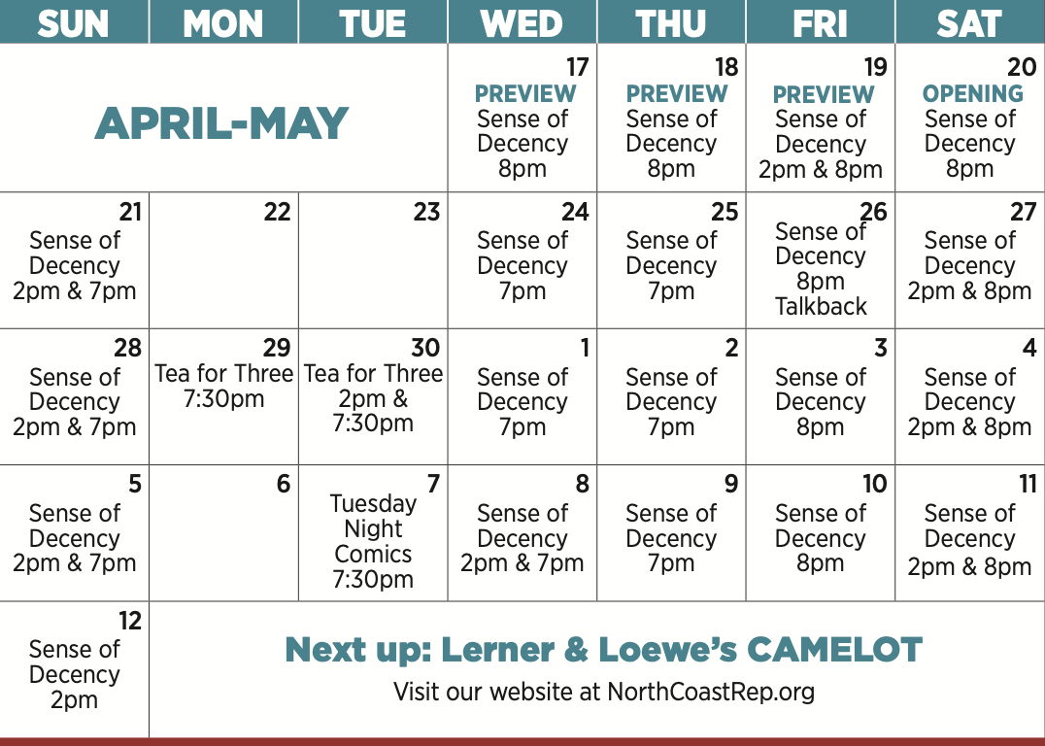

WHAT: NORTH COAST REPERTORY THEATRE presents
SENSE OF DECENCY
By Jake Broder
Based on the book “The Nazi and the Psychiatrist” by Jack El-Hai
Directed by David Ellenstein & Jake Broder

CAST: Frank Corrado,* Brendan Ford,* and Lucy Davenport.*

SCHEDULE: Previews start April 17
Opens: April 20
Closes: May 12
Wed., Thurs., Sun. @ 7pm, Fri. & Sat @ 8pm; Sat & Sun @ 2pm
Fri (April 19) @ 2 pm
Wed (May 8) @ 2pm

Added matinee performances at 2pm on Friday, April 19 and Wednesday, May 8. A talkback session with the director and cast is scheduled for April 26.

PRICES: Previews $49.00
Week Nights $62.00
Sat. Nights & Matinees $74.00
Sunday Nights $60.00

DISCOUNTS: Seniors, Students, Military & Educators $5.00 off admission. Rush tickets available for $20. Sold 15 minutes prior to showtime.

BIOS:

JACK EL-HAI is the author of The Nazi and the Psychiatrist, the book upon which Sense of Decency is based. That book began in 2008 when the son of Dr. Douglas M. Kelley let El-Hai explore a dozen boxes of Dr. Kelley’s papers and Nuremberg Trial artifacts long stored in a basement. El-Hai has written several other books of popular history and medicine. These include The Lobotomist, The Lost Brothers, and two forthcoming books: one about a face transplant patient and the other telling a historical true-crime tale. He has contributed articles to Smithsonian, GQ, The Atlantic, Wired, Scientific American, and other publications. Many of his works have been optioned or adapted for film, television, documentaries, and podcasts. After attending Carleton College, he earned an MFA in creative writing from Bennington College. He grew up in Los Angeles and now lives with his wife in Minneapolis.

JAKE BRODER (Playwright/Co-Director) lives in Los Angeles with his wife Lucy and children Ella & Louis. He recently was an Atlantic Fellow at the Global Brain Health Institute (at UCSF and Trinity College, Dublin), who commissioned his award-winning play UnRavelled www.unravelledplay.com. His play Our American Hamlet premiered at the Commonwealth Shakespeare Company, and was nominated for best new play, IRNE (Boston). His musical, Miravel, won the LADCC for best score, composed by Jake. He co-wrote and originated the role of Louis in Louis & Keely Live at the Sahara, winning Jake Ovation, LADCC, Garland and LA Weekly awards for Best Actor and Best Musical. It ran at the Geffen Playhouse, directed by Oscar-winner, Taylor Hackford, and since toured Chicago and SoCal. His Royal Hipness Lord Buckley played Off-West End (Soho Theatre) and Off-Broadway (directed by David Ellenstein at 59e59) and in LA. His new musical, (with Conor Duffy) Max & Willy’s Last Laugh, had a workshop presentation at Mosaic Theater in Washington D.C., and is moving towards a D.C. production. He was also a fellow at the O’Neill under artistic director John McDaniel. Jake's TV Writing includes Typewriter Days (Revolution Studios) and Black Hole Sun (Echo Lake), and Max & Willy’s Last Laugh, with Conor Duffy (Littleton Road Productions). As an actor, Jake recently shot “The Patient,” with Steve Carrell, was on “The Morning Show” on Apple TV+. and has a recurring role on HBO’s “Silicon Valley”. Broadway/West End includes: Mozart in Amadeus directed by Sir Peter Hall (Old Vic, Music Box, Ahmanson), When Harry Met Sally with Alyson Hannigan and Luke Perry (Theatre Royal Haymarket), and Ophelia & Juliet in the Reduced Shakespeare Company’s Complete Works of Shakespeare (Criterion) in London. He played Ira Gershwin in Words By: Ira Gershwin (Colony Theatre) and Einstein in Einstein Comes Through (North Coast Rep), both directed by David Ellenstein. He received his BA from Tufts University and trained at the Guildhall School of Music and Drama in London and has a Graduate Certificate from UCSF in Equity in Brain Health. He is proud to be premiering a new work with the lovely audience of North Coast Repertory Theatre, with the vision and guidance of David Ellenstein bringing this to life makes this a pleasure. In humility and joy, he profoundly hopes you enjoy this experiment.
DAVID ELLENSTEIN (Director) Born into a theatrical family, David is an actor, director, producer, and playwright. Before joining North Coast Rep in 2003 as Artistic Director, he served in that position for the Los Angeles Repertory Company and the Arizona Jewish Theatre Company (AJTC). He is a veteran of over 300 theatrical productions at theatres from San Diego to Maine, and from Alaska to Miami and most places in between. David has won numerous theatre awards, including the San Diego Theatre Critics Circle Award for “2018 Director of the Year.” David has also appeared in dozens of film and television roles, as well as having been guest faculty for numerous universities including California State University Northridge, Cal Arts, and Shakespeare workshops privately. He is now the Artistic Director of Laguna Playhouse as well as continuing to be the Artistic Director of North Coast Rep.
FRANK CORRADO* (Reichsmarschall Hermann Göring) was last seen at North Coast Rep as Max, the endearing patriarch in The Homecoming. He has also appeared here over the years in Madagascar, The Dumb Waiter, and The Drawer Boy, as well as serving as director of Harold Pinter’s Betrayal. In 2010, Theater Communications Group awarded him the William and Eva Fox Foundation Fellowship for “Distinguished Achievement.” He presently lives in rural New Hampshire where he mainly carries wood and blows snow.
BRENDAN FORD* (Dr. Douglas McGlashan Kelley) is happy to be returning to the North Coast Rep, where he played Dominic in Amy’s View and Howie in Rabbit Hole. Other credits: Richard in The Lion In Winter and Victor Fleming in Moonlight and Magnolias at the Colony Theatre, Declan in Many Happy Returns and Frank in Red Herring at Laguna Playhouse, Harper in One Slight Hitch at the Falcon Theater, Jamie in Long Day’s Journey at The Lyceum, Arthur in Camelot at Fullerton CLO, The Captain in Anything Goes for Reprise!, Neville Craven in Secret Garden at South Bay CLO, Vincent Van Gogh in Break of Day at the Lillian Theatre, Torvald in A Doll’s House at L.A. Rep., Marco in Florinda at the Freud Playhouse. At LATC, he played Laertes, Rosencrantz and Guildenstern in the six-actor Hamlet, and Leslie in The Hostage. Brendan grew up in New York City, where, among other roles, he played Laertes in Hamlet and Hastings in She Stoops to Conquer for the National Shakespeare Co., Claudio in Measure for Measure at Westbeth Theater Center, Romeo in Romeo and Juliet at Columbia Shakespeare Festival and Valere in Tartuffe at Westside Rep. Brendan has appeared in numerous films and tv shows.
LUCY DAVENPORT* (Dukie Kelley/ Emmy Göering) is delighted to be making her North Coast Rep debut. Lucy was born and raised in the UK. She trained at Oxford University and RADA and has since worked extensively on both sides on the Atlantic. US theatre includes: Anne Adams in Jake Broder’s play Unravelled for which she was nominated for Best Lead Performance (LADCCs). Other US theatre credits: Our American Hamlet (Commonwealth Shakespeare Co.), Yes Prime Minster (Geffen Playhouse). UK theatre includes: Elizabeth Bennett in Pride and Prejudice, Mary in The Secret Garden, Madame De Tourvel in Dangerous Liaisons and 3 seasons with the Oxford Shakespeare Company. Film includes Martin Scorsese’s “Gangs of New York,” Tim Burton’s “Alice in Wonderland,” Jay Roach’s “Dinner for Schmucks,” Betty Friedan in “Roe v Wade,” “Thor:Ragnarok” and “Dr. Strange.” TV includes “NCIS,”Doctor Who” and Mary Shelley in “Frankenstein” for the BBC. Lucy lives in LA with her husband Jake and their two children Ella and Louis.
EVELYN G. MYERS* (Production Stage Manager) (she/her): As a San Diego native, Evelyn is thrilled to be joining North Coast Repertory once again to Production Stage Manage this incredible project. Her favorite credits include: Globe For All: Comedy of Errors (The Old Globe), Globe For All: Henry V (The Old Globe), Hoopla! (La Jolla Playhouse), The Garden (La Jolla Playhouse), Pick Me Last (La Jolla Playhouse), Emily Driver’s Great Race Through Time and Space (La Jolla Playhouse x National Disability Theatre) The First and the Last (Hollywood Fringe Festival’s Encore Award), Savage in Limbo (Grand Central Art Center), and Bell, Book, and Candle (Kennedy Center Excellence in Stage Management Award).
KATELYN SLATER (Production Assistant) is excited to be back as a production assistant at North Coast Rep. Past shows include: This Random World, A Funny Thing...Forum, Another Roll of the Dice, and Amadeus. In addition to working backstage, Katelyn also loves to act and recently finished a production of The 39 Steps at Scripps Ranch Theatre.

DESIGN TEAM
MARTY BURNETT (Set Design) Resident Designer at North Coast Rep since 1992. Scenic designed over 250 productions at the theatre. Resident Designer at Coronado Playhouse 1981-84 and Fiesta Dinner Theater 1984-87. Co-owner Props and Drops 1987-91, Designing for Union Plaza, Hacienda and Sahara Hotels and Casinos, Las Vegas; Harrah’s, South Lake Tahoe and Claridge Hotel, Atlantic City; Drury Lane Theater, Chicago. At Laguna Playhouse designed Chapatti, Alexandros, and transfer designed Murder on the Links from North Coast Rep. Marty has a B.A. from Creighton University, Omaha, NE.
MATTHEW NOVOTNY (Co Light Design) is pleased to be designing another show for North Coast Rep, where he has designed close to forty shows over the past seven years. Matthew is currently the Lighting Designer in Residence for San Diego Musical Theatre as well as North Coast Rep, and his work can be seen at a wide variety of theatres across San Diego. Matthew holds a B.A. in Technical Theatre from San Diego State and a master’s degree in Lighting Design from Boston University. Matthew is married to his beautiful wife Amanda, with five AMAZING children: Ragan, Harper, Heston, Maddex, and Harrison.
ERIC MONTIERTH (Co Light Design) this is Erik Montierth’s second production with North Coast Repertory Theatre. His most recent lighting designs include: Dr.Jekyll and Mr. Hyde with North Coast Rep, Peter Pan with Ovation Theatre, August: Osage County with Backyard Renaissance, and Manifest Destinitis with Palomar College. He is excited to be working with such a wonderful company and can’t wait for you all to see such an amazing performance by all the cast and crew.
ELISA BENZONI+ (Costume Design) is thrilled to be working on her eighth season at North Coast Rep including numerous Craig Noel nominated productions. Elisa has also worked on over a hundred productions across Southern California with theatres such as The Old Globe, La Jolla Playhouse, Geffen Playhouse, South Coast Repertory Theatre, Laguna Playhouse, San Diego Repertory Theatre, Diversionary Theatre and New Village Arts. Being Italian born, Elisa has also had the opportunity to work and perfect her craft in Europe. Elisa holds a costume design M.F.A. from UCSD where she currently is an adjunct professor.
STEVEN LEFFUE (Sound Design) is a San Diego based sound designer, musician, and composer. He serves as Director of the Americas Region for the International Computer Music Association (computermusic.org), and has worked in various mediums including theater, music, film, performance art, and installation. Recent projects have appeared locally at Cygnet Theater, Diversionary Theater, East West Players, nationally at the Under the Radar Festival (NYC) and internationally at the Vienna Festwochen. More info at www.stevenleffue.com.
MATT FITZGERALD (Projection Design) is the Production Manager at North Coast Rep since 2022. Previous credits include Prop Design (Tartuffe), Projection Design (Intimate Apparel), Sound Design (Blues in the Night) and Assistant Stage Manager (The Cherry Orchard). Matt holds a Bachelor of Arts from San Diego State.
AUDREY CASTERIS (Props Design) is a San Diego based set designer/fabricator. This is her North Coast Rep debut! Recent set design credits include All Bark, No Bite at Coronado Playhouse, We Begin in a Tavern at the 2023 Orlando Fringe Festival, and The Resistible Rise of Arturo Ui and The Interference at Theatre UCF. She is also the Resident Scenic Design Assistant at The Old Globe. @audreycasterisdesigns
PETER HERMAN (Hair & Wigs Design) has previously designed wigs for over 30 North Coast Rep productions. Peter teaches wig and makeup design at San Diego State University. He is glad to be part of the creative team on this show.
About the North Coast Repertory Theatre under the artistic leadership of David Ellenstein since 2003, is a professional Equity theatre, currently celebrating its 42nd Season. North Coast Rep has received critical acclaim from media and audiences alike, and has evolved into one of the area’s leading performing arts organizations. North Coast Rep prides itself on employing the majority of its actors from Actors’ Equity Association for its high quality, award‐winning productions, and staging works by established and emerging playwrights. Throughout its history, North Coast Rep has created a platform where artist and audience thrive through the intimacy of live theatre, recognizing the power of theatre to challenge complacency, revitalize the imagination, nurture the unexpected and embrace the variety and diversity in our lives.
###

