FOR IMMEDIATE RELEASE

CONTACT: Nancy Richards – 917-873-6389 (cell) /nancy@northcoastrep.org
MEDIA PAGE: www.northcoastrep.org/press

THOUGHT-PROVOKING THEATRICAL EXPEPRIENCE
AS NORTH COAST REPERTORY THEATRE MOUNTS
WHAT THE CONSTITUTION MEANS TO ME
Written by Heidi Schrek
Directed by Shana Wride
February 26 - March 23, 2025

Solana Beach, Calif. - North Coast Repertory Theatre proudly presents WHAT THE CONSTITUTION MEANS TO ME, a transformative theatrical experience that has captivated audiences nationwide. San Diego favorite Jacque Wilke* brings playwright Heidi Schreck's Tony-nominated, Pulitzer Prize finalist to vibrant life, weaving personal narrative with constitutional history in this critically acclaimed production. Through masterful storytelling and unexpected humor, the play invites audiences to examine America's founding document through a contemporary lens, creating an unforgettable evening of theater that resonates long after the final bow. This play has been produced all over the country and makes it San Diego premiere at North Coast Rep, Runs February 26 through March 23.

Under the astute direction of Shana Wride, the exceptional cast features Jacque Wilke*, Andrew Oswald*, Genevieve Tai, and Em Danque. The production showcases the artistry of an accomplished design team: Marty Burnett (Scenic Design), Matthew Novotny (Lighting Design), Elisa Benzoni (Costume Design), Evan Eason (Sound Design), Audrey Casteris (Props Design), and Evelyn G. Myers* serves as Production Manager, with Ali Flores as Production Assistant and Ashton Botts as Dramaturg.
*The actor or stage manager appears through the courtesy of Actors’ Equity
Association.

WHAT THE CONSTITUTION MEANS TO ME previews begin on Wednesday, Feb. 26. Opening Night is set for Saturday, March 1, at 8 pm. The play runs Wednesday, Feb. 26, to Sunday, March 23, with performances on Wednesdays and Thursdays at 7 pm, Fridays and Saturdays at 8 pm, and Saturday and Sunday matinees at 2 pm and Sundays at 7 pm. Added matinee performances at 2pm on Friday, Feb. 28, and Wednesday, March 19. A talkback session with the director and cast is scheduled for March 7.

North Coast Rep is located at 987 Lomas Santa Fe Drive, Solana Beach, CA 92075.
Tickets: Previews - $52 (including Friday preview at 2pm), Weeknights - $62, Wed. & Sat. Matinees/Sat. Eve. - $74; Sun. Night - $60. For ticket information and to secure
your seats for WHAT THE CONSTITUTION MEANS TO ME, call 858-481-1055, or visit ww.northcoastrep.org.

Join us for this groundbreaking production that masterfully blends humor, heart, and history into an evening of theatre that will spark conversation and reflection.

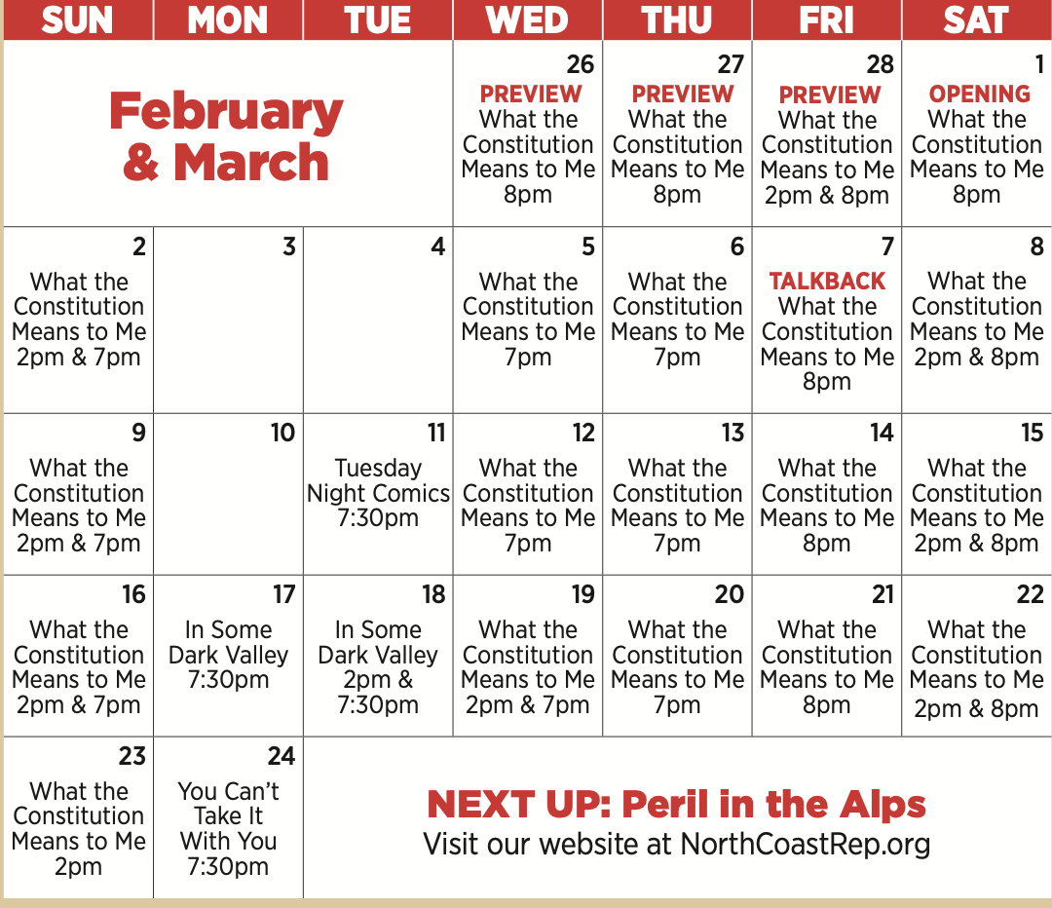

WHAT: NORTH COAST REPERTORY THEATRE presents
WHAT THE CONSTITUTION MEANS TO ME
By Heidi Schrek
Directed by Shana Wride

WHERE: North Coast Rep, 987 Lomas Santa Fe Drive, Solana Beach, CA 92075

SCHEDULE: Previews start February 26, 2025
Opens: March 1, 2025
Wed., Thurs., Sun. @ 7pm, Fri. & Sat @ 8pm; Sat & Sun @ 2pm
Added matinee performances at 2pm on Friday, Feb.28 and Wednesday, Mar 19. A talkback session with the director and cast is scheduled for Mar. 7

PRICES: Previews $52.00
Week Nights $62.00
Sat. Nights & Matinees $74.00
Sunday Nights $60.00

DISCOUNTS: Seniors, Students, Military & Educators $5.00 off admission. Rush tickets available for $20. Sold 15 minutes prior to showtime.

BIOS:

HEIDI SCHRECK (Playwright) is a writer and performer living in Brooklyn. Her critically acclaimed, award-winning play What the Constitution Means to Me played an extended, sold-out run on Broadway in 2019, and was nominated for two Tony Awards. It had subsequent sold-out runs at the Kennedy Center in Washington D.C as well as at the Mark Taper Forum in Los Angeles and will continue its national tour when safe to do so. A filmed version of “What the Constitution Means to Me,” starring Schreck, premiered this past October exclusively on Amazon Prime Video, and was nominated for a Critics Choice Award, a PGA Award, and a DGA Award. What the Constitution Means to Me was named Best of the Year by the New York Times, the Los Angeles Times, the Chicago Tribune, Time Magazine, The Hollywood Reporter, The New Yorker and more; NPR named it one of the “50 Great Pop Culture Moments” of 2019. Schreck’s other plays Grand Concourse, Creature and There Are No More Big Secrets have been produced all over the country and she has worked as a stage actor in NYC for almost 20 years. Her screenwriting credits include “I Love Dick,” “Billions,” “Nurse Jackie” and shows in development with Amazon Studios, Big Beach, Imagine Television and A24. As both an actor and writer she is the recipient of three Obie Awards, a Drama Desk Award, and a Theatre World Award; as well as the Horton Foote Playwriting Award and the Hull-Warriner Award from the Dramatists Guild. She was named one of Fast Company’s Most Creative People in Business in 2019 and was featured on Variety’s 2019 Broadway Impact List. Schreck was awarded Smithsonian Magazine’s 2019 American Ingenuity Award, for her work in the Performing Arts.

SHANA WRIDE (Director) is a San Diego based actor and director who has been involved in many shows at North Coast Repertory Theatre, most recently as Terri in Incident at Our Lady of Perpetual Help and as the Director of Dr. Jekyll and Mr. Hyde. She has also worked with The Old Globe Theatre, La Jolla Playhouse, The Shakespeare Center of Los Angeles, Diversionary Theatre, Cygnet Theatre, The San Diego Symphony, Intrepid Theatre, Moxie Theatre, Compass Theatre, The Colony Theatre, Open Fist Theatre, San Diego Repertory Theatre, Idaho Shakespeare Festival, Gaslamp Quarter Theatre, and Sledgehammer Theatre. While living in Los Angeles, she co-hosted the nationally syndicated radio show, “Women Aloud” with actor/comedienne Mo Gaffney. shanawride.com

JACQUE WILKE* (Heidi) is absolutely thrilled to be returning to North Coast Rep! Regional credits include: Human Error, The Outsider, Moon Over Buffalo, The Father, Unnecessary Farce, Lend Me a Tenor, Don’t Dress for Dinner (North Coast Rep), Baskerville: A Sherlock Holmes Mystery (Theatre Silco), Every Brilliant Thing (Happy Dagger Boulder Theatre), Ebenezer Scrooge’s Big San Diego Christmas Show (The Old Globe), Yoke/The Car Plays (La Jolla Playhouse), Pride and Prejudice, Stupid F***ing Bird, The Importance of Being Earnest, Travesties, Mistakes Were Made (Cygnet),The Happiest Place on Earth, Ballast, Next Fall, Side Man, Fair Use, The New Century (Diversionary), Honky (San Diego Rep), Blithe Spirit (Moonlight), Ironbound, Or, (Moxie) All My Sons, The Winter's Tale (Intrepid Theatre). Honors: Charles Jehlinger Award, Craig Noel Award. Training: American Academy of Dramatic Arts, The Groundlings Theatre. For Twyla Olive. jacquewilke.com

ANDREW OSWALD* (Legionnaire/Mike) was last seen at North Coast Rep as Count Rosenberg in Amadeus. Local credits: (Cygnet) Charlie in The Whale, Harry in Company; (Diversionary) Ed Perch in The Hour of Great Mercy * best actor award San Diego Critics Circle, A Kind of Weather, Regrets Only, Boys and Girls, The Further Adventures of Hedda Gabler; (La Jolla Playhouse WOW festival) The Music Sounds Different to Me Now; (Backyard Renaissance) The Elephant Man, Mr. and Mrs. Fitch. He portrayed Thomas Whaley in the short film “Whaley” as part of LA Screamfest. In New York, he worked with Tribeca Theatre Lab, Second Stage, Nada, and The Westbeth Theatre Center. Regionally, his work with Orlando, New Hampshire, and Wisconsin Shakespeare Festivals featured roles like Malvolio, Bottom, Count Orsino, and Captain Von Trapp. He will appear as Vanya this Fall in Cygnet’s Vanya and Sonia and Masha and Spike.

GENEVIEVE TAI (Debater) is a theatre actress with performances in local community theatre and school productions. Her passion for acting began in 2021 and has only blossomed in the last three years. Genevieve has built an impressive reputation for her commitment to her craft appearing in productions such as Phantom of the Opera, Hamlet and Midsummer Night’s Dream. Genevieve is equally enthusiastic about the work she does behind the stage, becoming a Teen Council Member at the La Jolla Playhouse this year. Along with her passion for theatre, Genevieve is an avid animal lover, and has operated her own rescue organization since 2020, being recognized by local broadcast news stations on ABC and CBS San Diego. Genevieve was also recognized as a GoFundMe Kid Hero of the Month, for her fundraising efforts towards animals. In 2024, Genevieve began to volunteer for the Student Visionary team for the Leukemia Lymphoma Society.

EM DANQUE (Debater) is thrilled to be making her North Coast Rep debut! A San Diego native, Em has been in many productions at Helix Charter High School and Grossmont College–as well as some productions at Coronado Playhouse and Young Actors Theatre. Some of her favorite roles include: Maureen in Rent, Wendy Darling in Lost Girl, Hannah/Ellie u/s in Freaky Friday, Paravicini in Mousetrap, and Woman/Eurydice/Vertumnus in Metamorphoses. She wants to thank her family, friends, and partner for their endless support and love.

EVELYN G. MYERS* (Production Stage Manager) (she/her) The Old Globe: Henry 6: Part 1 and Part 2, Ms. Holmes & Ms. Watson: Fat Ham, As You Like It, The Comedy of Errors, and Henry V. La Jolla Playhouse: The Garden, POP Tour (Hoopla!), POP Tour (Pick Me Last), POP Tour x National Disability Theatre (Emily Driver’s Great Race Through Time and Space). North Coast Rep: Sense of Decency, Pippin. Hollywood Fringe Festival: The First and The Last (Encore Award). Young Theatre: Bell, Book, and Candle (Kennedy Center Excellence in Stage Management Award).

DESIGNERS
MARTY BURNETT (Set Design) Resident Designer at North Coast Rep since 1992. Scenic designed more than 250 productions at the theatre. Resident Designer at Coronado Playhouse 1981-84 and Fiesta Dinner Theater 1984-87. Co-owner Props and Drops 1987-91, Designing for Union Plaza, Hacienda and Sahara Hotels and Casinos, Las Vegas; Harrah’s, South Lake Tahoe and Claridge Hotel, Atlantic City; Drury Lane Theater, Chicago. At Laguna Playhouse designed Chapatti, Alexandros, and transfer designed Murder on the Links, The Angel Next Door, Tartuffe and Camelot from North Coast Rep. Marty has a B.A. from Creighton University, Omaha, NE.
MATTHEW NOVOTNY (Light Design) is pleased to be designing another show for
North Coast Rep, where he has designed close to 40 shows over the past seven years. Matthew is currently the Lighting Designer in Residence for San Diego Musical Theatre
as well as North Coast Rep, and his work can be seen at a wide variety of theatres across San Diego. Matthew holds a B.A. in Technical Theatre from San Diego State and a master’s degree in Lighting Design from Boston University. Matthew is married to his beautiful wife Amanda, with five AMAZING children: Ragan, Harper, Heston, Maddex, and Harrison.
ELISA BENZONI+ (Costume Design) is thrilled to be working on her eighth season at
North Coast Rep including numerous Craig Noel nominated productions. Elisa has also worked on more than 100 productions across Southern California with theatres such as The Old Globe, La Jolla Playhouse, Geffen Playhouse, South Coast Repertory Theatre, Laguna Playhouse, San Diego Repertory Theatre, Diversionary Theatre and New Village Arts. Being Italian born, Elisa has also had the opportunity to work and perfect her craft in Europe. Elisa holds a costume design M.F.A. from UCSD, where she currently is an adjunct professor.
EVAN EASON (Sound Design) is thrilled to be returning to North Coast Repertory. Some of his previous work includes: Incident at Our Lady of Perpetual Help, Intimate Apparel, The Cherry Orchard (North Coast Repertory), Miracle on 34th Street, The Thanksgiving Play, Into the Woods, Beehive: The 60s Musical (New Village Arts), Evita, Lady Day at Emerson’s Bar and Grill (Cygnet), The Two Gentlemen of Verona, Measure for Measure (USD/The Old Globe), Eighty-Sixed, The Mystery of Irma Vep (Diversionary), Pick Me Last, Emily Driver’s Great Race Through Time and Space (La Jolla Playhouse), Good Trouble (Blindspot Collective).

AUDREY CASTERIS (Props Design) is a San Diego based scenic designer and fabricator. Recent North Coast Rep credits include props design for Heart Sellers, Sense of Decency and Camelot. Recent design credits include All Bark No Bite (Coronado Playhouse), We Begin in a Tavern (Orlando Fringe Festival 2023), The Resistible Rise of Arturo Ui (Theatre UCF), The Interference (Theatre UCF). Audrey is also the Resident Set Design Assistant at The Old Globe. @audreycasterisdesign

ALI FLORES (she/her - Production Assistant) is excited to be making her North Coast Rep debut! She has been working backstage on shows since 2018 and hopes to continue for as long as she can. Ali also creates backstage content on her social media platforms. Credits: Natasha, Pierre, and the Great Comet of 1812 (Cygnet Theatre - ASM), The Ferryman (New Village Arts - ASM), In Pieces (Teatro San Diego - SM), Evita (Cygnet Theatre - PA), Man & Moon (Moxie Theatre - SM), Fun Home (New Village Arts - ASM), Stranger Sings (Oceanside Theatre Company - SM), Sesame Street shows (SeaWorld San Diego - SM). Thank you, family and friends, for all your love and support. @stagemanager1618

ASHTON BOTTS (Dramaturg) - Ashton is an attorney, actor, and director based out of Kansas City, Missouri. Since serving as dramaturg for the Kansas City Repertory Theatre’s production of What the Constitution Means to Me, she has worked with multiple theatres across the country on their respective productions. She is grateful for the opportunity to combine her passions for theatre and the law and to collaborate with North Coast Rep on this important piece.

North Coast Repertory Theatre, under the artistic leadership of David Ellenstein since
2003, is a professional Equity theatre, currently celebrating its 43rd Season. North
Coast Rep has received critical acclaim from media and audiences alike, and has
evolved into one of the area’s leading performing arts organizations. North Coast Rep
prides itself on employing the majority of its actors from Actors’ Equity Association for its
high quality, award‐winning productions, and staging works by established and
emerging playwrights. Throughout its history, North Coast Rep has created a platform
where artist and audience thrive through the intimacy of live theatre, recognizing the
power of theatre to challenge complacency, revitalize the imagination, nurture the
unexpected and embrace the variety and diversity in our lives.

###

