FOR IMMEDIATE RELEASE PLEASE

CONTACT: Nancy Richards – 917-873-6389 (cell) /nancy@northcoastrep.org
MEDIA PAGE: www.northcoastrep.org/press

NORTH COAST REPERTORY THEATRE INVITES AUDIENCES
TO AN ENGAGING, HEARTWARMING CELEBRATION
OF FIVE GENERATIONS WITH SAN DIEGO PREMIERE OF
BIRTHDAY CANDLES
Written by Noah Haidle
Directed by David Ellenstein
June 4 – June 29, 2025

Solana Beach, Calif. – Playgoers are in for a treat as North Coast Repertory Theatre presents Noah Haidle’s BIRTHDAY CANDLES, a touching tribute to one woman’s life. Filled with laughter, tears and moments of reflection, the play explores the passing of time, the evolution of relationships, and the profound changes that occur in a person’s life from one year to the next. Through its characters and storytelling, BIRTHDAY CANDLES offers a unique perspective of life’s milestones. It honors five generations, an infinity of dreams, and one century-old cake. This is one party you won’t want to miss, so RSVP at the box office early to reserve yourself a place at the table.

David Ellenstein directs Matthew Grondin,* Katie Karel,* Martin Kildare,* James Newcomb,* Emelie O’Hara,* and Margot White* in BIRTHDAY CANDLES. The Design Team includes Marty Burnett (Set Design), Matthew Novotny (Light Design), Danita Lee (Costume Design), Ian Scott (Sound Design), Michael Wogulis (Props), and Peter Herman (Hair & Wigs). Philip Gold* is the Production Manager, and Victoria Hua, Production Assistant.

*The actor or stage manager appears through the courtesy of Actors’ Equity
Association.

BIRTHDAY CANDLES previews begin on Wednesday, June 4. Opening Night is set for Saturday, June 7, at 8 pm. The play runs Wednesday, June 4, to Sunday, June 29, with performances on Wednesdays and Thursdays at 7 pm, Fridays and Saturdays at 8 pm, and Saturday and Sunday matinees at 2 pm and Sundays at 7 pm. Added matinee performances at 2pm on Friday, June 6, and Wednesday, June 25. A talkback session with the director and cast is scheduled for June 13.

North Coast Rep is located at 987 Lomas Santa Fe Drive, Solana Beach, CA 92075.
Tickets: Previews - $52 (including Friday preview at 2pm), Weeknights - $62, Wed. & Sat. Matinees/Sat. Eve. - $74; Sun. Night - $60. For ticket information and to secure
your seats for BIRTHDAY CANDLES, call 858-481-1055, or visit ww.northcoastrep.org. Join us for an evening of unbridled joy, temporary disappointment, and those quiet glimpses of self-reflection that are certain to resonate well after the cast takes its final bow.

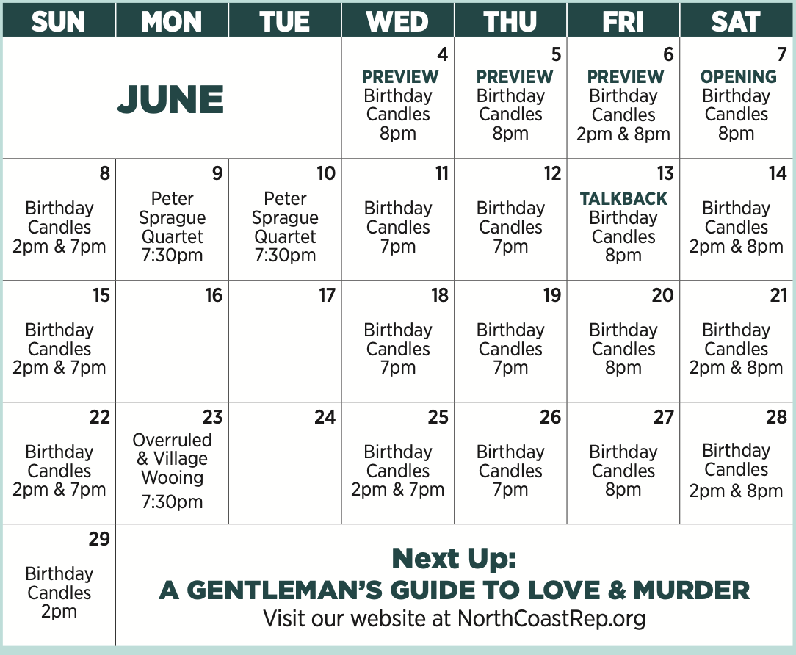

BIOS:

NOAH HAIDLE (Playwright) is an award-winning playwright whose work has been seen on six continents. For the 2017-2018 season, he was the writer-in-residence at the National Theater of Mannheim, Germany, a position first held by Friedrich Schiller in 1785. A graduate of Princeton and Juilliard, Noah lives with his perfect wife Kelsey, their heaven-sent son Butch, a dog, a bunny, and a blue lobster named Suzanne.

DAVID ELLENSTEIN (Director) Born into a theatrical family; David has worked in theatres across the country. He currently serves as Artistic Director of North Coast Rep and the Artistic Director of Laguna Playhouse. A veteran of over 250 theatrical productions, other theatres include: Coconut Grove Playhouse, Papermill Playhouse, Portland Stage. Renaissance Theatre, Actor’s Theatre of Phoenix, Alabama Shakespeare Festival, Laguna Playhouse, Southwest Shakespeare Company, AJTC, Meadow Brook Theatre, Portland Rep and Gaslamp Quarter Theatre. Winner of the San Diego Theatre Critics Circle Award for “2018 Director of the Year Award.”

MATTHEW GRONDIN* (Billy/John) Matt is delighted to be making his North Coast Rep debut! Credits include District Merchants, Tales of a 4th Grade Nothing (South Coast Rep) Arsenic and Old Lace (La Mirada Theatre), Native Son (Kirk Douglas Theatre), The City of Conversation, Women of Jeopardy, Good People (Ensemble Theatre Company) Moon for the Misbegotten (Rubicon Theatre) Stupid F*cking Bird, Bad Jews (Stage West) The Thanksgiving Play (Dezart Performs), Friends Like These
(NY Fringe), The Cripple of Inishmaan, Native Son (Antaeus Theatre – where he is a Company Member). Readings/Workshops include: Pasadena Playhouse, The Geffen Playhouse, South Coast Rep, EST/LA, Sacred Fools.

KATIE KAREL* (Alice/Madeline/Beth) is so happy to be returning to the North Coast, her theatrical home. Off Broadway: Lucky Duck, National Tour: Menopause the Musical 2; with North Coast Rep: Pippin, Always...Patsy Cline, Last of the Red Hot Lovers, and Sherlock Holmes & The Great Nome Gold Rush, and Laguna Playhouse: Tartuffe, The Remarkable Mr. Holmes. Selected Regional: Skylight, Indecent, The Humans, Chesapeake, You Can’t Take It with You, Valhalla, Heathers, Bloody Bloody Andrew Jackson, Into the Woods, The Addams Family, Sunday in The Park With George, Sweeney Todd, 1776, In Trousers, a few Hairsprays and a couple more Patsy Clines. Her thanks to everyone at North Coast Repertory, and to the cast and creative team. Love to Gary. Karel is passionate about her mentorship with LLS, Imerman Angels, and Friend for Life Cancer Support Network as a survivor. Connect with Katie at www.katiekarel.com

MARTIN KILDARE* (Matt/William) Broadway credits include Scar in The Lion King, A Raisin in the Sun, Timon of Athens, The Government Inspector, and The Herbal Bed. Also, as Bill in the North American tour of Mamma Mia! Off-Broadway appearances include Pride’s Crossing, Honor and the River, Candida, Labor Day, and Three More Sleepless Nights. For North Coast Rep, Bloomsday and Human Error. Recently, The Remarkable Mr. Holmes and Love Among The Ruins at the Laguna Playhouse. Other LA area theaters include Mark Taper Forum, Musical Theatre West, South Coast Rep, A Noise Within, La Mirada and 3D Theatricals. Nationally, over a dozen major regional companies, including a combined ten seasons with the California, Alabama and Utah Shakespeare Festivals. Film/TV: “Joker 2,” “Palm Springs,” “Clipped,” “Superstore,” “NCIS,” “Desperate Housewives,” “Law and Order” and many others. He studied at Stanford University, the American Conservatory Theatre, Theatre des Amandiers, in Paris, and Shakespeare’s Globe in London.

JAMES NEWCOMB* (Kenneth) The Old Globe: Twelfth Night, Coriolanus, and Much Ado About Nothing. San Diego Rep: Honky, Zoot Suit, Brooklyn Boy, and The Illusion. North Coast Rep: The Homecoming, Christmas Carol (as told by one man who cares - Streamed), How the Other Half Loves. Cygnet Theatre: Roy Cohn in Angels in America (Craig Noel award). Other Theatre: Oregon Shakespeare Festival (14 Seasons), Denver Center Theatre (9 Seasons), The Public Theatre, B.A.M. Utah Shakespeare Theatre, Shakespeare & Company (founding member), The Goodman, Chicago Shakespeare, Berkeley Rep. South Coast Rep, Portland Center Stage, Missouri Rep, Arizona Theatre Co., and Geva Theatre. Representative Roles include: Oxford Society Award for Richard III (O.S.F.)

EMELIE O’HARA* (Joan/Alex/Beth) Regional Theatre credits include: Henry VI Parts 2 & 3, Macbeth (Utah Shakespeare Festival); A Midsummer Night's Dream (Colorado Music Festival); Romeo & Juliet (Redhouse Arts Center); Hamlet, Comedy of Errors, Henry VI Parts 2 & 3, Edward III, Cymbeline, Troilus and Cressida (Colorado Shakespeare Festival); Little Women, A Midsummer Night’s Dream (Cincinnati Shakespeare Festival); Sense and Sensibility and The Electric Baby (Arvada Center for the Performing Arts), Becket (Drive Theatre); Love’s Labour's Lost (Courage Theatre); Macbeth (Sierra Repertory Theatre); Twelfth Night, A Midsummer Night’s Dream, Merlin (Theatricum Botanicum); The Lady M Project (Local Theatre Co.); and Private Lives (Adobe Theatre). Film credits include: “Don’t Blink,” “Stained Glass Windows.” TV credits include: Starz, USA, Lifetime. International: Kerry Tribe’s Critical Mass, London. Training: Moscow Art Theatre, Gaiety School of Acting.

MARGOT WHITE* (Ernestine Ashworth) Margot is thrilled to return to North Coast Rep, where she just received a Craig Noel Award for her portrayal of Beatrice in A View From the Bridge. Other favorite credits include: Broadway: Farinelli & the King (Belasco); Love, Love, Love (Roundabout); Constellations (MTC), Aaron Sorkin’s The Farnsworth Invention (Music Box); Off-Broadway & Regional: The Refugees, (Gulfshore Playhouse/World Premiere); Dirty Dancing (International Tour); The Traveling Lady (E.S.T, Dir Horton Foote); Pericles (Red Bull); Unspeakable (Harlem’s Apollo); Sweat (Pioneer Theatre); Talley’s Folly (The McCarter w/ Richard Schiff),Curious Incident.. (CTRep), for which she received the CT Critics Circle Featured Actress Award. TV/Film/Podcast: “FBI," “Bull," “Unforgettable," "L&O," "L&O: Criminal Intent," "Blue Bloods," “Limetown," “Ask for Jane." In addition to her acting career, she’s the founder & creator of Sweets of Adversity, a baking company specializing in creative concessions for special events, along with catering the edible props for shows On and Off-Broadway. More at margotwhite.com & sweetsofadversity.com

PHIL GOLD* (Stage Manager) is pleased to return to North Coast Rep with Birthday
Candles after last summer’s production of Camelot. Tours: Sisterella (European) and Soul Doctor (San Diego run). Off Broadway: Miss America’s Ugly Daughter. Recent regional credits include: The Curious Incident of the Dog in the Night-Time, The Little Mermaid, Little Shop of Horrors, Million Dollar Quartet, Richard III, Love Among the Ruins, The Wizard of Oz, Joseph…, The Realistic Joneses, and the world premieres of Dark of the Moon: A New Musical and All Things Equal.

MARISA KIKIS (Understudy) is absolutely thrilled to support the immensely talented cast and crew of Birthday Candles. As North Coast Rep's Engagement & Individual Giving Manager, she has the distinct pleasure of getting to know and love all of you - the patrons and donors who make productions like this one possible! Theatre: Plaza Suite, The Odd Couple, Lysistrata and Top Girls. TV: “Katy Keene,” “FBI,” “Shades of Blue,” “Younger” and a smattering of national commercials. BFA: NYU Tisch School of the Arts (Atlantic Theater Company). Thank you to David for this beautiful opportunity. Everything is for Alex and Sky!

DESIGNERS

MARTY BURNETT (Set Design) Resident Designer at North Coast Rep since 1992. Scenic designed more than 250 productions at the theatre. Resident Designer at Coronado Playhouse 1981-84 and Fiesta Dinner Theater 1984-87. Co-owner Props and Drops 1987-91, Designing for Union Plaza, Hacienda and Sahara Hotels and Casinos, Las Vegas; Harrah’s, South Lake Tahoe and Claridge Hotel, Atlantic City; Drury Lane Theater, Chicago. At Laguna Playhouse designed Chapatti, Alexandro, and transfer designed Murder on the Links, The Angel Next Door, Tartuffe, and Camelot from North Coast Rep. Marty has a B.A. from Creighton University, Omaha, NE.

MATTHEW NOVOTNY (Light Design) is pleased to be designing another show for
North Coast Rep, where he has designed close to 40 shows over the past seven years.
Matthew is currently the Lighting Designer in Residence for San Diego Musical Theatre
as well as North Coast Rep, and his work can be seen at a wide variety of theatres across San Diego. Matthew holds a B.A. in Technical Theatre from San Diego State and a master’s degree in Lighting Design from Boston University. Matthew is married to his beautiful wife Amanda, with five AMAZING children: Ragan, Harper, Heston, Maddex, and Harrison.

DANITA LEE (Costume Design, she/her/hers) is delighted to work with North Coast Rep again on this piece! Favorite projects include In the Heights (Music Theatre Wichita), Handbagged and The Madres (MOXIE), Water by the Spoonful and The Hot Wing King (Cygnet). ACD credits with Old Globe Theatre, La Jolla Playhouse, and North Coast Rep. She holds an MFA in Costume Design from SDSU. Thanks to the incredible team and wonderful cast! And to Michael J., the Lee & Woo families, SW, DVW and HRW—you are magic! danitalee.com
IAN SCOTT (Sound Design) is a composer and sound designer specializing in the development of new works and installations. His music and designs have been heard at Playwrights Horizons, Roundabout Theatre, Virginia Museum of Fine Arts, Yale University Art Gallery, Actors Shakespeare Project, Dorset Theatre Festival, Ars Nova, and Yale Repertory Theatre. Ian has made an extensive career as an A1 for productions with Audible Theatre, The New Group, Signature Theatre, New York Theatre Workshop, Tuacahn Amphitheater, Classic Stage Company, Theatre for the New City, Berkshire Theatre Festival, and others. Ian received his MFA in Sound Design from Yale School of Drama.
MICHAEL WOGULIS (Props Design) is a multi-disciplinary artist based in San Diego, who works in scenic, projections, and props design for theatre. Props design credits include: Little Women: The Musical (Moxie Theatre), Our Dear Dead Drug Lord (Moxie Theatre). Scenic design credits: The Prom (San Diego Musical Theatre), Gruesome Playground Injuries (Loud Fridge Theatre Group), Once on this Island (Oceanside Theatre Company), Miracle on 34th Street (New Village Arts), The Thanksgiving Play (New Village Arts), Clyde's (Moxie Theatre), The Glass Menagerie (Diversionary Theatre). Projection design credits: Once on this Island (Oceanside Theatre Company), La Havana Madrid (New Village Arts), Cleopatra (Moxie Theatre). Other credits: La Lucha (scenic artisan, WOW Festival/Optika Moderna), Here There Are Blueberries (assistant scenic resident, La Jolla Playhouse). Michael is a double alumnus of UC San Diego, having earned both a BA and an MFA in scenic design from the university. michaelwogulis.com

PETER HERMAN (Hair & Wigs Design) has previously designed wigs for more than 30
North Coast Rep productions. Peter teaches wig and makeup design at San Diego State University. He is glad to be part of the creative team on this show.

VICTORIA HUA (Production Assistant) has worked in various shows over 5 years in production and stage management positions. She is currently working in the San Diego and North County area. Previous productions include: The Little Fellow (Cygnet); On Her Shoulders We Stand (TuYo); Beehive - The 60’s Musical (New Village Arts); Tartuffe (North Coast Rep); Camelot (North Coast Rep); The Heart Sellers (North Coast Rep)

CREW:
CLARENCE LIGHTFOOT

North Coast Repertory Theatre, under the artistic leadership of David Ellenstein since
2003, is a professional Equity theatre, currently celebrating its 43rd Season. North
Coast Rep has received critical acclaim from media and audiences alike, and has
evolved into one of the area’s leading performing arts organizations. North Coast Rep
prides itself on employing the majority of its actors from Actors’ Equity Association for its
high quality, award‐winning productions, and staging works by established and
emerging playwrights. Throughout its history, North Coast Rep has created a platform
where artist and audience thrive through the intimacy of live theatre, recognizing the
power of theatre to challenge complacency, revitalize the imagination, nurture the
unexpected and embrace the variety and diversity in our lives.

###

