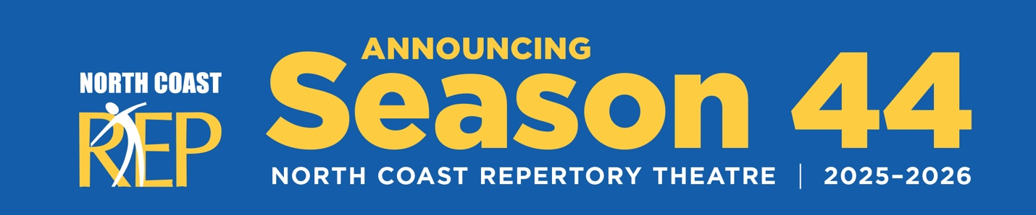

FOR IMMEDIATE RELEASE

NORTH COAST REPERTORY THEATRE ANNOUNCES DYNAMIC 2025-2026 SEASON

Featuring Three World Premieres, Acclaimed Classics, and the Return of a Holiday Favorite
Solana Beach, CA – North Coast Repertory Theatre proudly unveils its exciting 2025-2026 season, offering audiences an eclectic mix of world premieres, beloved classics, and theatrical treasures. Under the artistic direction of David Ellenstein, the upcoming season promises to deliver exceptional theatrical experiences for patrons of all tastes.
The season opens with the world premiere of BESIDE MYSELF (September 10 – October 5, 2025), a witty, surreal comedy by acclaimed playwright Paul Slade Smith. This innovative work explores identity and modern anxiety through a revolutionary medical procedure that creates an unexpected double dose of identity crisis. From the clever mind behind The Angel Next Door, The Outsider, and Unnecessary Farce, this comedic exploration promises to sparkle as two versions of one woman, trapped in a single body, wrestle for control with hilarious and profound results. Directed by David Ellenstein.
Following this is the San Diego premiere of EISENHOWER: This Piece of Ground (October 22 – November 16, 2025), featuring Tony Award Winner John Rubinstein. This powerful one-man tour de force transports audiences to Gettysburg, where an elderly Eisenhower reflects on his monumental military leadership and transformative presidency. Through masterful storytelling and rich historical detail, critics have called this compelling drama "awesome and awe inspiring in one" and "a show that could go straight to Broadway." Directed by Peter Ellenstein.
The holiday season brings the return of audience favorite 2 PIANOS 4 HANDS (December 11 – December 31, 2025), featuring Richard Todd Adams and Max Roll under the direction of Tom Frey. This musical comedy takes audiences on a journey about would-be careers as concert pianists, as the talented duo trade stories about piano lessons, pushy parents, and eccentric teachers while playing everything from Bach to Billy Joel. Broadway World praised it as "clearly made with love," noting that "both actors are incredibly accomplished pianists, and they are also very funny comedic actors."
The new year kicks off with another world premiere, LOUISA GILLIS (January 14 – February 8, 2026) by Joanna McClelland Glass, directed by David Ellenstein. This sophisticated psychological thriller explores family bonds, betrayal, and the possibility of healing in the aftermath of a haunting incident from 40 years ago. Glass's searing new drama weaves a masterfully crafted battle of wits and words laced with humor, where secrets unravel and alliances shift as a brilliant but fractured family grapples with the power of forgiveness.
Spring 2026 brings the world premiere adaptation of THE MALTESE FALCON (March 4 – March 29, 2026) by Matthew Salazar-Thompson, directed by Todd Nielsen. This electrifying adaptation of Dashiell Hammett's noir masterpiece features five versatile performers transforming between roles with quick-change artistry and acute timing to bring 1920s San Francisco's underbelly to hilarious life. The ensemble navigates through a labyrinth of deception and desire while delivering taut, unsparing prose that crackles with tension and mirth.
James Sherman's heartwarming romantic comedy BEAU JEST (April 22 – May 17, 2026) follows, directed by Omri Schein. This delightful Jewish-American story weaves together vibrant traditions, sizzling chemistry, and joyous celebrations. The Wall Street Journal noted it "has a lot to say about nuclear families of any ethnic persuasion," while the Chicago Sun Times called it "hilarious and quite moving" with wonderful blending of farce and genuine insight.
Summer begins with THE MOST HAPPY FELLA (June 3 – June 28, 2026), a new intimate version of Frank Loesser's romantic musical masterpiece directed by Jeffrey B. Moss. Set against the sun-drenched vineyards of California's Napa Valley, this passionate tale of unexpected love features soaring melodies, tender ballads, and vibrant Broadway showstoppers. The New York Times praised it as "a work in which you can hear the sound of a man's heart singing, openly and unabashedly."
The season concludes with Molière's classic SCAPIN (July 22 – August 16, 2026), adapted by Bill Irwin & Mark O'Donnell and directed by Christopher Williams. This timeless romp reimagined with contemporary American flair features Molière's crafty servant spinning outrageous schemes and disguises. Physical comedy and razor-sharp wit collide in what Culture Vulture called "a two-hour laugh riot" and "a generous gag-fest, packed with rib-tickling delights."
Subscriptions and individual tickets are now available through the North Coast Repertory Theatre box office. For more information or to reserve seats, please visit www.northcoastrep.org or call (858) 481-1055.

About North Coast Repertory Theatre
North Coast Repertory Theatre is a professional equity theatre founded in 1982. Now celebrating its 43rd season, North Coast Rep has received critical acclaim from media and audiences alike. North Coast Rep prides itself on employing the majority of its actors from Actors' Equity Association and staging provocative, entertaining, and intellectually stimulating plays.
CONTACT:
Nancy Richards
Director of Marketing & Communications
North Coast Repertory Theatre
(917) 873-6389
Nancy@northcoastrep.org

